ELCT-ULANGA KILOMBERO DIOCESE
TUMAINI LUTHERAN SEMINARY

A BRIEF REPORT OF COMPLETION OF DINING HALL
- (A) REPAIR OF FOUNDATION
This phase includes the following work;
- Foundation excavation
- Foundation plastering
- Foundation bitumen painting
- Foundation sand refill

(i) FOUNDATION EXCAVATION
The foundation excavation has been done well and is finished.

(ii) FOUNDATION PLASTERING
Plastering of the foundation also has finished as it is shown in the pictures below.
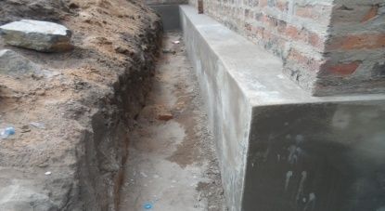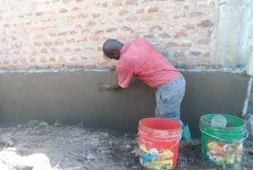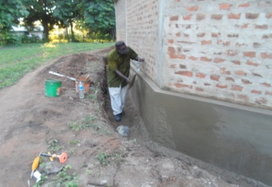

- FOUNDATION BITUMEN PAINTING
The work of painting foundation with bitumen is also finished. See the below.
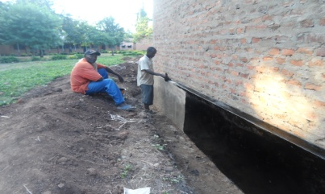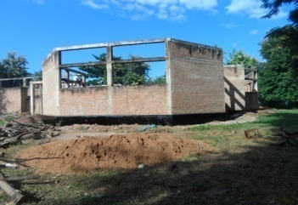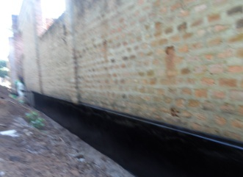

- FOUNDATION SAND REFILL
The work of refilling sand in the foundation is still continues. Outside the hall is finished, remains inside the hall where the work of refilling continues, it is our hope that two or three days later will be finished. See also the picture below.

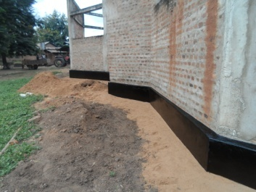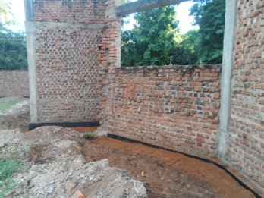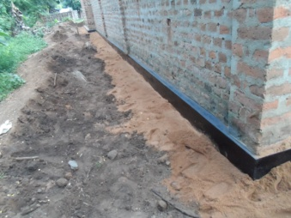
- (B) AREARS OF PROBLEM
From the foundation excavation the Committee observed problems in the following areas which need extra costs:
- One of the walls was built outside the foundation. To correct this mistake another foundation was built to support the wall which needed one trip of natural stones. Labour charge for this work is Tsh.150,000/- equivalent to US Dollar 72. See the pictures below.
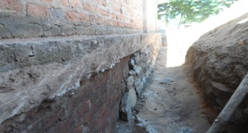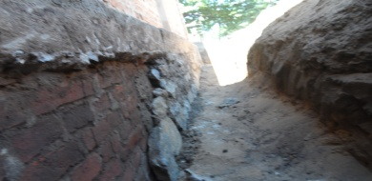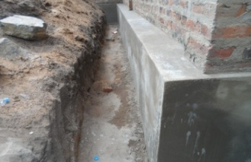

- Tearing down the hard floor to smooth plastering inside the dining hall.
Labour charge for this work is Tsh.200,000/- equivalent to US Dollar 96.
- To fill the gaps between the walls and pillars of the building by casting the concrete Labour charge for this work is Tsh.300,000/- equivalent to US Dollar 143. See the pictures below.
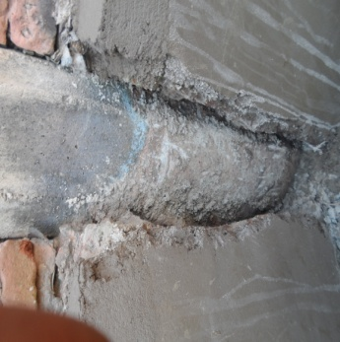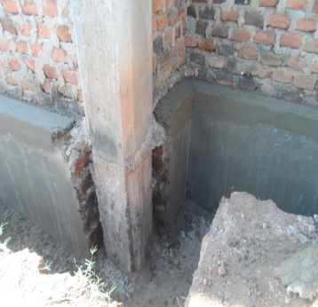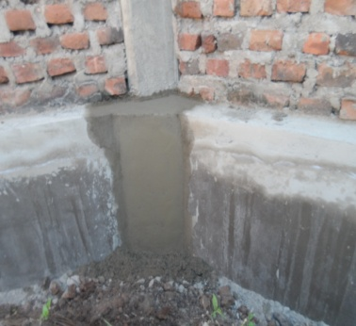
Decision: The Committee accepted the request from the Tenderor for these extra works.
- (A) TEARING DOWN CANOPIES
This phase includes the following work;
- Breaking down of canopies
- Removal of debris
- Supply of scaffolding
- From work and joinery
- Casting of Concrete
All of these works have been done well and are finished as pictures below shows. 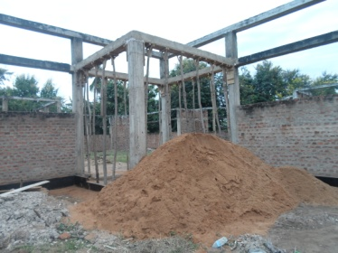 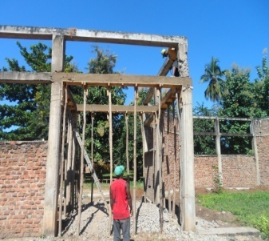 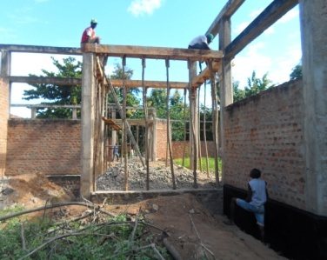

- (B) AREARS OF PROBLEM
Two pillars got problems (have cracks) one from each side as it is shown in the pictures.
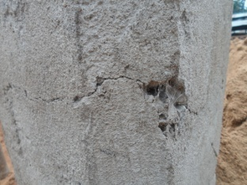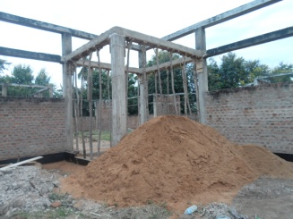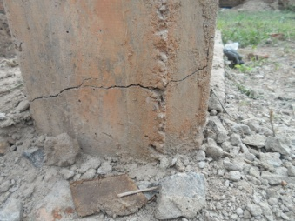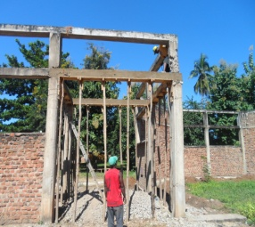
- (A) REPAIR AND COMPLETION OF THE WALLS
This phase includes the following work;
- Tearing down the wall
- Setting out
- Digging of trench
- Cast concrete of Foundation
- Build foundation with natural Stones
- Place DPC
- Wall Construction
All these works also have been done well except for tearing down the wall, which according to the Tenderor it was mistaken overlooked. So there was no need of breaking down the wall. The pictures below support the above explanation.
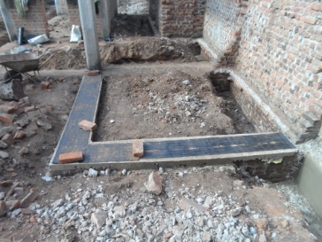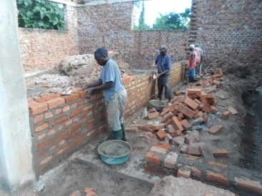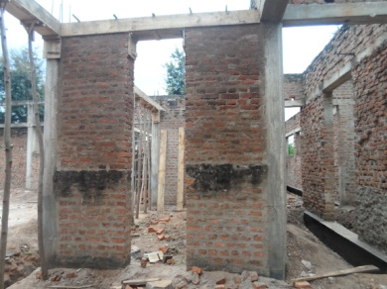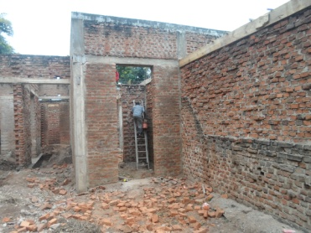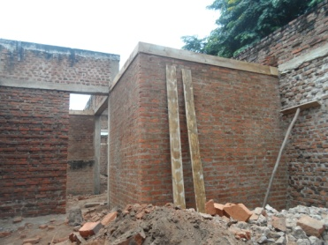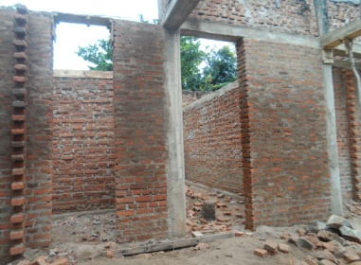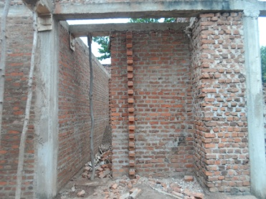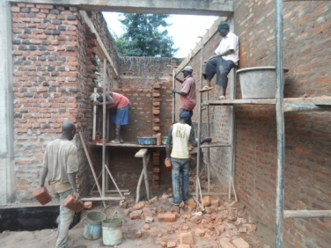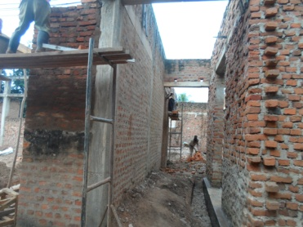
- (B) AREARS OF PROBLEM
In the construction of the walls there was a shortage of 5000 bricks which costs Tshs. 500,000/- equivalent to the USDollar 239., and the Tenderor got permission from the Committee to find the needed bricks in order to finish the walls.

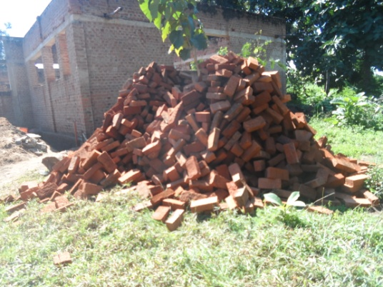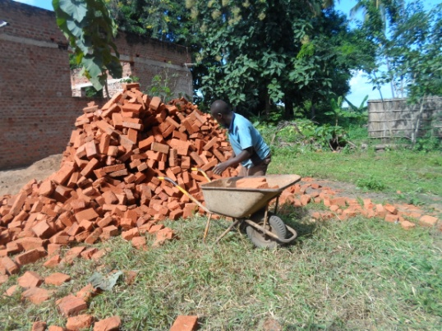

- THE NEW RINGBEAMS
The work of ring beams is going on as it is shown in the pictures below;

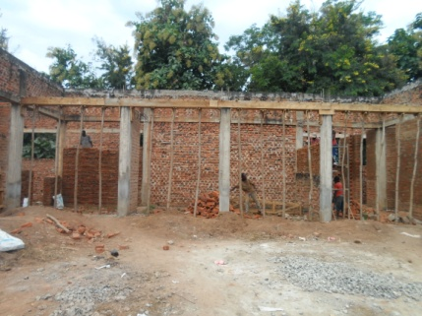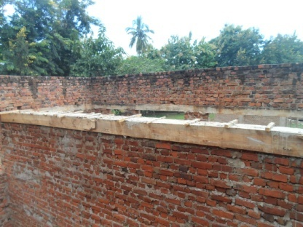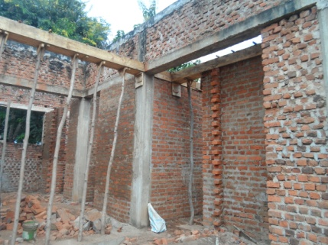

NB: The Tenderor is not yet payed for an additional works.

