NCBC ANNOUNCEMENT

NCBC City Wide Revival!!
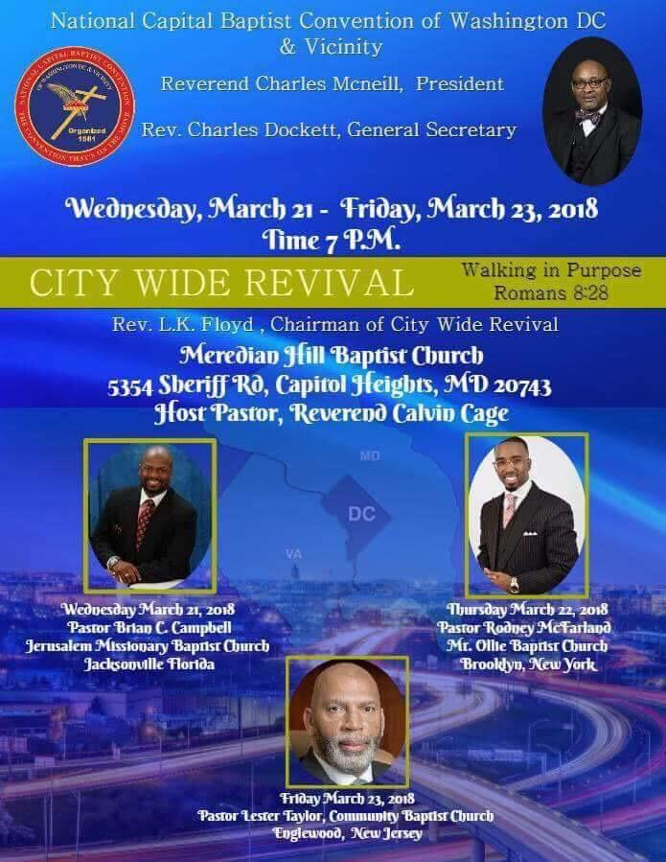
‌
Don't forget to bring a bag on Wednesday, March 21st, 25,000 pounds of free produce will be distributed!

NATIONAL CAPITAL BAPTIST CONVENTION
WASHINGTON, DC & VICINITY
REV. CHARLES W. MCNEILL, JR.
PRESIDENT

Network - Educate - Worship

