Woman’s Auxiliary
To
The National Capital Baptist Convention of Washington, D. C. & Vicinity
Presents
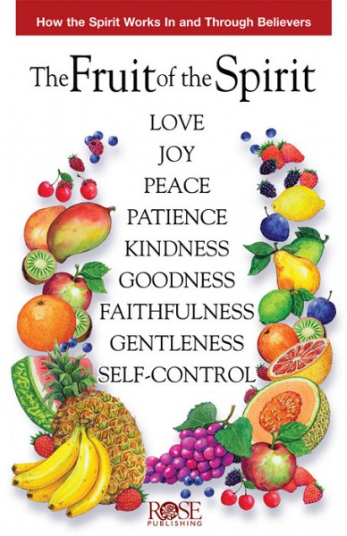
Saturday, April 28, 2018 @10:00am
Eastern Community Church
8213 Manson Street
Landover, Maryland 20785
Deaconess Elnora McCall. Auxiliary President
Rev. Charles W. McNeill Jr., NCBC President
Rev. Damion Briggs, Pastor

