January 12, 2012
Dear Prayer Partners,
I’ve loved getting 2011 Christmas letters, so I’m inspired to try once more to write. Things seem to change or be full of unknowns and surprises whenever I’ve picked up pen. I told Betsy (I live with her & Bob in Bellingham) “It’s the first year I never wrote a prayer letter!” Her smiling reply, “Well, it has been an ...unusual year...”
But one thing is sure: I’m 15 or 16 pounds fatter and healthier than last time I wrote. And praising God! Not only for physical health, but for all His blessings last year...including an almost continual supply of peace. How can I ever thank you for all your love, prayer and support. The mind boggles; the heart overflows. Thank you.
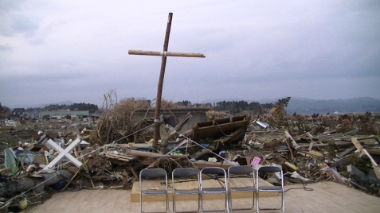*Of big surprises this year, the 3/11 earthquake, tsunami, and radiation disaster in Japan topped them all. Thank you for praying and giving during that time. Family and friends were glad I was here and safe, but my heart was there. A very hard time.
Government and other agencies have pretty much pulled out, after helping with cleanup and building temporary homes: each one 20’ by 20’, with thin walls, HOT in summer and COLD now, and residency limited to 3 years. The already high suicide rate has increased. Japanese, not used to expressing feelings, continue experiencing an overload of emotions: huge loss, fear, loneliness, unknown future, hopelessness, guilt--one man shared,“...all those cars of people trying to come in from side roads, and we wouldn’t let them in...they all died...”--and despair.
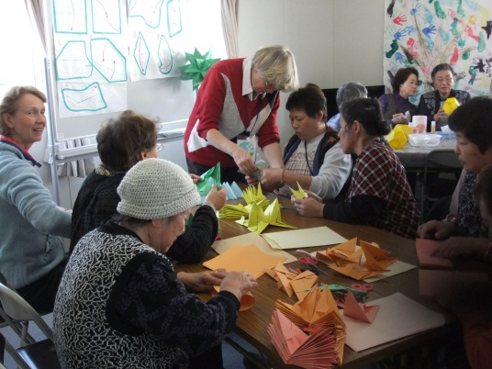In many areas, all but Christian groups have left. Christian volunteers continue to come each week (38 teams from Hokkaido alone...including one from Obihiro Glory Church!) bringing supplies—from rice to laundry soap—as well as musicians, handicraft teachers, and most importantly, listening ears, caring hearts, and the Good News of Jesus’ love, salvation, and hope. Some have joyously believed; others are starting Bible studies to find out more. OMFers Ho & Laura Jane Meas ministered in hard hit Miyako town this summer. From September, Mike & Rowena McGinty and a Japanese couple, the Honmas, have committed to serve for 2 years, and see how God leads.
All that to say: If He so leads, prayer is a most powerful thing for that area—pray for faith in Jesus, direction for future, hope, healing, and heat! And God’s wisdom, joy and power for those ministering.
*Another big surprise was hearing that Otofuke’s Mrs. Ohkawa (Big River) REALLY believed this summer, followed a few weeks later by her husband!!! And the “difficult, noisy” little son immediately began changing, and joining in with worship at church! Praise God! They continue Bible Study with the pastor and his wife; pray for baptism in His timing.
*And, Otofuke’s Mr. Kitsui had a heart attack—no oxygen for 20 minutes—was expected to die, and instead came out of the coma talking like before, and is in rehab hoping to walk again. His Dad, instead of his usual strict gruffness, has started caring for his son...and, the bipolar is doing better! Praise God.
*Otofuke’s Miss Mami is seeing people come to her eating disorder support group, after months of prayer. And she’s reaching out to Otofuke Christian Mrs. T, who finally opened up about her alcohol problem—something a person can’t deal with alone. Praise God! Mami says her Dad is much better, but please pray he believes in Jesus.
Otofuke prayer group continues faithfully, with weekly prayer meetings, cell, and a twice a month outreach called “Learning hymns in sign language” group. Coworker Bea returns from Home Assignment in Germany end of March, and Greg and Shireen Seymour (Australian OMFers) join her from June in Otofuke. *Surprise. Their baby boy just born Sat., with Down’s syndrome. Pray for wisdom.
*Two more big surprises this year had to do with Mom—first when she fell in May trying to help Dad, and got a compressed fracture in her back plus squished vertebrae—2 months “quiet” during her favorite gardening season—followed in July by news of immediate need for open heart surgery! Two more months of enforced quiet. Thanking God she’s much better. You can imagine how glad I was to be in the US and able to help them, along with my wonderful sisters and a wonderful caregiver. Dad’s not so steady on his feet, etc., but doing his best with this “aging transition time”.
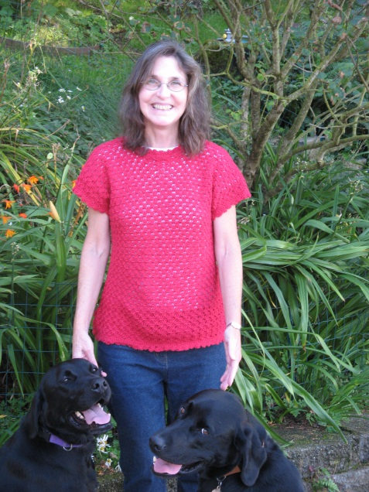*Another great surprise was going to OMF Home Assignment Reunion Training this summer...and how God ministered to all of us, and in amazing ways to me!
*Finally, I liked when the doctors were surprised, to see me healthier and healthier (aside from 3 or 4 upsets) to the point I switched from Swedish Medical in Seattle to Bellingham’s Peacehealth. Up to now, no significant change in carcinoid tumor sizes. So thankful. More tests this month, and a cat scan in March. I take medicines to deal with digestion (messed up by tumors’ hormones), no chemo, but lots of prayer.
God continues to give no promises regarding Japan yet—He doesn’t say “You will go back”, nor “You won’t go back”. He just keeps giving peace and lots of chances for inner growth and healing—I feel like He’s been “redoing and refreshing” —as well as strengthening this body. Sometimes I soak in the beauty and rest, other times I fight anxiety, other times I want to just dance and worship, because of all he’s doing. He’s also given chances here to minister to different people, and be ministered to, a wonderful Home Group, and church—I’ve heard whole series of sermons!, a wonderful Bible study, two wonderful homes, walks with people and dogs, and so much more.
What He also has given lately is words like Hope, Wait, Persevere, Give Thanks, Trust, Love, Worship, Abide, Peace, etc. “Be glad for all God is planning for you; be patient in trouble, and always be in prayer.” (Ro 12:12)
Thank you for waiting and hoping with me, and for praying! I thank Him so much for you...and for HIM!! May He bless you with the best year yet, of getting to know Him and His love. In His great love,
Marianne Murphy

