October 23-24, 2014

Tucson, Arizona
Site Hosts: GAP Ministries/4Tucson

When: 9 a.m. – 4 p.m. both days
Where: GAP Ministries, 2861 N Flowing Wells Rd #161, Tucson, AZ 85705
Phone for Directions Only: (520) 877-8077
Registration Information:
Tiane Kennedy – Public Relations Director - GAP Ministries
520-955-3088 (able to accept checks made payable to the Grant Writing Training Foundation)
Dr. Bev Browning – Director - Grant Writing Training Foundation
480-768-7400 (able to accept credit card payments made payable to the Grant Writing Training Foundation)
Registration Fee: $299 per person; three or more from the same organization: $249 each. Sorry, no purchase orders will be accepted. If you pay and are unable to attend, you can designate a substitute or receive a copy of the handout materials and virtual consulting bonus.
What’s included in the Registration Fee?
- Continental breakfast and lunch both days – Value: $30
- Notebook with tabbed handouts (PPT and writing exercises) and USB thumb drive with a copy of the handouts – Value: $25.00
- Grant Writing for Dummies – Fifth Edition – Signed by Dr. Bev Browning (Value $25)
- One hour of virtual consulting with Dr. Browning – good for up to six months following the workshop (Value: $500)
- Certificate for 14 hours of training completion (highly valuable for your career!)
What Does a Comparable Training Program Cost?
- Grant Writing USA - $425 per person
- Grantsmanship Center - $895 per person

How Can You Come Prepared for Grant Writing Boot Camp?
- Bring a computer, power cord, and a power strip and word processing software.
- Bring information on your organization’s background/history.
- Bring information on your current programs and activities.
- Bring demographics on the needs of the community where you provide services.
- Bring writing paper for additional notes.
- Bring a pen/pencil for writing, if needed.

Grant Writing Boot Camp™
A Program of the Grant Writing Training Foundation (Goodyear)
In Partnership with GAP Ministries (Tucson)
Facilitator: Dr. Beverly A. Browning (Dr. Bev)
www.grantwritingbootcamp.us
drbeverlybrowning@gmail.com

OVERVIEW
This comprehensive hands-on boot camp covers everything from learning grants-related terminology to learning how to conduct funding searches to actually writing the critical, high point review sections of a sure to win grant application/proposal. Bring “real” project idea and supporting documentation and complete 95% of your proposal narrative onsite! Laptops/netbooks welcome (remember to bring your power cords and a power strip)!

COURSE DESCRIPTION
This course covers the essential grant seeking and grant writing strategies and skills required to successfully submit competitive corporate and foundation proposals, and state and federal grant applications for funding consideration. Emphasis is placed on researching and writing.

CONTINUING EDUCATION UNITS
The Grant Writing Training Foundation is an approved training provider for the Grant Professionals Certification Institute (GPCI) and for Certified Fund Raising Executives International (CFRE). Each seven-hour training day carries 7.0 continuing education units with both GPCI and CFRE. The full two-day training program enables participants to apply for 14.0 units of continuing education. www.grantcredential.org and www.crfe.org.

TOPICS
Finding Funding, Communicating with Potential Funders, Partnerships, and Formats:
Finding Government and Foundation Funding Sources
Qualifying the Funding Opportunity and Your Organization
Cultivating Donor and Bid Letting Agency Relationships
Pros and Cons of Community Partnerships
Considering Grant Writing Teams
Reviewing Grant Writing Formats
The Case Statement:
- Describing Your Organization
- Describing Your Request to the Funder
- Developing a Compelling Problem Statement
- Writing a Program Design and Planning the Evaluation Process
- Demonstrating Sustainability
Wrapping up the Funding Package and Follow-up:
Planning the Budget
Recommended Attachments
Finishing Touches
Following Up

LEARNING OBJECTIVES

Day 1:

FINDING FUNDING, COMMUNICATING WITH POTENTIAL FUNDERS, PARTNERSHIPS, AND FORMATS:
Finding Government and Foundation Funding Sources
- Discuss funding sources for grant narrative information
- Discuss sources identifying best practices
Qualifying the Funding Opportunity and Your Organization
- Discuss pre-planning checklist
Cultivating Donor Relationships
- Discuss all requirements and expectations for donor relationships
Pros and Cons of Community Partnerships
  - Discuss the advantages and disadvantages of including community partners in your pre-writing planning process, the writing process, the implementation process, and the evaluation process.
Considering Grant Writing Teams
- Discuss benefits of forming a grant writing team
- Discuss team roles
- Discuss maintaining team momentum
Reviewing Grant Writing Formats
- Discuss a letter of inquiry
- Discuss a letter proposal
- Discuss a concept paper
- Discuss a research project proposal format
THE CASE STATEMENT:
Describing Your Organization
- Complete the Grant Applicant Organization’s Background and Capability Statement
Developing a Compelling Problem Statement
- Complete problem statement writing exercise
- Discuss the importance of research skills to find current, relevant problem statement language.
Describing Your Request to the Funder
- Prepare a purpose statement

Day 2:

THE CASE STATEMENT (CONTINUED):
Writing a Program Design and Planning the Evaluation Process
- Discuss the difference between a goal and an objective
- Complete global goals and measurable objectives writing exercise
- Complete logic model exercise
- Complete timeline chart
- Complete the management plan
- Complete the evaluation plan
Demonstrating Sustainability
- Discuss how a funder looks at the grant applicant's ability to continue grant-funded activities when grant monies are expended

WRAPPING UP YOUR FUNDING PACKAGE AND FOLLOW-UP:
Planning the Budget
- Discuss budget line items
- Discuss direct and indirect costs
- Discuss project in-kind and cash match worksheet
- Discuss project budget request worksheet
- Discuss merged project budget request form
- Discuss supplementing versus supplanting
Recommended Attachments
- Identify appropriate attachments to support grant request
- Discuss how to organize attachments to facilitate funder's review and determination process
Finishing Touches
- Discuss how to create aesthetic appeal to a grant reviewer
Following Up
- List the critical organizational and housekeeping steps once a grant request has been mailed to the funder
- Discuss why grant proposals are rejected and how to handle a rejection letter
- Discuss how to retool a grant application for resubmission to other types of funders

ABOUT THE FOUNDER AND LEAD TRAINER

Dr. Beverly A. Browning (Dr. Bev) has been consulting in the areas of grant writing, contract bid responses, and organizational development for over four decades. Her clients have included chambers of commerce, faith-based organizations, units of local and county municipal governments, state and federal government agencies, school districts and colleges, social and human service agencies, hospitals, fire departments, service associations, and Fortune 500 corporations. Dr. Bev has assisted clients and workshop participants throughout the United States in receiving awards of more than $400 million.
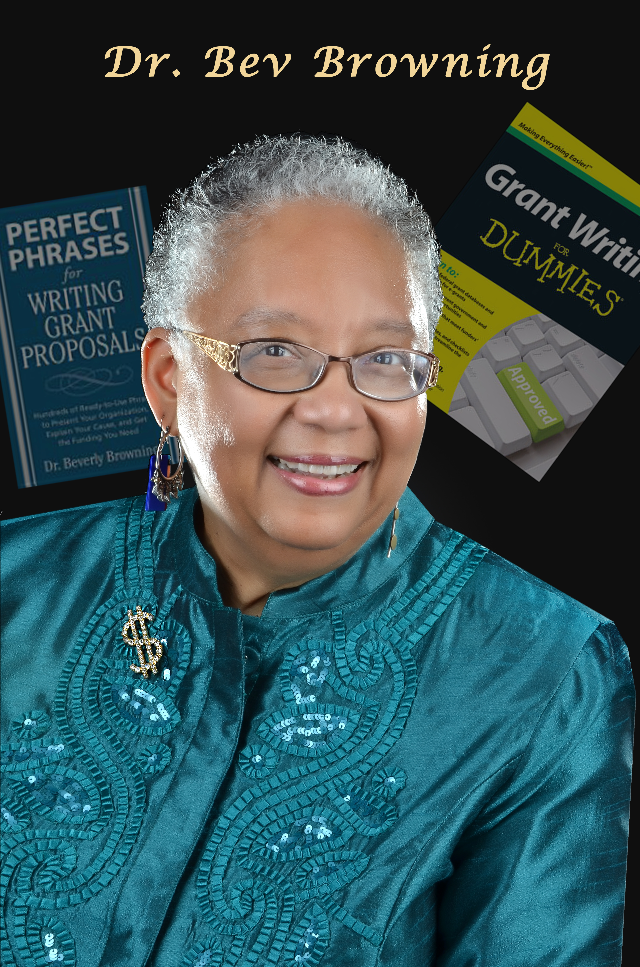

Dr. Bev is the author of over 41 grants-related publications, including Grant Writing For Dummies™(5 editions), Grant Writing for Educators, How to Become a Grant Writing Consultant, Faith-Based Grants: Aligning Your Church to Receive Abundance, Perfect Phrases for Writing Grant Proposals, and Perfect Phrases for Fundraising).

She holds degrees in Organizational Development, Public Administration, and Business Administration. Dr. Bev is a grant writing course developer and online facilitator for Ed2Go.com. She is a current member of the Grant Professionals Association; Founder and Director of the Grant Writing Training Foundation (www.grantwritingbootcamp.us), and Vice President for Grants Professional Services at eCivis Inc. (www.ecivis.com)

Grant Writing Boot Camp

October 23 & 24, 2014 – 9 a.m. to 4 p.m.
Location: GAP Ministries
2861 N Flowing Wells Rd #161, Tucson, AZ 85705

Grant Writing Boot Camp/Registration Contact:
Grant Writing Training Foundation
Dr. Bev Browning, Director/Trainer
Email: drbeverlybrowning@gmail.com/Phone: 480-768-7400/Fax: 800-859-2330
Tiane Kennedy, Public Relations Director
Email: tiane@gapmin.com/Phone: 520.955.3088

Registrant’s Name :

Organization Representing:

Organization Street Address:

Organization City/State/Zip:

Organization Primary Telephone Number:

Personal Secondary Telephone Number:

E-mail Address:

Please check your form of payment (SORRY, NO PURCHASE ORDERS OR PAY AT THE DOOR REGISTRATIONS; an advance count is needed for preparation expenses incurred by the Foundation):
____Check enclosed - Make check payable to Grant Writing Training Foundation and mail to GAP Ministries no later than OCTOBER 3, 2014.
____Credit card payment with information below - Major credit cards will be accepted. Your credit card statement will show a charge to the Grant Writing Training Foundation. Fax your form to: _800-859-2330 or email to: drbeverlybrowning@gmail.com. Credit card receipts will be emailed; check receipts will be available at the workshop.

Please enter ALL credit card information requested below
_____________________________________________________________________________________________

Check one: ______Visa _______Master Card _______American Express _______Discover
Name on Credit Card:
Credit Card Number:
Credit Card Expiration Date:
Credit Card Code (for AMEX-4 digits on front; for others, 3 digits on back by signature line):
Credit Card Billing Street Address:
Credit Card City/State:
Billing Zip Code for Credit Card:
Credit Card Holder Telephone Number with Area Code:
Email address of cardholder:
_____ (<<please check or initial and fill in the amount you are remitting) - I authorize a charge of $_______ to the above credit card.

A portion of your registration will be donated to GAP Ministries.

