A Little Glitz and A Little Glass Tour

Created Especially
For
NAYDO

April 12th 2014
(8:30am-12:00pm Approximately)

We start our tour with a trip to Marti’s Boutique for some shopping. Marti’s is opening early just for you so we can enjoy all the beautiful clothes and jewelry. This is the newest upscale boutique from Laredo. Ratablos, linens, fine jewelry and exquisite home furnishings will be on display.

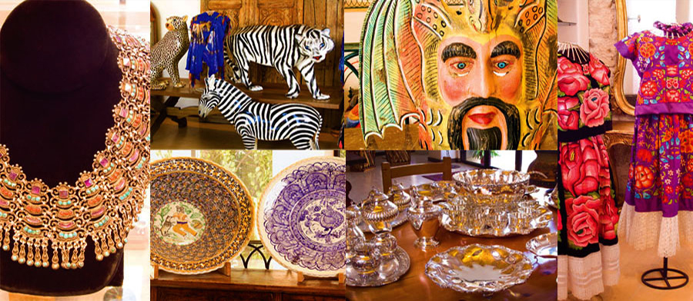

From Marti’s we are off to Garcia Art Glass, Inc. the first hot glass studio in the area specializing in one of a kind original hand blown glass where you will get the rare chance to see glass blowing up close and in person! Their creations range from the functional to the whimsical for the home, office, restaurants, and hospitals. Recently Ms. Garcia has taken on new site specific projects such as glass mobiles, wall sculpture, lighting fixtures and chandeliers. You will be treated to a private glass blowing demonstration and have time to view the works of art in the studio or purchase a one of a kind piece to take home.

Garcia Art Glass was founded in 1998. After receiving her B.F.A. in industrial and environmental design, Gini eventually opened a hot glass design and fabrication center that specializes in the creation of one-of-a-kind blown glass lighting and sculpture, including tablescapes and art for the wall. These creations, made to client specifications, range from the functional to the whimsical for homes, corporate offices, restaurants, and hospitals. Recently, she traveled to Murano, Italy and studied the "Chandelier for the New Millennium."

Using blown glass as a filter for light, each of Gini's creations is designed with the overall environment in mind. Recent clients include AT&T, Wells Fargo, United Way, Volvo, and Warner Brothers, The JW Marriott Resort here in San Antonio as well as numerous restaurants and hundreds of residential commissions. Garcia Art Glass, Inc. employs talented team members with a combined experience of fifty years in design, blown glass fabrication, lighting, metal work and installation.

