

***Texas Hill Country Shopping and Sipping Tour***

***Created Especially***

***For***

***NAYDO***

***April 12th 2014***

***(9:00am-4:00pm Approximately)***

*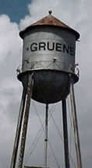Guests will board their fully air-conditioned mini bus for approximately a 45-minute transfer to Gruene, Texas. A quaint cotton gin town nestled in the Texas Hill Country. Filled with antique shops, a wine tasting shop, and the world famous “Gruene Hall - Oldest Honky-Tonk in the State of Texas”, featured in the movie “Michael”, where John Travolta did his famous dance as an angel.*

*You will have some time for shopping before lunch which will be at the Grist-Mill restaurant, featuring its beautiful view of the Guadalupe River. This building is over 100 years old and at one time was the actual cotton gin.*

[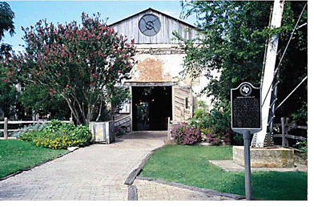](http://www.google.com/url?sa=i&rct=j&q=gristmill+restaurant+images&source=images&cd=&cad=rja&docid=oXq4puT6ybE1lM&tbnid=qVkgAcmeoUzgiM:&ved=0CAUQjRw&url=http://www.overmountainsams.com/member_news/news_adams_200802.htm&ei=m8TyUdOXG4Os9ATi54CwDQ&bvm=bv.49784469,d.aWM&psig=AFQjCNExD_EwbxpcHH6CxGdUykBHMNMvfQ&ust=1374950882724928)

*After a little more sightseeing and shopping it is off to Dry Comal Creek Vineyards. The vineyard is known for its rich alluvial soil, laced with limestone, flattened shale chips; which provides ideal growing conditions for the grapes.*

*Dry Comal Creek is a relatively new venture, but its wines have achieved awards and been recognition for their outstanding quality. The picturesque setting with lovely limestone structures is a beautiful setting to learn from the owner and expert about Texas wines and enjoy a few tastings. Guest will be given a souvenir glass to take home.*

