B11 Officer Injury & Death
Core Training Course

This course is dedicated to all the men and women behind the badge,
who have made the ultimate sacrifice to society in their quest to maintaining civility,
and to proudly fulfill their commitment to protect and serve.

Presented by Chaplain Todd W. Pynch
International Conference of Police Chaplains
Northwest Region 2 Regional Training Seminar
January 9, 2013

Table of Contents

Topic | Page
MEET YOUR INSTRUCTOR | 3
COURSE OVERVIEW | 3
IS YOUR CHAPLAINCY PROGRAM READY? | 4
DEALING WITH OFFICER INJURIES | 4
DEALING WITH LINE OF DUTY DEATHS (LODD) | 5
DEATH NOTIFICATION PROCEDURES | 5
TYPES OF LAW ENFORCEMENT FUNERALS | 6
LODD FUNERAL FOR DEPUTY KELLY FREDINBURG | 7
LODD FUNERAL FOR CAPTAIN TOM TENNANT | 8
LODD FUNERAL FOR SENIOR TROOPER BILL HAKIM | 9
PROCESSION & MEMORIAL SERVICE PICTURES | 10
LODD FUNERAL SERVICES | 11
OTHER CONSIDERATIONS | 13
CARING FOR YOUR OFFICERS | 13
CARING FOR YOUR COMMUNITY | 14
SAMPLE OF LODD ORDER OF SERVICE | 15
RESOURCES | 16

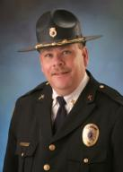
MEET YOUR INSTRUCTOR:
Todd Pynch has served as a chaplain for 19 years and has worked around Emergency Services since 1975. Todd is a Master Chaplain with the International Conference of Police Chaplains (ICPC). In January 2003 he formed Crisis Chaplaincy Services as a nonprofit organization and has served as their full time Executive Chaplain since that date. Crisis Chaplaincy Services provides chaplaincy support to agencies in Benton, Marion, Polk, Lynn & Yamhill Counties and responds to approximately 450 calls a year. Prior to serving fulltime as a Chaplain, Todd spent more than 17 years in the ministry. 13 of those years were spent in Corvallis, Oregon where he served as the Senior Pastor of Northside Church. Todd has been married to his wife Martha for 27 years and has two children, Cari (20) and Andrew (12).

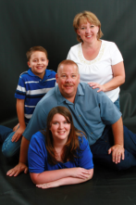
Todd has extensive training in Critical Incident Stress Management and currently teaches Crisis Intervention classes to emergency responders at Chemeketa Community College in Salem. Todd has also taught classes for APCO in the past and was the recipient of the 2005/2006 APCO 911 Benefactor Award. He has received several other awards as well, including the Community Partner Hero Award from the American Red Cross in 2009. One week after the attack on 9/11/01, Todd was in Ground Zero working with emergency responders there. During his career he has dealt with three LODD’s, including those from the Woodburn bombing in 2008. He has officiated over the honor services for eight other emergency responders, including the suicide of a firefighter in 2010. Todd is a co-leader of the Marion County Sheriff’s Office Trauma Team as well as the Benton County Sheriff’s Office Peer Support Team and is a member of the Oregon State Police Critical Incident Support Team. He has been a long-time member of the ICPC and currently serves as the Oregon Area Representative for the Northwest Region 2 of ICPC.

COURSE OVERVIEW:
- We will talk about the impact of officer injury or death incidents upon your chaplaincy.
- We will talk about how to respond to officer injury incidents.
- We will talk about how to respond to a line of duty death (LODD).
- We will talk about how to make LODD notifications.
- We will talk about the various kinds of law enforcement funerals.
- We will talk about the procedures of conducting law enforcement funerals.
- We will talk about how to help departments deal with the loss of a coworker.

IS YOUR CHAPLAINCY READY?
If one of your officers is injured or killed, one of two things will happen:
- You will have the opportunity to make a ____________________ ____________________.
OR…
- You will be left to observe on the ____________________ while others do your work.
- Is your chaplaincy ____________________ to properly respond to an incident involving an injury or death of one of your officers?

- Have you done any ____________________ for a LODD?

DEALING WITH OFFICER INJURIES
- Responding To The Scene:
- Make sure you have ____________________ to be there.
- Offer words of ____________________ & ____________________.
- Be a ____________________ presence, not a dominating force on scene.
- Coordinate the notification of the spouse & family with the ____________________.
- Making Notifications To The Spouse & Family:
- Gather ____________________ ____________________ from involved officers.
- Ask ____________________ if you don’t know the answers.
- Partner up with the supervisor or a member of the Command Staff.
- Check to see if the officer has a ____________________ of who will make the notification.
- Try to respond to the residence as ____________________ as possible.
- Start with good news at the __________________ and then move inside the house for the rest.
- ____________________ all questions as best as possible.
- Be prepared to ____________________ family members to the hospital.
- Make sure parents & other family members are notified as well.
- Responding To The Hospital:
- Respond as ____________________ as possible.
- Notify the ____________________ ____________________ and inform them of the situation.
- Have a ministry of ____________________.
- ____________________ for needs you can meet and then do so.
- Don’t ____________________ your welcome.
- Offer to ____________________ with the family if this seems appropriate.
- Make sure the officer and family has your ____________________ ____________________.

DEALING WITH LINE OF DUTY DEATHS
- Responding To The Scene:
- Take your ____________________ with you!
  - Extra cell phone battery.
  - Cell phone chargers (AC & DC)
  - Toiletries
  - Extra clothing
  - Medications
  - Laptop Computer
  - Appropriate phone lists
- Before you ever get there, get some ____________________ enroute.
- Remember it is likely a ____________________ ____________________ so don’t cross the tape unless requested to do so.

- Be prepared for your own ____________________ impact because it will hit you hard!
- Offer ____________________ & ____________________ to affected officers on scene.
- If possible, ___________________ the body so you can properly answer the families questions.
- Assist in coordinating ____________________ escort of body to funeral home.
- Carry a ____________________ in your vehicle and drape the body with it prior to procession.
- ____________________ all required information for making notification to the family.
- Try to shut down all electronic communication until the family has been notified.
- Make sure the ______________ is not releasing any identifying information prior to notification.

- Making The Notification:
- Make the notification as ____________________ as humanly possible.
- The ____________________ should accompany the Commander/Chief/Sheriff.
- Decide in advance ____________________ is going to make the notification.
- Recommendation: don’t ____________________ directly in front of the residence.
- If you are making the notification, make sure the Commanding Officer is prepared to offer condolences.

- Answer all ____________________ as honestly as possible.
- Provide status of ____________________ if pertinent.
- Make sure ____________________ support is available to the family.
- Provide contact information about who will be the __________________ _________________.
- If appropriate, ____________________ the family to the Funeral Home/Morgue.
- Be prepared to make multiple notifications to_________________ appropriate family members.
- If you are not involved in the notification, contact the family as soon as possible.

TYPES OF LAW ENFORCEMENT FUNERALS
- Active Members:
- Line of Duty Death
- Receives ______________ _______________ including casket watch, gun salute, flag presentation, taps, bag pipes, medals presentations, campaign hat presentation, retiring of badge, individual agency rituals

- Will likely have ____________________
- Quite possibly will have ____________________ attendance
- Will have intense ____________________ coverage.
- Most likely will have involvement of ____________________ officials

- Off Duty Tragic or Accidental Death
- Typically receives ____________________ honors including flag presentation, taps, bag pipes, possibly gun salute

- May or may not have procession
- Most likely with have _________________________ attendance

- Natural Death
- Generally receives ____________________ honors including possible flag presentation & taps
- Could have gun salute if there was prior ____________________ service
- Likely will ___________ involve procession
- Attendance will likely be ____________________ agencies

- Suicidal Death
- Level of honor will be decided by ____________________ ____________________
- Very ____________________ services
- ____________________ needs to be offered in the midst of confusion
- Suicide issue can’t be ____________________

- Retired Members:
- ____________________ or Accidental Death
- ____________________ Death
- ____________________ Death
- Retired members services generally have limited honors but that will be decided by departmental policy.

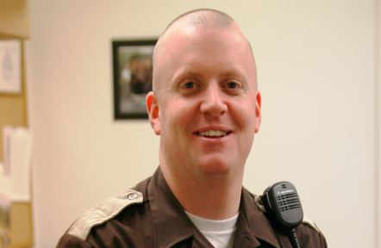
LINE OF DUTY FUNERALS

Deputy Kelly Fredinburg
Marion County Sheriff’s Office
EOW: June 16, 2007

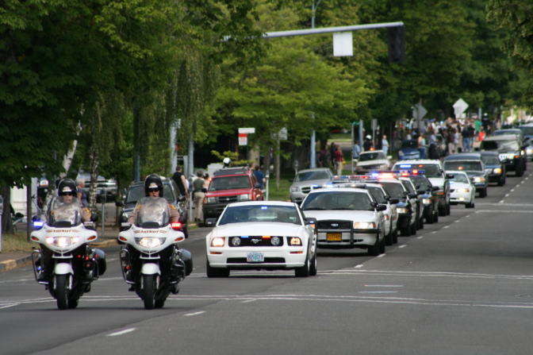

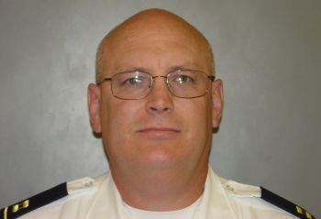
Captain Tom Tennant
Woodburn Police Department
EOW: December 12, 2008

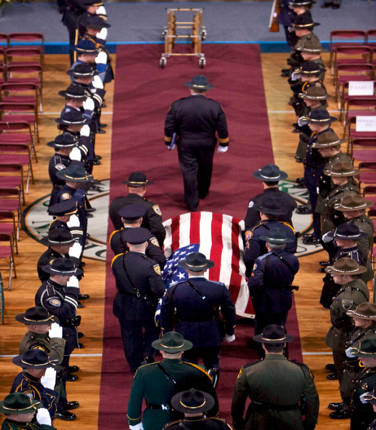

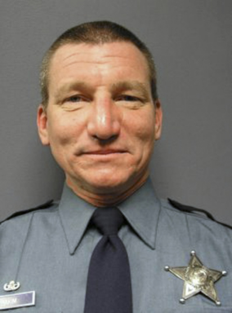
Senior Trooper Bill Hakim
Oregon State Police
EOW: December 12, 2008

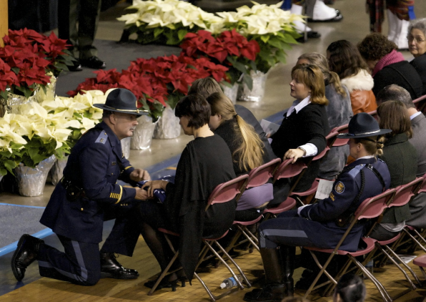

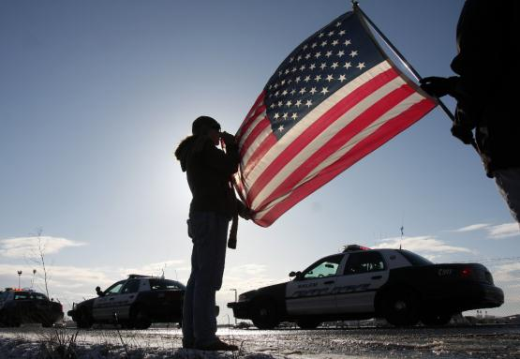

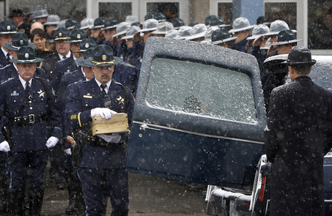
Procession for Captain Tom Tennant Service

Honor Guard at Senior Trooper Bill Hakim’s Service

LINE OF DUTY FUNERALS:
- Key Players:
- ____________________ Commander or Funeral Operations Coordinator
- ____________________ or Minister & Chaplain’s ____________________
- ____________________ ____________________ ____________________
- ____________________ Liaison Officer
- ____________________ Coordinator
- ____________________ ____________________ Coordinator
- ____________________ Coordinator
- ____________________ Coordinator
- ____________________ Coordinator
- This is ____________________ a complete list

- Meeting With The Family:
- You will want to ____________________ the elements of a police funeral to them.
- You need to find out if this is what they want.
- The family’s wishes takes ____________________ over all other desires.
- If the family does not want an honors service, are they open to the department having one?
- Approximately how many family members will ____________________ the service?
- Are there any ____________________ ____________________ for family members?
- Does the family want the ____________________ to officiate or someone else?
- Does the family want the body to be ____________________?
- If the body is cremated, would the family like/want a casket anyway in the front?
- Does the family want there to be a __________________ _________________ in the service?
- If so, ____________________ would the family want to share?
- Does the family want any kind of ____________________ presentation?
- Discuss dignitary presence such as Governor, Judges etc.
- Are the dignitaries permitted to ____________________ during the service?
- Is the family open to meeting with the Governor & others before the service?
- Is the ____________________ allowed to be present in the service?
- Will the ____________________ be public or private?
- Would the family like some kind of ____________________ after the service?

- Planning For The Service:
- I highly encourage you to use an Incident Command Structure.
- You will need all the ____________________ you can get!
- I highly encourage you to stay ____________________ in overall planning decisions.
- Make sure the family’s wishes are represented & honored throughout the planning process.
- Try to pick a ____________________ for the service that allows for out-of-state travel.
- Pick a ____________________ that is large enough to handle the crowd.
- Prepare yourself for ____________________.
- Find __________________ time for you to gather your thoughts in preparation for the service.

- The Service Itself, Recommendations For The Chaplain:
- In the procession I encourage you to consider riding in the funeral coach.
- Don’t be afraid to show ____________________ as long as you can still guide the service.
- Have a _________________ _________________ for the family that is private & comfortable.
- Have a clearly defined order of service & then follow it! (see example in resource section)
- Trust that ____________________ will speak through you as you have prepared.
- Offer comfort, hope, understanding & peace to your audience.
- I recommend you have a fellow Chaplain ____________________ with you.
- Follow the directions of the Honor Guard Commander.
- Know how to ____________________ before you’re up in front of everyone!
- Go purchase your dress uniform ____________________ so you’re prepared.

- After The Service, Caring For Yourself:
- Prepare for a huge emotional letdown & adrenaline dump to occur.
- Process through your own ____________________ that you’ve put on hold.
- Take time for your ____________________ ____________________.
- ____________________ with your ____________________.
- Consider talking to a ____________________ or close friend.

OTHER CONSIDERATIONS
- Viewings
- Will there be viewings for the ____________________?
- Will there be viewing for the ____________________ of the agency?
- Will there be viewings for ____________________ agency personnel?
- Will there be viewings for the ____________________?

- Processions
- Will there be a procession ____________________ to the service?
- Will there be a procession to the ____________________?
- If either above is yes, what will the ____________________ be?
- Where will you ____________________ all the vehicles?

- Committal Service
- ____________________ will it be?
- ____________________ will attend?
- Is it ____________________ or ____________________ service?

CARING FOR YOUR OFFICERS
- During The Incident:
- You are not Superman – accept that you will need help and get it.
- ____________________
- ____________________ Support – don’t forget the families!
- ____________________ Briefings
- Have someone in the PD as much as possible.
- Don’t forget about your ____________________ and office staff.
- There is an absolute need for a ministry of ____________________!
- After The Memorial Service:
- Recruit an outside ____________________ ____________________.
- Hold a ____________________ for involved officers.
- Consider a Crisis Management Briefing for the Department.
- Provide an opportunity for officers & wives to ____________________ together.
- Don’t be afraid to recommend ____________________.
- Channel a way for officers to stay ____________________ to the LODD family.

- Long Term:
- Expect to see ____________________ ____________________ issues.
- Expect to see ____________________ issues.
- Expect to see ____________________ issues.
- Prepare for ____________________ – they are not fun!
- ____________________ – good or bad?
- Prepare for the impact of the ____________________ if there is one.
- The ____________________ doesn’t go away overnight.

CARING FOR YOUR COMMUNITY
- Needs To Be Handled By ____________________ ____________________
- ____________________ Vigils
- Example of Woodburn Proud
- ____________________

MEMORIAL SERVICE

William Robert Hakim

December 20, 2008
Arrival of Coach with Sr. Trooper Hakim | Golden’s
Escort of Family Into Armory | Honor Guard, Chaplain Pynch
Placement of Sr. Trooper Hakim | Casket Detail
Beginning of Death Watch | Combined Honor Guard
Escort of Family to Private Room | Honor Guard, Chaplain Pynch
Seating of Officers & Public | Honor Guard
Escort of Family Into Service | Honor Guard & Chaplains
Audience Brought to Attention | Lt. Ladd
Campaign Hat Brought Into Auditorium | Honor Guard
Audience Seated | Chaplain Todd Pynch
Opening Remarks | Chaplain Todd Pynch
Invocation | Chaplain Todd Pynch
Life History | Chaplain Todd Pynch
Honorary Speakers
- Governor Ted Kulongoski
- Superintendent Tim McLain
- Sr. Trooper Blain Allen
- Ed Marshman, FBI
- Colleen Domenesh, ATF
- Bob Milling, Family Member
Picture Tribute | Sound Tech
Eulogy | Chaplain Todd Pynch
Closing Prayer (Prayer for Chief Russell, Tennant Family) | Chaplain Todd Pynch
Honors Instructions to Audience | Chaplain Todd Pynch
Flag Detail Unfold Flag | Honor Guard
Last Call | NCC
21 Gun Salute | Rifle Team
Taps | Trumpeter
Flag Detail: Fold & Present to Superintendent | Honor Guard
Presentation of US Flag | Superintendent McLain
Presentation of Oregon Flag | Governor Kulongoski
Presentation of Campaign Hat | Superintendent McLain
Amazing Grace | Portland Police Bureau Highland Guard
Dismissal of Law Enforcement & Uniform Formation Outside | Honor Guard
Escort of Urn & Family to Vehicles | Honor Guard, Chaplains
Dismissal of Audience | Honor Guard
Procession to Oregon Public Safety Academy | Vehicles

RESOURCES
- Information About Conducting LODD Services:
www.ohiocops.com/manual/sample.html

www.nationalcops.org/agenciesforms/general.pdf

www.icpc4cops.org

www.policelink.monster.com/.../13510-honor-guard-101-line-of-duty-funeral-protocol

www.policechiefmagazine.org/magazine/index.cfm?...id..

www.thefreelibrary.com/Law+Enforcement+Funeral+Manual.-a0115568677

Law Enforcement Funeral Manual (Second Edition) by William P. Sanders
ISBN: 0-398-076660-X Publisher: Charles C. Thomas

- Contact Information:
Chaplain Todd W. Pynch
Crisis Chaplaincy Services
387 Court St. NE ~ Salem, OR 97301
503-932-1314 (Cell) ~ 503-763-8522 (Office)
tpynch@ccschaplain.com (email) ~ www.ccschaplain.com (web page)

