B04 Ceremonies & Events
Core Training Course
Instructor Notes

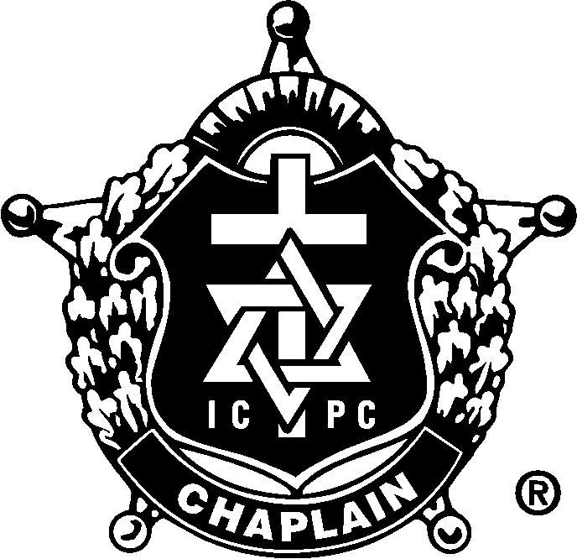

Presented by Chaplain Todd W. Pynch
International Conference of Police Chaplains
Northwest Region 2 Regional Training Seminar
January 7, 2014

Table of Contents

Topic | Page
MEET YOUR INSTRUCTOR | 3
COURSE OVERVIEW | 3
THE NEED FOR LAW ENFORCEMENT CEREMONIES AND EVENTS | 4
EXAMPLES OF LAW ENFORCEMENT CEREMONIES AND EVENTS | 4
HOW TO CREATE & PLAN FOR LAW ENFORCEMENT CEREMONIES AND EVENTS | 5
LINE OF DUTY FUNERALS/MEMORIAL SERVICES | 5
ACTIVE DUTY FUNERALS/MEMORIAL SERVICES | 6
OFF DUTY FUNERALS/MEMORIAL SERVICES | 6
DEALING WITH THE SUICIDE OF A LAW ENFORCEMENT OFFICER | 6
RETIRED PERSONNEL FUNERALS/MEMORIAL SERVICES | 7
K-9 MEMORIAL SERVICES | 7
PLANNING & HOLDING LAW ENFORCEMENT RECOGNITION SERVICES | 7
AGENCY SPECIFIC CEREMONIES & EVENTS | 9
NEEDS BASED CEREMONIES & EVENTS | 9
PUBLIC PRAYERS FOR CEREMONIES & EVENTS | 9
LAW ENFORCEMENT FUNERAL CHECKLIST | 10
FUNERAL PROCESSION GUIDELINES | 12
THE FUNERAL SUPPLY KIT | 13
UNITED STATES FLAG ETIQUETTE | 14
EXAMPLES OF LAW ENFORCEMENT CEREMONIES AND EVENTS | 15
INFORMATION ABOUT LAW ENFORCEMENT MONTH | 16

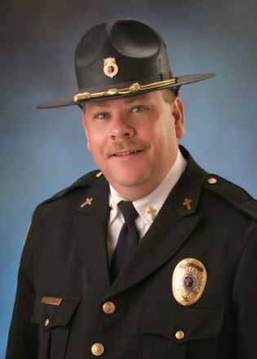
MEET YOUR INSTRUCTOR:
Todd Pynch has served as a chaplain for 22 years and has worked around Emergency Services since 1975. Todd is a Master Chaplain with the International Conference of Police Chaplains (ICPC). In January 2003 he formed Crisis Chaplaincy Services as a nonprofit organization and has served as their full time Executive Chaplain since that date. Crisis Chaplaincy Services provides chaplaincy support to Oregon agencies in Benton, Marion, Polk, Linn & Yamhill Counties and responds to approximately 450 calls a year. Prior to serving fulltime as a Chaplain, Todd spent more than 17 years in the ministry. 13 of those years were spent in Corvallis, Oregon where he served as the Senior Pastor of Northside Church. Todd has been married to his wife Martha for 30 years and has two children, Cari (21) and Andrew (13).

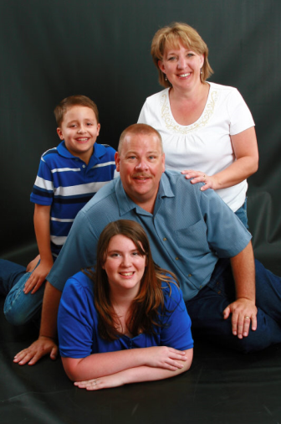
Todd has extensive training in Critical Incident Stress Management and currently teaches Crisis Intervention classes to emergency responders at Chemeketa Community College in Salem. He has received several awards during his career including the 2005/2006 APCO 911 Benefactor Award, the Community Partner Hero Award from the American Red Cross in 2009, the Oregon State Police Superintendent’s Special Recognition Award in 2009, and multiple Distinguished Service Awards from the agencies he serves. One week after the attack on 9/11/01, Todd was in Ground Zero working with emergency responders there. During his career he has dealt with three LODD’s, including those from the Woodburn bombing in 2008. He has officiated over the honor services for more than a dozen other emergency responders, including the suicide of a firefighter in 2010. Todd is a member of Peer Support Teams with the Marion County Sheriff’s Office, the Benton County Sheriff’s Office and the Oregon State Police. He has been a long-time member of the ICPC and currently serves as the Oregon Area Representative for the Northwest Region 2.

COURSE OVERVIEW:
- We will discuss the need for law enforcement ceremonies and events.
- We will discuss the different types of law enforcement and events.
- We will discuss how to create and plan for law enforcement ceremonies and events.
- We will discuss the different types of law enforcement funerals and memorial services.
- We will discuss how to deal with the suicide of a law enforcement officer.
- We will discuss how to plan and hold a law enforcement recognition service.
- We will discuss how to pray in public ceremonies and events.

INTRODUCTION:
- The Need For Ceremonies And Events
- To honor the lives and work of police officers
- To aid in the grief process for families of police officers
- To draw public attention to the work and dedication of police officers
- To allow the community to express appreciation to police officers and their families
- To give positive visibility to police officers and law enforcement agencies

- Examples Of Ceremonies
- Line-of-Duty Death Funeral Service
- Active Duty Funeral Service
- Off Duty Funeral Service
- Retired Officer Funeral Service
- K-9 Memorial Service
- Law Enforcement Recognition Service
- Awards Ceremony
- Promotion Ceremony
- Building Dedication Ceremony
- Equipment Dedication Ceremony
- A Candlelight/Prayer Vigil

HOW TO CREATE AND PLAN CEREMONIES AND EVENTS:
- Determine the Type of Event
- Is it an incident specific event?
- Is it a regular occurrence event?
- Is it an annual event?
- Appropriate planning must match the type of event you are having.

- Who Should Be Involved In Planning
- You will need assistance! You cannot do this alone.
- Start planning immediately – especially with LODD’s.
- Seek support from area law enforcement chaplains and clergy.
- Check to see if there is a State team already organized.
- Involve key personnel from the agency you are serving.

- Planning the Event
- Form a planning team & schedule meetings
- Make a checklist of all aspects of the event.
- Review and update the checklist at every meeting
- Make regular reports to the involved agency.
- After the event gather feedback for future planning.
- Have your planning team do an evaluation.
  - What worked well?
  - What did not work well?
  - How can we improve?
  - What changes need to be made to the format of the ceremony?

FUNERAL/MEMORIAL SERVICES:
- Line of Duty Death
- Seek guidance from your department policies or manual.
- Be a chaplain!
- Support the family in their grief.
- Support the surviving officers of the agency
- Maintain a constant ministry of presence.
- Assist the family’s clergy (if any) if they are involved in the service.
- Be a liaison with clergy in the community.

- Help bring balance to the service:
- Religious & denominational rituals are respected.
- Law enforcement traditions are respected.
- Community involvement/needs are respected.

- Address the critical elements of the service:
- Do you have a venue large enough?
- Do you have an Honor Guard?
- Do you have a bagpiper?
- Do you have a trumpet player?
- Do you have a rifle team?
- Is your sound system adequate?
- Will you videotape the service?
- What is the seating arrangement?
- Will dignitaries be allowed to speak?
- Will dignitaries be allowed to visit with the family?
- Will the media be allowed to attend?

- Make certain that the family’s wishes are respected at all times.
- Don’t take advantage of the situation just to proselytize.

- Active Duty
- Determine your department’s policy about active duty deaths.
- Know what the customs of your State dictate.
- These are often handled very similar to LODD’s.
- Full Honor Guard
- Bugler
- Bagpipes
- Flag presentation
- May include rifle detail
- These services tend to be large so plan accordingly.

- Off Duty
- Determine your department’s policy about off duty deaths.
- Know the customs of your State.
- Be careful of precedent setting.
- Usually contain some of the elements of an honors service.
- Small Honor Guard detail.
- Bugler
- Bagpipes
- Flag presentation
- Often do not include rifle detail

- Suicide
- Determine your department’s policy about suicides.
- Know the religious traditions of the family.
- Be a liaison between the family and the department.
- Be very aware of others who are at risk.

- Retired Personnel
- Does their department have a policy?
- Know whether or not they can be buried in their uniform.
- Make sure to recognize their years of service
- May or may not include an Honor Guard detail.
- May or may not include other law enforcement traditions.
- Try very hard to honor the wishes of the family.

- K-9 Services
- Follow your department policy.
- Recognize the valuable contribution of the dog.
- Recognize the loss to their human partner.
- Could have potential impact on community due to familiarity of dog.

LAW ENFORCEMENT RECOGNITION SERVICE
- Their Purpose:
- To honor law enforcement officers who have died during the past year.
- To aid families who have lost an officer in their grieving process.
- To draw positive attention to the work of law enforcement.
- To allow the public to show their appreciation to police officers.
- To remind the public of the sacrifices made by law enforcement officers & their families.

- Their Names:
- Police Memorial Service
- Peace Officers Memorial Service
- Law Enforcement Memorial Service
- Law Enforcement Appreciation Day
- Whatever is deemed appropriate

- Who Should Be Involved:
- Local Law Enforcement
- County Law Enforcement
- State Law Enforcement
- Federal Law Enforcement

- When to Have the Service:
- During Police Memorial Week – the week of May 15th.
- In December in connection with COPS Project Blue Light.
- When appropriate for your agency.
- When scheduled by a local community group or church.

- Where to Have the Service:
- In a sponsoring local church.
- In a public park.
- At a fairgrounds facility.
- Just make sure the location is big enough to accommodate the size of the crowd.

- Elements of the Service
- Music
- Bagpiper?
- Ensemble from church or community
- Law enforcement choir
- Instrumental music
- Patriotic music

- Speaker
- Local TV/Radio personality
- Local, State or Federal law enforcement leader
- Politician
- Pastor or Clergy
- Professional Speaker

- Dignitaries
- Local, State & Federal law enforcement officials
- Political leaders
- District Attorney
- Judges
- Have reserved seating for them
- Determine in advance if they are going to speak & for how long.

- Law Enforcement Members & Families
- The families of fallen officers.
- Active law enforcement & their families.
- Retired law enforcement & their families.
- Ceremonial Elements of the Service
- Presentation of Colors.
- National Anthem or Pledge of Allegiance.
- A Roll Call of Fallen Officers.
- A Memorial Wreath – can be blank or complete.
- Individual Flowers for Fallen Officer Families.
- Escorting of Families.
- Playing of Taps.
- Playing of Amazing Grace.

OTHER CERMONIES:
- Agency Specific:
- Swearing In ceremonies.
- Promotion ceremonies.
- Awards ceremonies.
- Building dedications.
- Equipment dedications.
- Retirement ceremonies.
- Any event that can bring positive attention to the agency.

- Needs Based:
- Weddings.
- Funerals.
- Baptisms or Baby Dedications.
- Blessing of a New Home.

- Public Prayers:
- Pray with sincerity – make sure your prayer is meaningful.
- Pray without compromise – you don’t have to set aside your personal beliefs.
- Pray with sensitivity – take into consideration people of other faiths.

LAW ENFORCEMENT FUNERAL CHECK LIST¹
The Chief/Departmental Head and/or his/her designated representative shall:
- Immediately assign a planning team, consisting of the chaplain(s) and/or departmental personnel, to the family of the deceased member.

- Send computer message regarding death and funeral arrangements to all departments/agencies in the country.

- Arrange for black or blue mourning bands and/or black arm bands and building bunting (if desired).

- Make arrangements to provide meals for the family from the time of death until the day of the funeral.

- Prepare fallen member’s remembrance bulletin or card. Send it to the printers.

- Plan parking for visiting police and emergency vehicles on the day of the funeral.

- Plan route to the cemetery. This route could include a drive by of the headquarters, the fallen member’s home, and schools in the community.

- Arrange for a Casket Guard at the visitation and, if desired, a Color Guard for the funeral service.

- Obtain white gloves for use by Pallbearers, Casket Guard, and any others.

- Make a list of all agencies in attendance at the visitation and funeral service for later thank you notes.

- Obtain guest book(s) and uniformed personnel or others to be in charge of the book (Note: guest books are often provided by the funeral home).

- Arrange drivers for the family and make sure that there are enough vehicles for the family’s use.

- Provide resource persons to meet the family’s needs: meals, childcare, household chores, etc.

- Have a uniformed member available to stay at the house for security while the family is making funeral arrangements, as well as during the visitation, the wake, and the funeral.

- Arrange for any flowers – carnations. [Note: the use of flowers at Jewish funerals is discouraged – check with the family’s Rabbi.]

- Arrange for pallbearers in consultation with the family.

- Arrange for ushers to assist the funeral director during the funeral service.

- Make motel/hotel arrangements for visiting police officers.

- Arrange for security for the visiting police and emergency vehicles, as well as the directing of the parking of these vehicles.

- Provide for a funeral meal or refreshments and servers.

- Provide for set up personnel for the funeral meal: tables, chairs, etc.

- Line up clean up personnel after the meal.

- Arrange for a bugler to play “Taps” at the conclusion of the graveside service.

- Arrange for bagpipe(s) or pipe and drum corps (if desired) (Note: one piper may be sufficient in most circumstances).

- Arrange for a firing detail to fire blank rifle, shotgun or pistol volleys at the conclusion of the graveside service. (usually a 21-gun salute, three sets of seven shooters)

- Have an Honor Guard in front of the fallen member’s home and headquarters from the time of death through the funeral service and meal.

- Arrange for the police station/post, city/government flags to be flown at half-staff.

- Arrange for the national or state flag as a casket cover for presentation to the family (Make sure the pallbearers know how to fold the flag!).

- If the burial of the deceased member is to be out of state or the region, arrange for a suitable escort to the grave site and contact a local law enforcement agency to arrange a graveside committal service.

PROCESSION TO THE CEMETERY¹
The motorcade route to the cemetery should be as direct as possible. The route could include the fallen officer’s police facility, his/her home, the community’s civic center and schools. The motorcade could be up to a mile or more in length.

The following is a suggested order of vehicles in the motorcade:
- The first police vehicles will be those from the department of the fallen officer.

- All other police and emergency vehicles not directly involved in the funeral service.

- The lead police vehicles for the member’s department/agency (these may be motorcycles).

- The funeral director and the police chaplain and/or the religious officiant.

- The police vehicles for the pallbearers.

- The Hearse.

- A flower carrying vehicle, if used (this could be a fire truck).

- The member’s family and friends vehicles.

Note: It is advisable to have a tow truck available in case of vehicle breakdown.

Upon arrival at the cemetery, the police and emergency vehicles, all lights turned off, are parked and the uniformed law enforcement personnel are assembled. (Note: Consideration should be given to allowing spouses of law enforcement personnel to stand by their spouses in this formation at the cemetery.) When the hearse arrives at the cemetery, a pipe and drum corps can be added to lead the procession of the hearse to the grave site. If a color guard is to be used, they would follow the pipe and drum corps. Next, if desired, a saddled, riderless horse with boots placed in the stirrups backwards, can also be added to lead the procession. The flower vehicle, if used, would be dropped off at this point and the flowers taken to the grave site. The immediate family vehicle(s) would follow the hearse. Honorary pallbearers can be added to walk beside the hearse to the grave site. At the grave site the vehicle or vehicles are unloaded and parked. The pallbearers go to the hearse and carry the casket to the grave site.

THE FUNERAL SUPPLY KIT1
It is strongly suggested that a funeral supply kit be created and maintained/refilled by each department or agency. The following items should be considered in this kit:

- Black (or blue) badge mourning ribbons, enough for all department/agency members.

- A dozen pairs of white gloves in various sizes.

- Blank ammunition for the firing detail.

- List of needed functions and roles for the funeral:
- Family Liaison Planning Team members and contact information.
- Honor Guard members and contact information.
- Color Guard members and contact information.
- Pipe or Pipe and Drum Corps contact information.
- Bugle player contact information or prerecorded tape.
- Local state Concerns of Police Survivors (COPS) contact information. (Their website: nationalcops.org)

- A copy of the Law Enforcement Manual

From:
¹ Sanders, W.P. (2006) The Law Enforcement Funeral Manual: a Practical Guide for Law Enforcement Agencies When Faced with the Death of a Member of Their Department, second edition, Charles C. Thomas Publisher, Springfield, IL

UNITED STATES FLAG ETIQUETTE²
The below listed United States flag etiquette is from the American Legion and the United States Flag Code. Other countries have similar traditions and regulations. Since most law enforcement funerals are military in nature, check with that country’s armed forces for a source of specific flag etiquette.

Draping The Casket With A Flag:
The United States Flag Code states that although draping of the casket with an American flag is “usually reserved for veterans or highly regarded State and National figures, the Flag Code does not prohibit this use for an American citizen.” Therefore, the American flag can be used to drape the casket of any United States fallen law enforcement member.

How To Drape The Casket:
When the American flag is used to cover a casket, it should be so placed that the union (the blue field) is at the head and over the left shoulder of the deceased. The flag should not be lowered into the grave or allowed to touch the ground.

Folding The Flag At The Graveside:
There is no United States Flag Code provision for folding of the flag. The triangular fold is traditional.
Flying the flag at half-staff: The American flag, when flown at half-staff, should be first hoisted to the peak for an instant and then lowered to the half-staff position. The flag should be again raised to the peak before it is lowered for the day. A state flag or any other flag or pennant in a display is lowered or removed when the Flag is at half-staff. No flag or pennant should be placed above the Flag of the United States

Displaying The Flag:
When displayed from a staff in a religious institution or public auditorium, the Flag of the United States should hold the position of superior prominence, in advance of the audience, and in the position of honor at the clergy or speakers right as they face the audience. Any other flag so displayed should be placed on the left of the clergy person or speaker or to the right of the audience.

Displaying A Flag Across A Street Or At An Entrance To The Cemetery:
When the flag is displayed across and over the middle of a street, it should be suspended vertically with the union to the north, in an east and west street, or to the east, in a north and south street. Flags are often displayed over the middle of a street as a way of marking the funeral procession route to the cemetery of at the entrance to the cemetery.

²American Legion. National Americanism Commission (1996) Let’s be Right on Flag Etiquette. Indianapolis, Indiana. Quoting from: United States Flag Code

(Title 36, Chapter 10, paragraphs 170-178).

EXAMPLES OF LAW ENFORCEMENT CEREMONIES AND EVENTS

Holiday Project Blue Light Ceremony
December 9, 2009

(Thanks to Brian Ducolon, Career Center Instructor, the Law Enforcement/Criminal Justice Program
at the Bay-Arenac Career Center, Caro, Michigan)

Project Blue Light is a nationwide recognition of Police Officers who have died in the line of duty. In 2009, at the First Presbyterian Church in Bay City, Michigan, twenty-three departments and eleven family members were given wreaths along with ornaments to display in their homes and departments during the holiday season.

THE PROGRAM:
Presentation of Colors (a local police department color guard)
Pledge of Allegiance
Introduction
(three students spoke from the Career Center)
Song
(a local High School Choir)
Opening Prayer
(a local clergy person)
Speaker
(a local police commander)
“Christmas in Heaven”
(song sung by the wife of local fallen officer)
Wreath and Ornament Presentation
Moment of Silence
Taps in Echo

Processional

(led by local pipe and drum corps)

LAW ENFORCEMENT MONTH
In 1962, President John F. Kennedy signed a proclamation which designated May 15th as Peace Officers Memorial Day and the week in which that date falls as "Police Week". Every year since, tens of thousands of law enforcement officers from around the world converge on Washington, DC to participate in a number of planned events which honor those that have paid the ultimate sacrifice. The first official memorial service took place on May 15, 1982. On that date, approximately 125 people gathered in Senate Park to honor 91 law enforcement officers. Over the past 22 years, we have honored over 3,000 law enforcement officers from around our nation. Today, the National Peace Officers' Memorial Service has become one in a series of events which includes the Candlelight Vigil, which is sponsored by the National Law Enforcement Officers Memorial Fund (NLEOMF) and seminars sponsored by Concerns of Police Survivors (COPS).

By going on the website policeweek.org a variety of ceremonies and events can be located. Each of these ceremonies and events could be offered locally or regionally. Examples of these services could include:
- A Blue Mass
- A law enforcement memorial service
- A police unity tour
- A candlelight vigil
- A pipe band march and service

For more on any of the above celebrations and events go to: The National Law Enforcement Officers Memorial Fund (NLEOMF) at: policeweek.org, Concerns of Police Survivors (COPS) at: nationalcops.org, or The Fraternal Order of Police (FOP) at: grandlodgefop.org

Contact Information:
Chaplain Todd W. Pynch
Crisis Chaplaincy Services
387 Court St. NE ~ Salem, OR 97301
503-932-1314 (Cell) ~ 503-763-8522 (Office)
tpynch@ccschaplain.com (email) ~ www.ccschaplain.com (web page)

