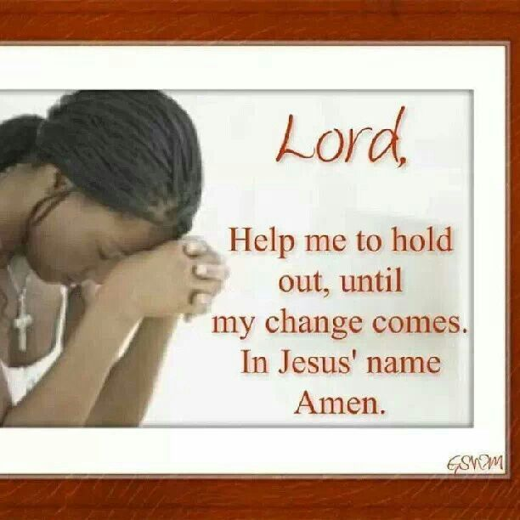
“Praise be to the God and Father of our Lord Jesus Christ, the Father of compassion and the God of all comfort, who comforts us in all our troubles, so that we can comfort those in any trouble with the comfort we ourselves receive from God.” 11Corinthians 1:3-4 NIV
Bereavement Meditations
October 2019
“Lord, Help Me to Hold Out”
My way may not be easy
You did not say that it would be.
But if it gets dark,
I can’t see my way, You told me to put my trust in Thee, that’s why I’m asking You.
Lord, help me to hold out
Until my change comes.
“Because he hath set his love upon me, therefore I will deliver him: I will set him on high, because he hath known my name.” Psalm 91:14 KJV
I believe I can hold out!
I believe I can hold out!
I believe I can hold out,
Until my change comes.

“He who dwells in the secret place of the Most High
Shall abide under the shadow of the Almighty”
Read Psalm 91

