[](http://www.google.com/imgres?imgurl=http://www.emmanueloc.org/images/prayer_requests.jpg&imgrefurl=http://www.emmanueloc.org/prayerrequests.html&h=1125&w=1500&tbnid=QY5Lz-ryXYm8OM:&zoom=1&docid=t2IiMOFmhfLwxM&ei=Nr_aU4TAFdWwyATc14KAAg&tbm=isch&ved=0CGUQMygpMCk&iact=rc&uact=3&dur=1388&page=3&start=29&ndsp=18)

***Louise Gentles Joe Dawson Evelena Beckham***

***Sis K. Missick Cedric Cash Ina Mae Ferguson***

***Velma Gordon Dellion Sitladin Mark Wright***

***Marsha Williams Wellington Beckham Xavier Bass***

[](http://www.google.com/url?sa=i&rct=j&q=&esrc=s&source=images&cd=&cad=rja&uact=8&docid=0QHiqDXm697skM&tbnid=Y1N62EBAbgQ2zM:&ved=0CAUQjRw&url=http://www.hdbackgroundpoint.com/birthday-backgrounds.html&ei=D8DaU4K8B42YyAScw4LYBg&bvm=bv.72185853,d.aWw&psig=AFQjCNH1rczi6p226x8lXuxH62ctXhK1Mg&ust=1406931327375837)

[](http://www.google.com/url?sa=i&rct=j&q=&esrc=s&source=images&cd=&cad=rja&uact=8&docid=MDyQAwBhY5LCzM&tbnid=i0eoZqdQyolP-M:&ved=0CAUQjRw&url=http://www.hdd-save.com/archives/59&ei=FMPaU8SOONSqyAStyIGQBA&bvm=bv.72185853,d.aWw&psig=AFQjCNEBM9WEnP_cf9KHs04c6zNkMTxtKg&ust=1406931466724154)



4. Patricia Harding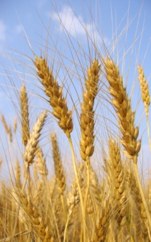

**August**

**Dianne King - 5th Tre’Von Williams - 5th**

**Dion Wildon Jr. - 7th Walter Smith Sr.- 9th**

**Helen Moore 25th  Horane Allison 31st**

**KarleenPreece 14th Se’Quann Pierre 20th**

|  |  |
| --- | --- |
|  |  |
|  |  |
|  |  |
|  |  |

|  |  |
| --- | --- |
|  |  |
|  |  |
|  |  |
|  |  |
|  |  |
|  |  |
|  |  |
|  |  |
|  |  |
|  |  |
|  |  |
|  |  |
|  |  |
|  |  |
|  |  |
|  |  |
|  |  |
|  |  |

**Anniversary**

|  |  |
| --- | --- |
| **Pam Jarrett** | **4-Jun** |
| **Reginald & Patricia Harding** | **14-Jun** |

HH

**Sunday, August 24, 2014**

**Speaker:**

**Henry & Ina Mae Ferguson Aug 13th**

**Sherman & Sharon Smith Aug 12th**

**Walter & Elizabeth Smith Aug 31st**

**Ned & Joan Hanna Aug. 31st**

**The Gentles Family** on the passing of **Gladstone Gentles**, husband, father, grand-father and friend.

**The Beckham/Williams Family** on the passing of **Wellington Beckham**, son, father, brother, grand-father, nephew, uncle, cousin & friend.

Sunday August 24, 2014

[](http://www.google.com/url?sa=i&rct=j&q=&esrc=s&source=images&cd=&cad=rja&uact=8&docid=x159Pwj-f43MEM&tbnid=BthM5WcEthqaIM:&ved=0CAUQjRw&url=http://www.glmilitaryfellowship.org/sermon_notes_January16_2011.html&ei=9kp1U478LceEqgau2ICoCA&bvm=bv.66917471,d.b2k&psig=AFQjCNHnALke2RJQzpn2a-14gEptGYET0g&ust=1400281984633908)[](http://www.google.com/url?sa=i&rct=j&q=&esrc=s&source=images&cd=&cad=rja&uact=8&docid=SizjxPd5oRb-hM&tbnid=6ROss3SoiXO5eM:&ved=0CAUQjRw&url=http://kingdomresponse.org/book&ei=Pkp1U639LsKLqAaWyoKoCA&bvm=bv.66917471,d.b2k&psig=AFQjCNHnALke2RJQzpn2a-14gEptGYET0g&ust=1400281984633908)

OFFICE HOURS

Thursday & Friday Noon -6pm.

(786) 955-6475

To make arrangements for Baby Dedication and Baptisms please contact

Trecia Reid at (954) 682-8945 or the Office. You can also visit our website for direct registration of your child for dedication.

[Luke 6:38](http://www.biblegateway.com/passage/?search=Luke%206:38#en-NIV-25185) : [Ps 79:12; Isa 65:6, 7](http://www.biblegateway.com/passage/?search=Ps%2079:12,%20Isa%2065:6,%20Isa%2065:7&version=NIV)

**This Week in Ministry**

Today: Worship Service 9:00am

Monday: Prayer Meetings **as of Sept 1**

Tuesday: Home Cell Group Meetings 7:30pm

Wednesday

Thursday: Cell Leaders Huddle **Resume Sept 4**

Friday

Saturday

[](http://www.google.com/imgres?imgurl=http://hqwallbase.com/images/big/enjoy_your_breakfast-1530228.jpg&imgrefurl=http://hqwallbase.com/136175-enjoy-your-breakfast/&h=3268&w=3878&tbnid=sXVoAlaLIXmvhM:&zoom=1&docid=t7oSTbx5f-VnaM&ei=qR2_U_S6NoSTyATrz4GoAQ&tbm=isch&ved=0CAwQMygEMAQ4rAI&iact=rc&uact=3&dur=1040&page=27&start=303&ndsp=12)

[](http://www.google.com/url?sa=i&rct=j&q=&esrc=s&source=images&cd=&cad=rja&uact=8&docid=cYkmJSc2oZHQCM&tbnid=2Xdd7JhNEOQNMM:&ved=0CAUQjRw&url=http://revivaltime.webs.com/apps/videos/channels/show/1289102&ei=TaX2U5TEONDJsQTDh4HAAw&bvm=bv.73373277,d.cWc&psig=AFQjCNHH3XNaiFF4kVmGFCk4y9E_0ETKEg&ust=1408759483657287)

[](http://www.bing.com/images/search?q=image+of+prayer&qs=n&form=QBIR&pq=image+of+prayer&sc=8-15&sp=-1&sk=#view=detail&id=19A4FFAF1FB329434B1F304B594520622AC3E8EC&selectedIndex=19)

**Every Monday 7-8pm starting September 1st**

**Monthly Fasting & Prayer Sept 6th, 7-8am**

**COGOP-Gordon-Conwell Seminary Consortium is coming to South Florida. For further details please contact Deacon Richard Clarke.**

WE NEED YOUR ASSISTANCE](http://www.google.com/imgres?imgurl=http://preview.turbosquid.com/Preview/Content_2009_07_15__14_22_04/NoWalking.jpg6d5f3d79-78b1-4dc6-9d46-182fe83adbabLarger.jpg&imgrefurl=http://www.turbosquid.com/FullPreview/Index.cfm/ID/432379&h=600&w=600&sz=83&tbnid=SpiuRf5BR29c8M:&tbnh=86&tbnw=86&zoom=1&usg=__7jb8lNGNrupWNBl-xWBO9_QECOs=&docid=M3fRTGEBplokYM&sa=X&ei=HGPDUY7tOYfg8wTMnYDoBw&ved=0CFoQ9QEwAQ&dur=219)

Please refrain from excessive walking duringservice and

NOchewing of gums, eating or drinking in the sanctuary.

***Thank you!!!***

1. [Luke 6:38](http://www.biblegateway.com/passage/?search=Luke%206:38#en-NIV-25185) : [S Mt 7:2](http://www.biblegateway.com/passage/?search=Matt%207:2&version=NIV)

WORD CONFERENCE 7:30pm

Community Breakfast

**Saturday**

**September 13th at 9 AM**

**Ministry Schedule**

**Mission Trip to**

Madre de Dias,Costa Rica

**Nov 6-10**

**Sundays 9:00am Worship Celebration**

**9:40am Kidz Worship**

**11:15am Sunday School**

**3rd Sundays 6:30pm Evening Service**

**2nd Sundays 6:30pm Men & Woman’s Meetings**

**Mondays 7-8pm Prayer**

**Tuesdays 7:30pm Home Cell Meeting**

**Fridays 2nd& 4th 7:30pm God Seekers Youth Service**

**Sat prior to 1st**

**Sundays 7-8am Fasting & Prayer**

**2nd Saturdays 9-11am Community Breakfast**

|  |  |  |
| --- | --- | --- |
| **SEPTEMBER - DECEMBER 2014**  **REVELATION EXPOSITION: THE KING IS COMING**  **Wednesdays at 7:30 p.m.**  September 10 & 24; October 8 & 22  November 5 & 19; December 3  **End-Time Events & Second Coming of Christ**  Prominent Pastors & Bible Teachers will expose and explain  the biblical truths relating to the Second Coming of  Jesus Christ and events preceding and following  this highly & eagerly anticipated prophetic fulfillment.  **GRACE UNITED COMMUNITY CHURCH**  901 NW 183rd Street, Miami Gardens, FL 33169  www.mygraceunited.com  Telephone (305) 651-1446 | | |
| **EXPOSITORS**  **Rev. Newton King Maranatha SDA Church**  **Rev. Ethelence Taitt Faith & Life Fellowship Ministries**  **Rev. Albert Guthrie Open Bible Community Church**  **Bp. Clarence Harris Diversity Int. Television Network**  **Rev. Juan Valdes Reasons for Hope Ministry**  **Rev. Boyze Edwards Grace United Community Church**  **Rev. Donald Forrester Victory Christian Center**  Host: Bishop Dr. Dennis Archibald & Dr. Cynthia Archibald |



[http://www.lfmcogop.org/img/blank.png](javascript:void(0);)

**[](http://en.wikipedia.org/wiki/File:Flag_of_Costa_Rica_(state).svg)**

**You must make reservations NOW!!!!**

[](http://www.google.com/url?sa=i&rct=j&q=&esrc=s&source=images&cd=&cad=rja&uact=8&docid=x1v7DKbcRQnegM&tbnid=bKudXbht1zCfqM:&ved=0CAUQjRw&url=http://www.christianforumsite.com/threads/hello-everyone.39043/&ei=V9_jU-e_MMKlyQTB7IH4Dw&bvm=bv.72676100,d.aWw&psig=AFQjCNH6ybW1ZzVPDqmxqcpfEYE9TR7IDg&ust=1407528777235216)

Deposit due by September 21.

Retreat is December 12 – 14.  
Volunteers & Donations needed

*More information to come*

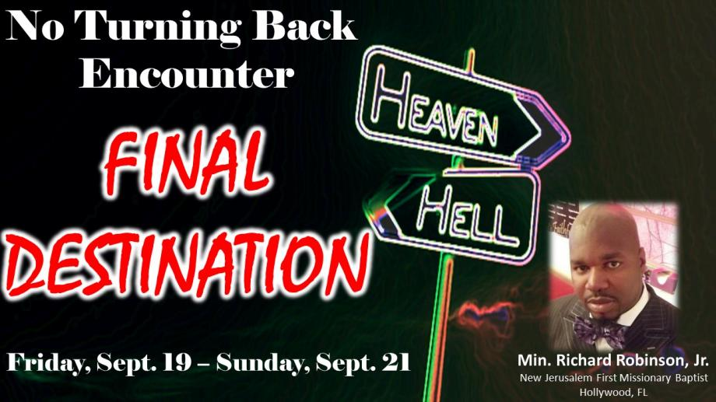

**Prayer Meeting Every Monday 7-8 as of Sept 1**

**Fasting & Prayer Sept 6 7-8am**

**No Turning Back Encounter Sep.19-21**

**God Seekers Sept. 12 7:30 pm**

**Deeper Retreat Dec. 12- 14**

This Bulletin is produced with you in mind. Please follow carefully for information on upcoming events in the church and our community.

[](http://www.google.com/url?sa=i&rct=j&q=&esrc=s&source=images&cd=&cad=rja&uact=8&docid=qCSLlLbajKgYwM&tbnid=zApBK6GvftFTXM:&ved=0CAUQjRw&url=http://www.merchantcircle.com/business/Love.Fellowship.Ministries.7869556475/picture/view/3480881&ei=l6d-U4_PCcm3sATJwIHIBA&bvm=bv.67720277,d.b2k&psig=AFQjCNGCmnMqDLI2k9PpnjQma0NNbQqTkA&ust=1400895747685235)

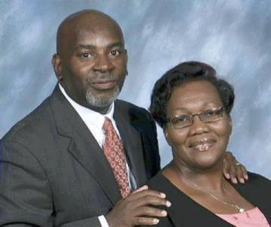

**2245 W. Bunche Park Dr.**

**Miami Gardens, Fl 33054**

Telephone: (786)955-6475

Pastor: Bishop W. B. Heron

Associate Pastor: Min. Karen Clarke

Pastor Emeritus: Bishop Walter Smith

[www.lfmcogop.org](http://www.lfmcogop.org)

[http://www.lfmcogop.org/img/blank.png](javascript:void(0);)