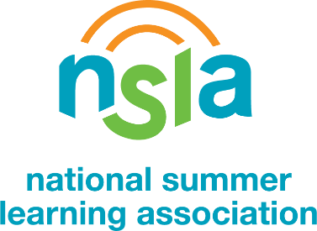

Proclaim Summer Learning Week in Your Community
Proclaim Summer Learning Day, Week, or Month in your community and show how essential summer learning is in closing the achievement and opportunity gaps in America.
- Share this sample proclamation language with your mayor, governor, or local elected official. Recommend a day, week, or even a month long celebration. National Summer Learning Week is taking place from July 8-13, 2019.
- If you have not heard from your local leader’s office within two weeks, reach out to them again and share resources found on the National Summer Learning Association’s (NSLA) website to show the importance of summer learning such as the Summer by the Numbers flyer.
- Once proclaimed, celebrate on Twitter with the two hashtags #SummerLearningWeek and #Proclamation to let us know your community is part of the celebration!
You can find the sample proclamation language on the following page.

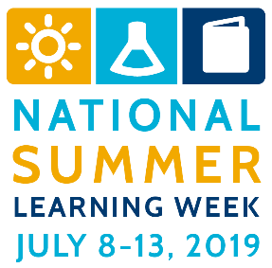

SAMPLE PROCLAMATION FOR SUMMER LEARNING WEEK
Whereas: Summer Learning Day/Week/Month is a time to reflect on the importance of keeping youth learning, safe, and healthy every summer, ensuring they return to school in the fall ready to succeed in the year ahead; and
Whereas: Summer learning loss is a significant contributor to the achievement gap — a gap which remains constant during the nine months of the school year but widens during the summer months; and
Whereas: Summer learning programs are proven to maintain and advance students’ academic and social/emotional growth, keep children safe and healthy during the summer, and send young people back to school ready to learn. Additionally, summer youth employment programs engage older youth in meaningful activities that allow them to explore careers of interest, take on new responsibilities, contribute to their community, and earn money for the future; and
Whereas: A wide array of public agencies, community-based organizations, schools, libraries, museums, recreation centers, camps, and businesses in our community contribute to the well-being of youth through summer programming; and
Whereas: Summer learning is a critical component of our collective effort to ensure all students graduate from high school prepared for college, careers, and life;
Now, therefore, I, First and Last Name, do hereby proclaim July XX-XX, 2019 as SUMMER LEARNING DAY/WEEK/MONTH in Name of Location, and do commend this observance to all of our citizens.

