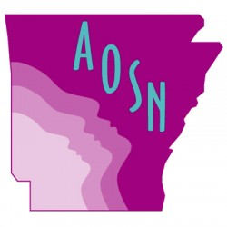
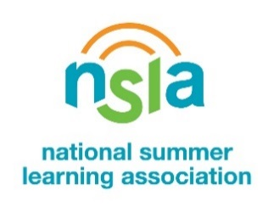

For Immediate Release
Contact: Graycen C. Bigger
Communications Coordinator, AOSN
870.335.7409
gcolbert@astate.edu

[[Name of Organization] Joins Thousands of Education Champions across the Country in Celebration of National Summer Learning Week (July 8-13)
[CITY, ARKANSAS—Date XX, 2019] – School’s out! Summer fun and learning are in! [NAME OF ORGANIZATION] joins the National Summer Learning Association (NSLA) in celebrating National Summer Learning Week, a celebration dedicated to elevating the importance of keeping kids learning, safe and healthy every summer; ensuring young people return to school ready to succeed. That’s why during July 8 to 13, each day of Summer Learning Week is devoted to a different critical summer issue, from the enriching possibilities of STEM (science, technology, engineering and mathematics) to arts programming to summertime programs that strengthen career development skills for young people. [NAME OF ORGAINZATION] also joins communities everywhere in calling out the importance of reading and access to good nutrition as part of the formula for an enriching and healthy summer.

[insert quote from organizational representative] Our goal this year is to serve XNumber of youth in [INSERT NAME OF COMMUNITY].

[NAME OF ORGANIZATION]’s event will highlight the importance of summer learning opportunities within [INSERT THEME] at [INSERT NAME AND/OR SHORT DESCRIPTION OF EVENT] on July XX.

National Summer Learning Week aims to unite community organizations, summer learning programs, and families in advocacy efforts and celebrations hosted by hundreds of partner organizations from libraries to museums, parks and recreation centers to civic and non-profit groups all to promote awareness of the power and magic of summer programs to close opportunity gaps among youth throughout the nation.

“We know that summer learning loss is real, but we should not place so much of our focus narrowly on the summer academic slide that we ignore the many other “lost opportunity” summer issues that impact children’s physical, mental and emotional well-being,” said Aaron Philip Dworkin, NSLA CEO.

[INSERT HIGHLIGHTS OF THE EVENT, WHICH MAY INCLUDE OPEN HOUSES FOR COMMUNITY MEMBERS, STEM OR READING CHALLENGES, OR OTHER COMMUNITY HIGHLIGHTS]

“Summer learning programs are a vital resource for families across Arkansas.” “Without access to these quality programs students can lose two-three months of acquired reading and math skills. The loss of these skills during summer months in elementary school accounts for a majority of the achievement gap for low-income students by the time they reach the ninth grade. Quality programs like these help close that achievement gap,” commented Arkansas Out of School Network Director Laveta Wills-Hale.

[insert event logistics information]

# # #
The Arkansas Out of School Network (AOSN) is one of 50 statewide afterschool networks working to promote an expansion of school-based and school linked afterschool and summer programs serving children and youth ages 5-19. AOSN’s mission to create safe, healthy and enriching experiences for Arkansas youth during out of school times.
The National Summer Learning Association (NSLA) is the only national nonprofit exclusively focused on closing the achievement gap by increasing access to high-quality summer learning opportunities. NSLA recognizes and disseminates what works in summer learning, develops and delivers capacity-building offerings and convenes and empowers key actors to embrace summer learning as a solution for equity and excellence in education. For more information, visit www.summerlearning.org.

