First Calvary Baptist Church
Scholarship Ministry

Elnora Shields
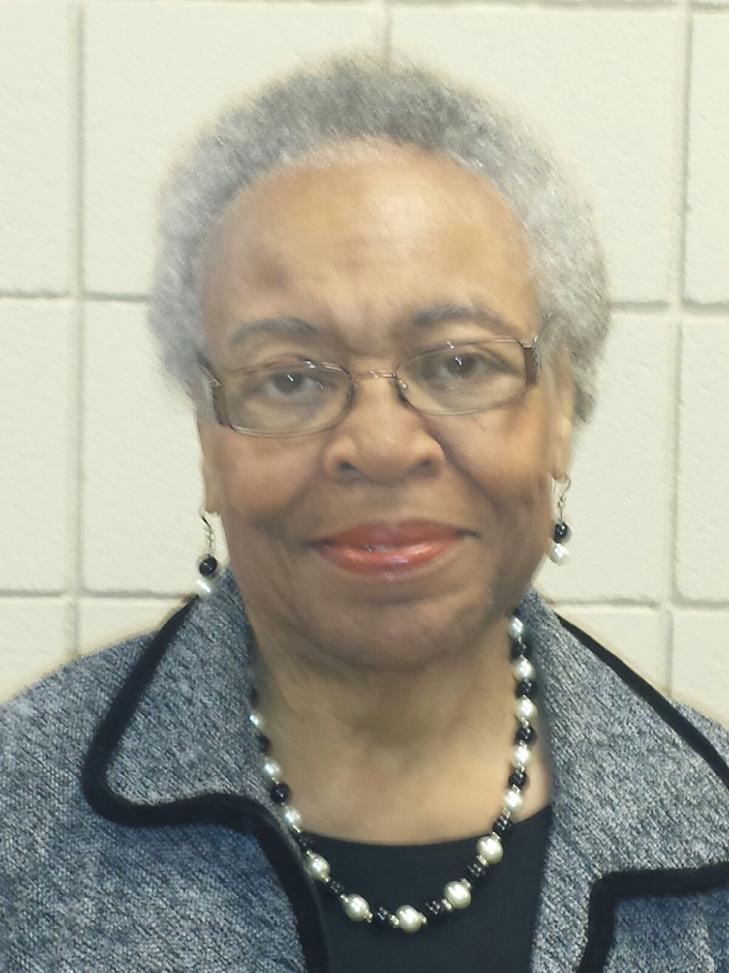

Academic Scholarship Application

CRITERIA
The recipient of the First Calvary Baptist Church $1500 Academic Scholarship will be selected on the basis of academic achievement (GPA) and church membership. Each applicant should also include a written essay and two recommendation letters to complete the packet. The recipient(s) will be REQUIRED to attend the reception on Graduation Sunday.

ACADEMICS
Students must currently have a “3.5” or greater unweighted grade point average. Only unweighted GPAs will be considered because some private schools do not use weighted grade point averages.

ESSAY
The applicant will complete a 250 word typed, double-spaced essay in which you describe your goals, how you plan to achieve them, and how an education will help you make a contribution to your community.

CHURCH MEMBERSHIP
Student should be a member or affiliate of the body of First Calvary Baptist Church.
Membership (for the purposes of the FCBC Scholarship) is defined as a student who is a member through 1) baptism, Christian experience, Associate membership; 2) has a parent/legal guardian who is a member of First Calvary and actively participating in the life of the church; and 3) active participant in church ministries and consistent attendance in worship.
Affiliate is defined as a student who participates in FCBC outreach ministries such as, Scouts or Recreation Ministry.

Involvement is defined as an active/consistent participation in a church ministry (i.e. worship, fellowship, evangelism, discipleship, Sunday school, and Bible study ministries). Involvement is considered as participation from August - April

The Chairperson of the ministry must provide written confirmation of student’s active participation in the ministry for the current school year.

The following is a list of typed documents that each student must provide/fill out completely for the Elnora Shields Academic Scholarship. All items must be submitted to First Calvary Baptist Church Scholarship Ministry (NO LATER THAN WEDNESDAY, APRIL 24, 2019 AT 7:00 PM.):

- Application for the “FCBC Scholarship”
- Copy of high school (official) transcript (issued by the Guidance Counselor)
- Church /Ministry Statement – Must be signed by Ministry Chairperson
- 250 word typed essay (completed and signed by student) Separate from Katara Harris Merit essay
- *Two (2) personal recommendation letters (see below). These letters must be completed and signed by persons recommending the student for the scholarship
- PROOF of ADMISSION TO AN INSTITUTION OF HIGHER LEARNING

*Written recommendations must be from the following: one (1) church member (excluding the Pastor and parents), and one (1) from the following: guidance counselor, teacher, coach, etc. Recommendations should be no more than 100 words typed clearly describing the applicant’s personal drive. Two (2) letters of recommendation are required and must be typed and signed.

***IMPORTANT!!! Please make sure that ALL 6 items above are completed and submitted together in a sealed 8 ½ by 11 envelope. Incomplete packets WILL NOT be accepted for consideration. To prevent late arrival, plan early to have your transcript and recommendation letters available to you so you can place them in a sealed envelope to be included with your total packet.

DEADLINE
The Scholarship Ministry must receive all materials in the Scholarship Ministry mailbox (outside the church office) by 7:00 pm, Wednesday, April 24, 2019. LATE APPLICATIONS WILL NOT BE ACCEPTED!
If there are questions concerning the contents of the Scholarship Application Packet, please contact Brenda Carter (brenda_6470404@yahoo.com) or scholarship@firstcalvary.org.

First Calvary Baptist Church
Elnora Shields Academic Scholarship Application

NAME____________________________________________________________

ADDRESS_________________________________________________________

BIRTHDATE______________________ SEX: Male_______ Female______

PARENTS/GUARDIANS ____________________________________________

HOME TELEPHONE_______________________________________________

CELL PHONE_____________________________________________________

EMAIL ADDRESS ___________________________________________________

HIGH SCHOOL____________________________________________________

DATES ATTENDED________________________________________________

HONORS__________________________________________________________

___________________________________________________________________

___________________________________________________________________

ARE YOU OR YOUR PARENTS OR GUARDIAN A MEMBER OF FIRST CALVARY? Yes_____ No_____

CHURCH ACTIVITIES/MINISTRIES___________________________________

____________________________________________________________________

____________________________________________________________________

____________________________________________________________________

NAME AND LOCATION OF COLLEGE/UNIVERSITY YOU WILL ATTEND:

First Calvary Baptist Church
Scholarship Packet FINAL CHECKLIST
For Elnora Shields Academic Scholarship

- Scholarship Application:
Students may apply for both but may only receive one scholarship.

  - Elnora Shields Academic Scholarship _____Yes or No______
  - Katara Harris Merit Award _____Yes or No______

- Official Copy of high school transcript (issued by the Guidance Counselor)
- Community Service Form(s)-Must be signed by the Community Service Rep.
**Only Required for Katara Harris Merit Award**
- Church/Ministry Statement – Must be signed by Ministry Chairperson
- 250 word typed essay (completed and signed by student)
- *Two personal recommendation letters. These must be completed and signed by persons recommending the student for the scholarship.
- Proof of acceptance to an institution of higher learning

I have used the above checklist to validate that my application packet is complete and includes all of the items listed above for the appropriate scholarship.

I understand that I may apply for either scholarship or both. I also understand that only completed applications will be considered and I must submit the above items in a sealed 8 ½ x 11 envelope by 7:00pm on Wednesday April 24, 2019 and placed in the Scholarship Ministry mailbox.

Student Signature _____________________________________________________

_______________________________________________________________________

First Calvary Baptist Church
Scholarship Ministry

Katara Harris
Merit Award Application

CRITERIA
The recipient of the $750 Katara Harris Merit Award will be selected on the basis of 3 criteria:
- Community Service,
- Church Membership and
- Academics.
All three criteria are equally important, and each is equally weighted in the selection process. The recipient(s) will be REQUIRED to attend the reception on Graduation Sunday.

The three criteria will be judged, in part, by:

COMMUNITY SERVICE/ESSAY
Student must actively participate in community service. Community service is defined as committing acts that are not self-serving and not receiving monetary compensation. Examples of community service include volunteering at food banks, afterschool programs, nursing homes, candy striper in a hospital setting, rescue mission and Mobile Markets. In addition, the applicant must complete a 250 word essay typed, and double-spaced describing how the student’s community service impacted his/her goals, how he/she plans to achieve them, and how a college education will help him/her make a contribution to the community. Points will be deducted if the essay does not meet the 250 word minimal requirement.

Students should complete a minimum of 20 hours of community service between June 2018 and April 2019. Written confirmation must be submitted by an authorized representative where the service was performed. Please note: Parents/guardians are prohibited from writing letters of recommendations.

CHURCH MEMBERSHIP
Student may or may not * be a member of the body of First Calvary Baptist Church.
Membership is a member through 1) baptism, Christian experience, Associate membership; 2) has a parent/legal guardian who is a member of First Calvary and is actively participating in the life of the church; and 3) active participation in church ministries and consistent attendance in worship
*Affiliate is defined as a student who participates in FCBC outreach ministries such as, Scouts or Recreation Ministry.

Please have the Ministry Chair complete and sign the Church Membership/Involvement Statement to be submitted with your application.

The following is a list of typed documents each student must provide/fill out completely for the Katara Harris Merit Award and submit to First Calvary Baptist Church Scholarship Ministry:

ACADEMICS
Students must currently have a minimum grade point average of “2.5”.

The following is a list of typed documents each student must provide/fill out completely for the Katara Harris Merit Award and submit to First Calvary Baptist Church Scholarship Ministry:

- Application for the “Katara Harris Merit Award”
- Official Copy of high school transcript (issued by the Guidance Counselor)
- Community Service Form(s)-Must be signed by the Community Service Rep.
- Church /Ministry Statement – Signed by Ministry Chairperson
- 250 word typed essay (completed and signed by student) Separate from the Elnora Shields Academic Scholarship essay
- *Two personal recommendation letters (see below). These must be completed and signed by persons recommending the student for the scholarship.
- PROOF of ADMISSION TO AN INSTITUTION OF HIGHER LEARNING.

*The two (2) written recommendations should be from the following:
- One (1) from church member (excluding the Pastor and parents/guardians), and
- One (1) from the following: guidance counselor, teacher, coach, etc.

Recommendations should be no more than 100 words typed clearly to describe the applicant’s personal drive. Two (2) letters of recommendation are required and must be typed and signed.

***IMPORTANT!!! Please make sure that ALL SEVEN (7) items above are completed and submitted together in a sealed 8 ½ by 11 envelope. Incomplete packets WILL NOT be accepted for consideration. To prevent late arrival, plan early to have your transcript and recommendation letters available to you so you can place them in a sealed envelope to be included with your total packet.

DEADLINE
The Scholarship Ministry must receive all materials in the Scholarship Ministry mailbox (outside the church office) by 7:00 pm, Wednesday, April 24, 2019.

If there are questions concerning the contents of the Scholarship Application Packet, please contact Brenda Carter (brenda_6470404@yahoo.com) or scholarship@firstcalvary.org.

First Calvary Baptist Church
Katara Harris Merit Award Application

NAME____________________________________________________________

ADDRESS_________________________________________________________

BIRTHDATE______________________ SEX: Male_______ Female______

PARENTS/GUARDIANS ____________________________________________

HOME TELEPHONE_______________________________________________

CELL PHONE_____________________________________________________

EMAIL ADDRESS____________________________________________________

HIGH SCHOOL____________________________________________________

DATES ATTENDED________________________________________________

HONORS__________________________________________________________

___________________________________________________________________

___________________________________________________________________

___________________________________________________________________

ARE YOU OR YOUR PARENTS OR GUARDIAN A MEMBER OF FIRST CALVARY? Yes_____ No_____

CHURCH ACTIVITIES/MINISTRIES___________________________________

____________________________________________________________________

____________________________________________________________________

NAME AND LOCATION OF COLLEGE/UNIVERSITY YOU WILL ATTEND:

_______________________________________________________________________

COMMUNITY SERVICE – Katara Harris Merit Award
Please use a separate sheet per Community Service Involvement

Name of Student________________________________________________________

Community Service Activity (please describe):
________________________________________________________________________
________________________________________________________________________
__________________________________________________________________________________________________________________________________________________________________________________________________

In 2-3 sentences describe how this service impacted your life.________________________________________________________________________________________________________________________
__________________________________________________________________________________________________________________________
_____________________________________________________________

Approximate number of Community Service hours rendered: __________________

Dates of Community Service__________________________________

Name of Agency/Organization_____________________________________________

Community Service Representative’s Name (Please print):

_______________________________________________________________________

Complete Address (location of project, if applicable):
________________________________________________________________________
________________________________________________________________________

Telephone Number (of project’s office, if applicable):__________________________

Signature/Title of Representative (must be signed to be considered):

________________________________________________________________________

Date ________________________________________

First Calvary Baptist Church
Church Involvement and Ministry Statement

This notice is to provide written confirmation that

(Student’s Name)

has been an active participant in the _____________

____________________Ministry for the current school year.

Signature of Ministry Chair / Designee

Date

First Calvary Baptist Church
Scholarship Packet FINAL CHECKLIST
For Katara Harris Merit Award

- Scholarship Application:
Students may apply for both but may only receive one scholarship.

  - Elnora Shields Academic Scholarship _____Yes or No______
  - Katara Harris Merit Award _____Yes or No______

- Official Copy of high school transcript (issued by the Guidance Counselor)
- Community Service Form(s)-Must be signed by the Community Service Rep.
**Only Required for Katara Harris Merit Award**
- Church Ministry Statement – Must be signed by Ministry Chairperson
- 250 word typed essay (completed and signed by student)
- *Two personal recommendation letters. These must be completed and signed by persons recommending the student for the scholarship.
- Proof of acceptance to an institution of higher learning

I have used the above checklist to validate that my application packet is complete and includes all of the items listed above for the appropriate scholarship.

I understand that I may apply for either scholarship or both. I also understand that only completed applications will be considered and I must submit the above items in a sealed 8 ½ x 11 envelope by 7:00pm on Wednesday April 24, 2019 and placed in the Scholarship Ministry mailbox.

Student Signature _____________________________________________________

Parent/Guardian Signature _______________________________________________

Date _________________________________________

