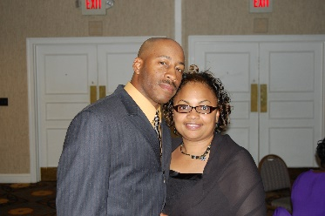
Meet Brother Alvin and Sister Melissa Newsome
- Married 8 years
Marriage Wisdom Nugget:
Marriage is work and at times, can go haywire but we know Love Conquers all. We forgive often and strive to focus on what we like about each other.
Two Favorite scriptures
I have told you these things, so that in me you may have peace. In this world you will have trouble. But take heart! I have overcome the world.” John 16:33
Wait for the LORD; be strong and take heart and wait for the LORD. Psalms 27:14

