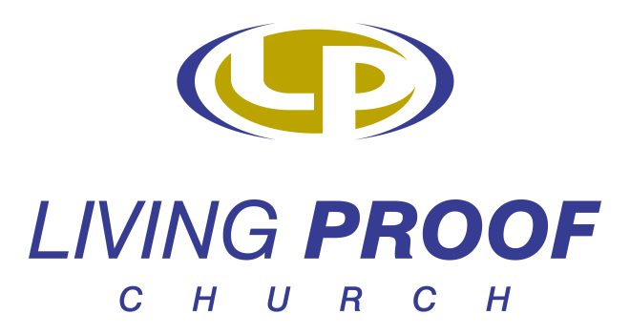

Dear Parent,

Please complete the following information on your child. This information will solely be used for accountability purposes and to contact you and your child about upcoming events, schedule changes, and other ministry related activities.

Student’s Name:____________________ Grade:_____ Age:_____

Date of Birth:__________ Parents’ Name(s):__________________________________

Address:____________________________________________________________________

Telephone Number:_______________ Email Address:________________________

List any know allergies:_________________________________________________________
____________________________________________________________________________

Is there anything else we should know about your child:______________________________
____________________________________________________________________________

Thank you for allowing your child to be a part of our wonderful Middle School Program.

The Middle School Program staff requests permission to take photographs and/or videos of your child while participating exclusively in Middle School Program activities. These photographs and videos will only be displayed on bulletin boards located on church property, the Middle School Program quarterly newsletter, DVDs produced by the Living Proof Church staff, the Living Proof Church website (www.livingproofchurch.org) , or printed material associated with various Living Proof Church ministries.

Please indicate whether or not you will give us permission to photograph your child or have him or her appear on Living Proof Church videos by checking one of the boxes below.

I permit my child to be photographed and appear on a video: _____
I do not want my child to be photographed or appear on a video: _____

Child’s Name (print):__________________________

Parent’s Name (print):_________________________

Parent’s Signature:____________________________ Date:_______________

Thank you for allowing your child to be a part of our wonderful Middle School Program.

