Cambodia 2020

Join Life Community as we meet urgent needs and bring health
to hurting and oppressed people.

October/November 2020

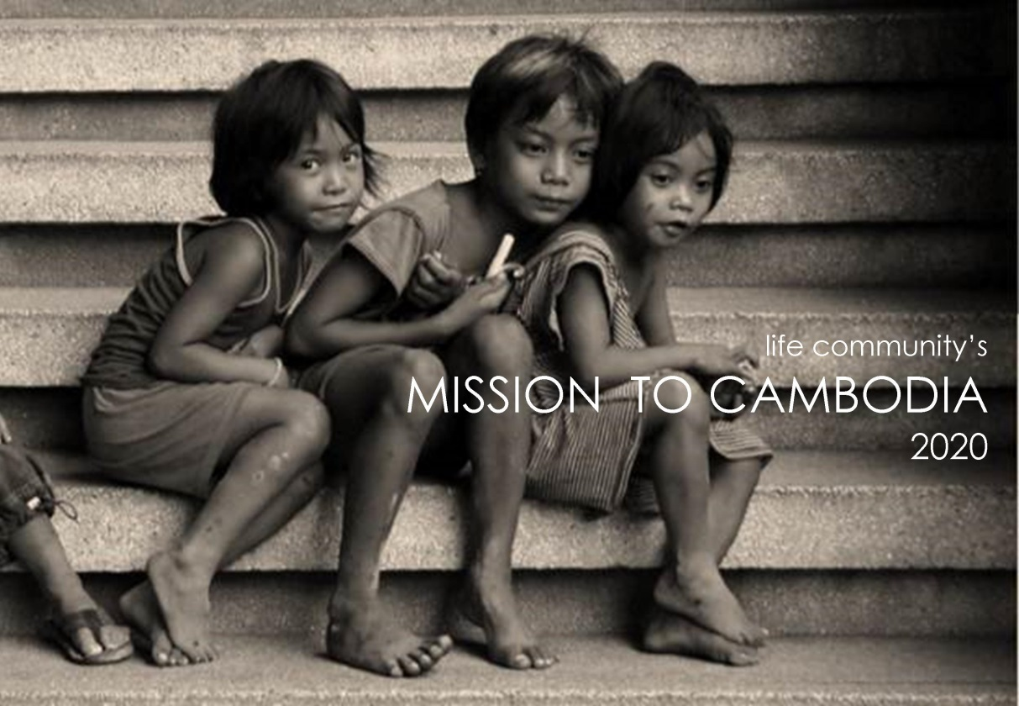

What is FCOP?

www.fcopi.org

FCOP International is a Christian Ministry dedicated to building the kingdom of God through meeting urgent needs and doing good deeds to bring holistic health to hurting and oppressed people.

What they do…
- Operate 106 church/orphan homes through Cambodia
- Operate and oversee approximately 6,000 churches and home groups as well as train and oversee all the leaders
- Care for 3,000 orphans and separated children each year
- Staff- 600 widows (one for every five children we care for)
- Rescue, train, equip and release sexually trafficked young women
- Provide advance educational training for qualified orphans
- Continue the family relationship with 15,000 orphans who have been raised even for a short time in our homes
- Provide vocational training and assistance for micro-enterprises
- Provide medical and dental care teams to remote areas

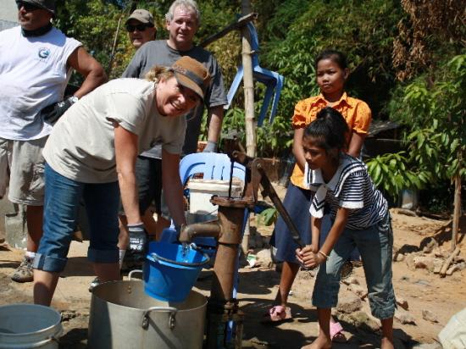

Why Go?

Pastor Ted Olbrich is the founder of FCOP…

I cannot over emphasize the importance of teams coming to Cambodia. We had great teams this month and two more showed up while I was leaving for the USA. The work they accomplished was astonishing, but I keep telling people that whet the work teams do physically, wonderful as it is, is not the greatest value of the team….The fact that the team came thousands of miles just to see these children completely destroys the social stigma they are branded with. “You’re an orphan so you were bad in your previous life; you deserve to suffer!” The kids that these teams come to see become instant celebrities, and it changes their outlook and self value forever. “Someone came half way around the world just to see me!”

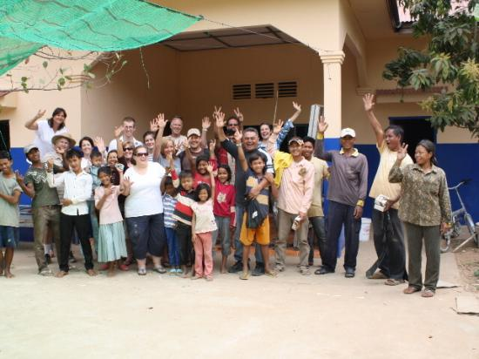

What to Expect?
We are going to Cambodia as a “construction” team. As FCOP homes are being used daily by the children, they have many projects from basic wear and tear. Also, with the harsh sun and the stormy rains, they have constant needs for the homes to be fixed up so that our children can have the best possible homes.

We will be in Cambodia at the same time as a dentist and part of our work will be to assist him.

- You will WORK, this is general labor every day
  - Painting, digging, building fences, etc.
- We will have time to minister and pray for these children including a church service or bible study
- Spend quality time with the children
  - Facepainting, singing, playing, etc.

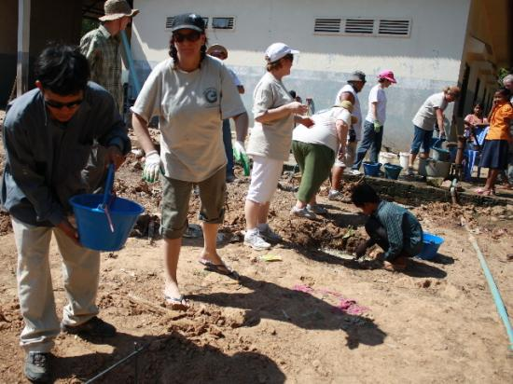
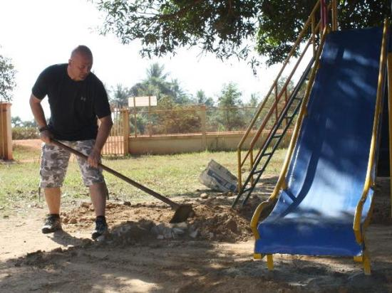

Cost & Fundraising

$2100.00 Per person
Includes…
- Flight
- Hotel
- All meals
- All ministry and materials
Extra money will be needed for personal spending, souvenirs, etc.

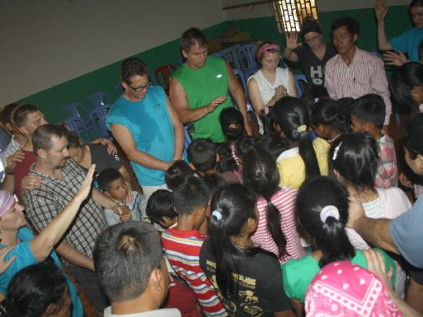

Timeline
Listed below are dates of Team Meetings and monthly fundraisers. Most fundraisers do not have exact dates, just the month in which we will host them- dates TBD.

ALL APPLICATIONS DUE BY January 12th. (Application located on last page)

January 19th: 1st Team Meeting
1st Deposit of $100

February 16st: Team Meeting – Work on letters together

March 22nd: 2nd Deposit $500 due
Team Meeting

April 26th: Team Meeting

May 31st: 3rd Deposit $500 due
Team Meeting

June 28th: Team Meeting

July 26th: Deposit $500 due
Team Meeting

August 23rd: Team Meeting August 21

October 4th: Final Deposit $500 due
Team Meeting

1 week before departure: Final Team Meeting

October/November: MISSION TO CAMBODIA

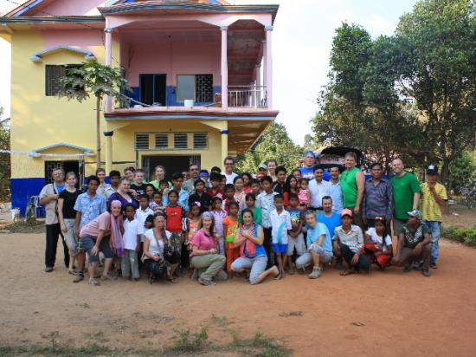

Contact…

Mission Coordinator: Lindsay Adarme
Sugger556@aol.com

Life Community Contact: Jaime Johnson
jaime@lifecommunityaz.com
480.545.1111

Information Packets are available for download at: www.lifecommunityaz.com. Please click on “Connect”, then “World Missions”.

Missions Trip Application

Name ______________________________________ Age ______________________

Email Address __________________________________________________________________

Phone number _________________________________________________________________

Do you attend Life Community Church? _________________________________________

Have you participated in a Missions trip in the past? ____________________________________

If so, where? ____________________________________________________________________

If you are selected, are you prepared to commit to the team meeting, the cost and the expectations of the trip? __________________________________________________________________________

Please list any medical conditions you have ______________________________________________

The Cambodia mission consists of ministry with the people and children but also manual labor. Is there anything that may prevent you from completing these tasks?__________________________________

What skill or talent do you have to offer the team? __________________________________________

What is an area of growth for you? _______________________________________________________

