Cambodia 2018

Join Life Community as we meet urgent needs and bring health
to hurting and oppressed people.

Mission to Cambodia
November 2018

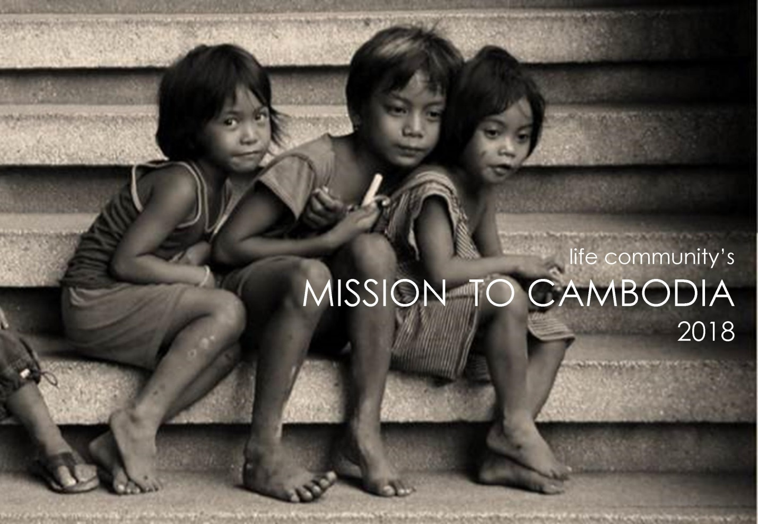

What is FCOP?

www.fcopi.org

FCOP International is a Christian Ministry dedicated to building the kingdom of God through meeting urgent needs and doing good deeds to bring holistic health to hurting and oppressed people.

What they do…
- Operate 106 church/orphan homes through Cambodia
- Operate and oversee approximately 6,000 churches and home groups as well as train and oversee all the leaders
- Care for 3,000 orphans and separated children each year
- Staff- 600 widows (one for every five children we care for)
- Rescue, train, equip and release sexually trafficked young women
- Provide advance educational training for qualified orphans
- Continue the family relationship with 15,000 orphans who have been raised even for a short time in our homes
- Provide vocational training and assistance for micro-enterprises
- Provide medical and dental care teams to remote areas

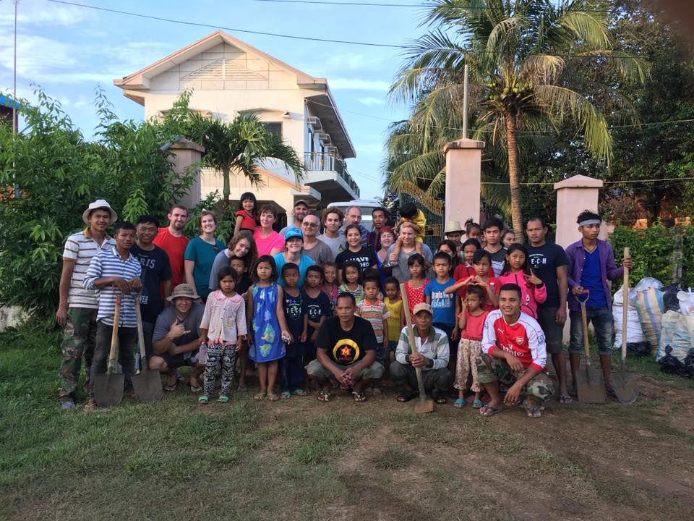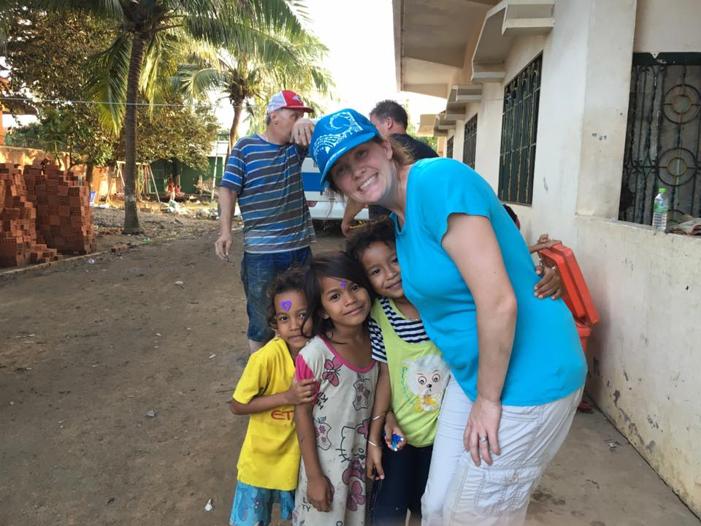

Why Go?

Pastor Ted Olbrich is the founder of FCOP…

I cannot over emphasize the importance of teams coming to Cambodia. We had great teams this month and two more showed up while I was leaving for the USA. The work they accomplished was astonishing, but I keep telling people that whet the work teams do physically, wonderful as it is, is not the greatest value of the team….The fact that the team came thousands of miles just to see these children completely destroys the social stigma they are branded with. “You’re an orphan so you were bad in your previous life; you deserve to suffer!” The kids that these teams come to see become instant celebrities, and it changes their outlook and self value forever. “Someone came half way around the world just to see me!”

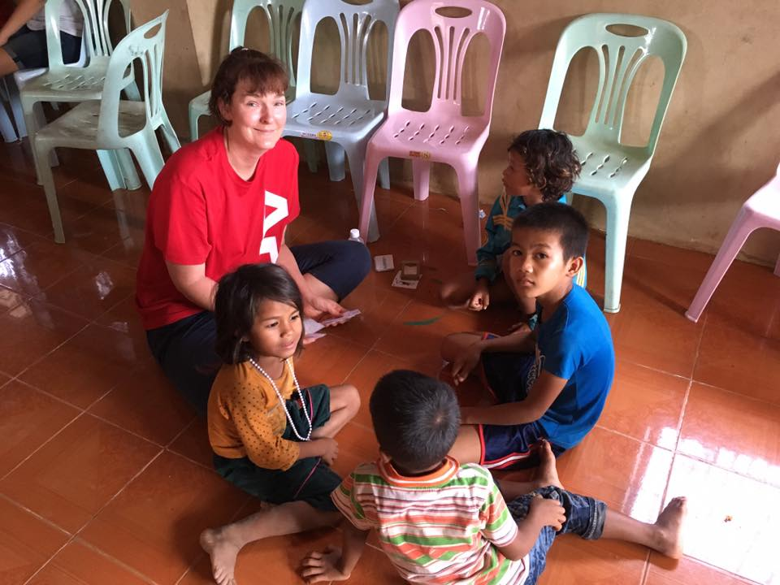

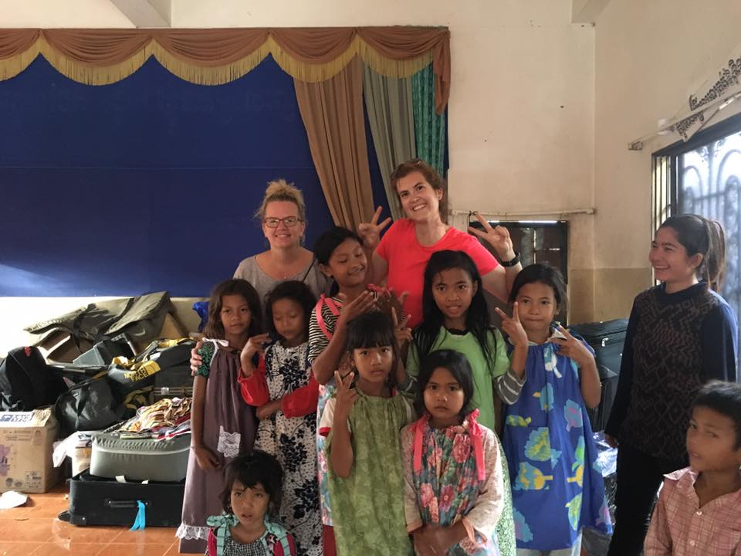
What to Expect?
We are going to Cambodia as a “construction” team. As FCOP homes are being used daily by the children, they have many projects from basic wear and tear. Also, with the harsh sun and the stormy rains, they have constant needs for the homes to be fixed up so that the children can have the best possible homes.

- Physical Labor for the construction project from 8a-4p everyday Monday-Friday
  - The projects can range from painting, to chain link fences, to digging ditches and pouring concrete. The heat is challenging to work through on top of demanding physical work.
- Team Breakfast, Lunch and Dinners
  - Expect to eat rice, chicken, pork, or beef everyday for every meal. This can get hard at the end of the trip eating the same thing for every meal, but having a good attitude and upfront understanding is important
- Building relationships with the Khmer Adults and children
  - These children think westerns are super stars and can’t believe they would come just to serve them. This interaction is such an amazing experience
- A new cultural and spiritual perspective
  - You will come back changed! You are going there to change the lives of the Cambodians, but expect God to change your heart and expect an encounter with Him.

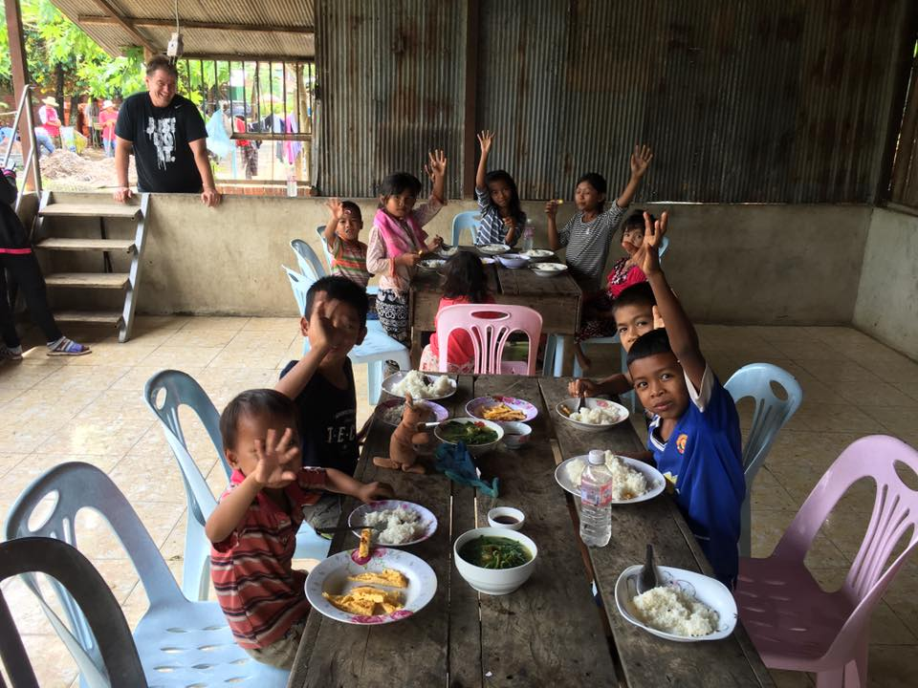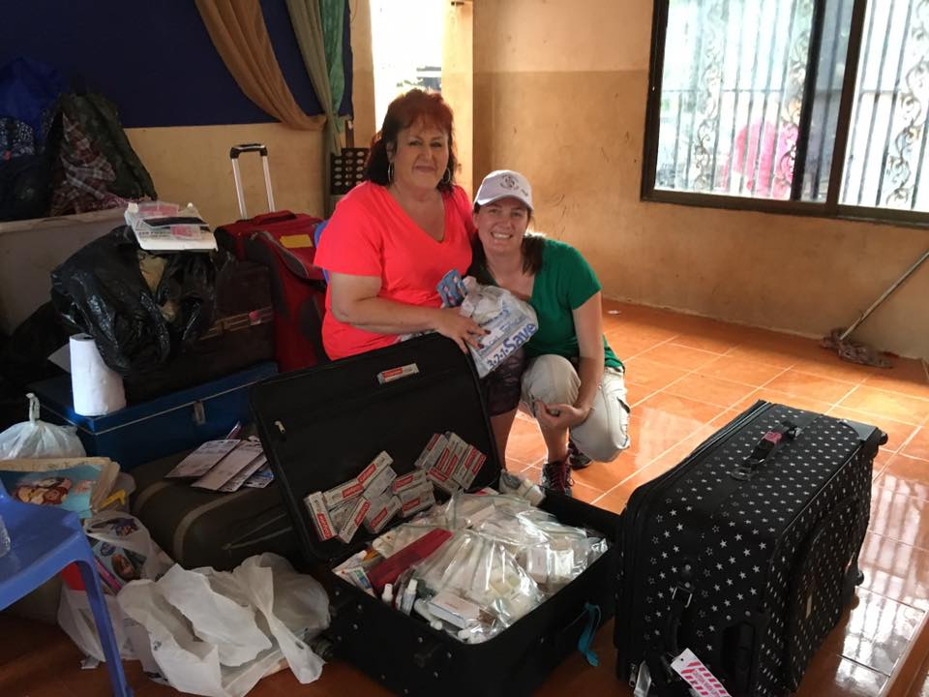

Cost & Fundraising

$2300.00 Per person
Includes…
- Flight
- Hotel
- All meals
- All ministry and materials
Extra money will be needed for personal spending, souvenirs, etc.

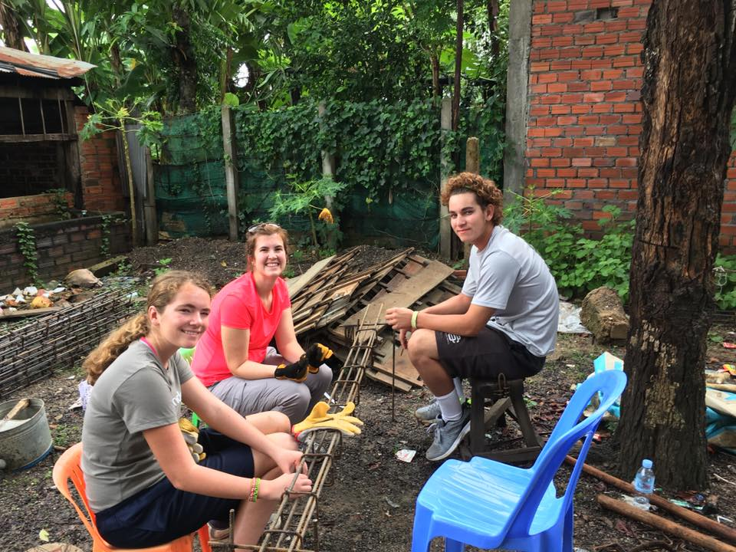

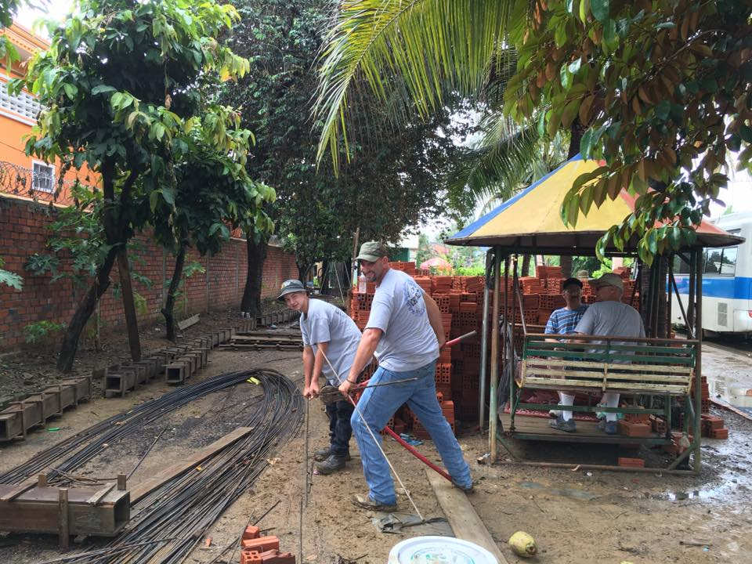

Timeline
October 8, 2017: Interest Meeting
October 22, 2017: Interest Meeting
January 14, 2018: 1st Team Meeting – 1st Deposit $300 due
February 11, 2018: Team Meeting
No Meeting in March
April 8, 2018: Team Meeting – 2nd Deposit $500 due
No Meeting in May
June 10, 2018: Team Meeting
July 8, 2018: Team Meeting – 3rd Deposit $500 due
August 12, 2018: Team Meeting
September 9, 2018: Team Meeting – 4th Deposit $500 due
October 14, 2018: Final Team Meeting – 5th and Final Deposit $500 due
Depart for Cambodia end of October/Early November. Dates TBD.

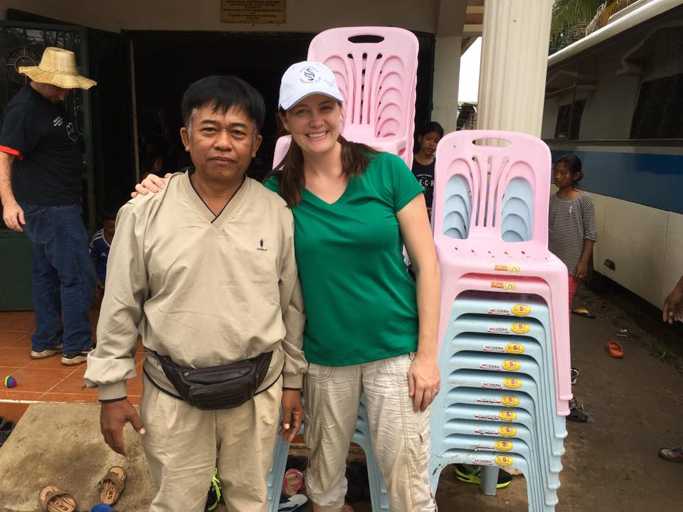

Contact…

Mission Coordinator: Lindsay Adarme
Sugger556@aol.com
714.661.4231

Life Community Contact: Jaime Johnson
jaime@lifecommunityaz.com
480.545.1111

Information Packets are available for download at: www.lifecommunityaz.com. Please click on “Ministries”, then “Cambodia”.

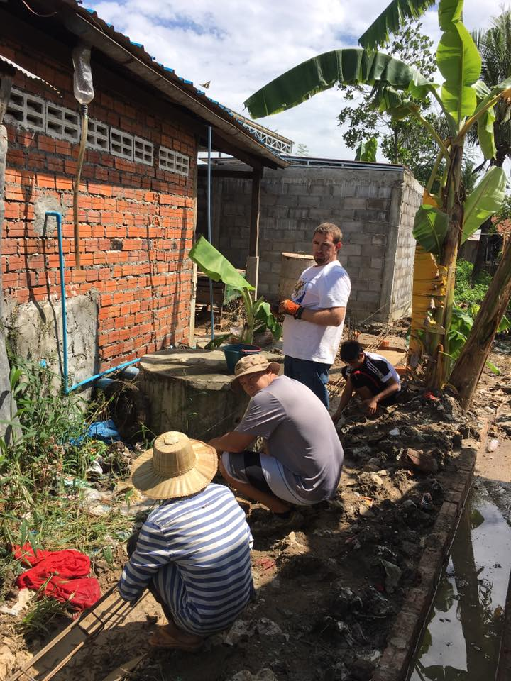

Missions Trip Application

Name ______________________________________ Age ______________________

Email Address __________________________________________________________________

Phone number _________________________________________________________________

Do you attend Life Community Church? _________________________________________

Have you participated in a Missions trip in the past? ____________________________________

If so, where? ____________________________________________________________________

If you are selected, are you prepared to commit to the team meeting, the cost and the expectations of the trip? __________________________________________________________________________

Please list any medical conditions you have ______________________________________________

The Cambodia mission consists of ministry with the people and children but also manual labor. Is there anything that may prevent you from completing these tasks?__________________________________

What skill or talent do you have to offer the team? __________________________________________

What is an area of growth for you? _______________________________________________________

