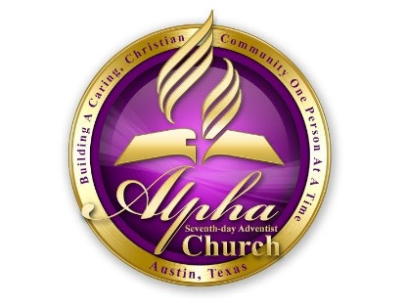
Alpha Seventh-Day Adventist Church
2017 Ministry Event Report
Submission Deadline: December 23, 2017

Ministry Head:

Ministry:

Review Period:

Budget: $

Goals:

Describe the goals your Ministry had set out to accomplish this year?

Which goals have your Ministry accomplished?

Which goals have not been accomplished and why not?

Are there other events, programs, etc. accomplished, beyond your stated goals?

Which accomplishments are you most satisfied with?

Comments

