



**www.ShareFestWillCounty.com**

**Fairmont School**

**735**

**Green Garden Place**

**Saturday July 13, 2019**

**am**

**10:00**

**—**

**2:00**

**pm**

***Free***

***–***

***Health Screenings***

***—***

***Social Services***

***Employers looking to hire!***

***Free Books, Free Clothes, & Free Home Items***

**12:00**

**am**

**-**

**2:00**

**pm**

***Truckloads of Free Food***

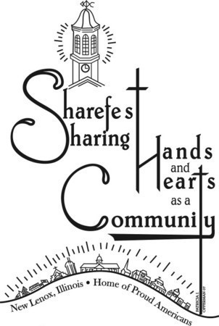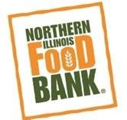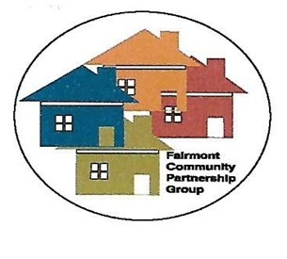

**Fairmont Community Partnership Group**

