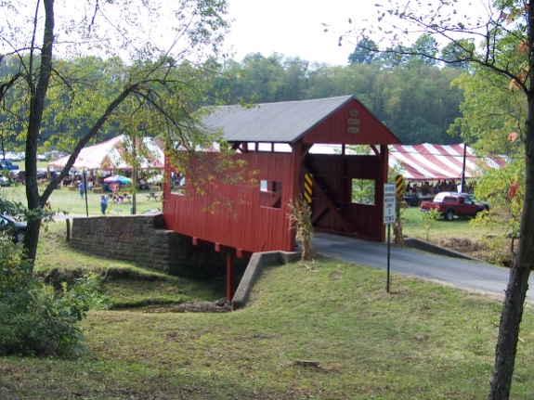
Krepps Covered Bridge Festival
Saturday, September 17, 2016
10:00 a.m. – 6:00 p.m.
Sunday, September 18, 2016
10:00 a.m. – 4:00 p.m.
Calling all Vendors and Crafters

Would you like to be part of the fun?

The Hickory U.E.P. Church will sponsor the Washington and Greene Counties Covered Bridge Festival at the Krepps Covered Bridge for the twelfth year. The Krepps Covered Bridge is a working bridge in a beautiful rural setting near the farming community of Hickory, PA. This is a family friendly venue with a country fair flavor. Attendance been good each year, and based on feedback from attendees and vendors, we are known as a quality event. We have consistently attracted 2000+ guests (2511 by actual count in 2015).

We feature different entertainers on the stage throughout each day, delicious homemade food, an antique tractor show, antique/classic car and truck show, children’s activities, American exploration period plus civil war re-enactors (when available), and, of course, fantastic vendors and crafts. Specific events are subject to change. We have a Church Service at 8:30 a.m. on Sunday. We will continue to improve the quality of all activities in 2016.

We would like to count you and your artistic endeavors as a key part of the 2016 Krepps Covered Bridge Festival. We appeal to quality crafters and home product and personal care vendors and want to provide a great experience for you and our guests. We are limiting vendors to 18 spaces under the Festival tent and another 18+ spaces in Vendor Alley with vendor supplied tents. Spaces under the Festival tent are 8’ x 13’; Vendor Alley spaces are 10’ x 16’. Space under the tent tends to sell out early.

Enclosed is an application for you to fill out and send back to let us know you would like to be a part of the 2016 Festival. Reserve a space under our tent or your own by May 1, 2016 for $40 for the two days; by June 1 the registration is $45; after July 1 registration is $50. First time vendor fee is $40. We will be looking for you – please let us know you are coming!

Return the completed form with your check or money order made out to Hickory U.E.P. Church to:
Suzanne Stewart
2038 Stillwater Lane
McDonald, PA 15057

Hope to hear from you soon,
Suzanne Stewart
Suzanne Stewart
Chair, Vendor Committee,
Krepps Covered Bridge Festival
quiltsuz@aol.com
724-288-5032 (cell)

VENDOR REGISTRATION FORM

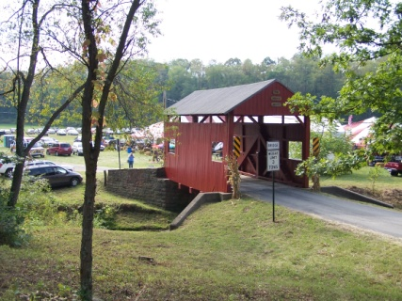
2016 Washington County Covered Bridge Festival
Krepp’s Covered Bridge, Hickory, PA
Saturday, September 17, 2016
10:00 a.m. – 6:00 p.m.
Sunday, September 18, 2016
10:00 a.m. – 4:00 p.m.

Name and/or Name of Business: _____________________________________________________________
Address: ______________________________________________________________
Telephone: _____________________ E-Mail: _________________________

Type of Vendor: Crafts Home or Personal Care

Description of Products Sold:

Number of Spaces: _____ X $40.00 ($45 after May 1, $50 after July 1) Per Space = $_______ Enclosed
Have Tent ____ Need under a Festival Tent____ Will use a generator_____

Special Needs and/or Requests:

Outdoor spaces for your own tent are 10’ X 16’; Festival tent spaces are 8’ X 13’. Sorry No Tables Supplied and No Electricity Available for Craft Tents.
Check or money order payable to: Hickory U.E.P. Church
Payment due date: By May 1 for lowest price
Mail completed form and payment to: Suzanne Stewart
2038 Stillwater Lane
McDonald, PA 15057
Call or e-mail with questions/comments to: 724-288-5032 or quiltsuz@aol.com
Sponsored by: Hickory United Presbyterian Church (www.hickoryup.org)
All Proceeds Benefit the Church Building Fund and Programs

