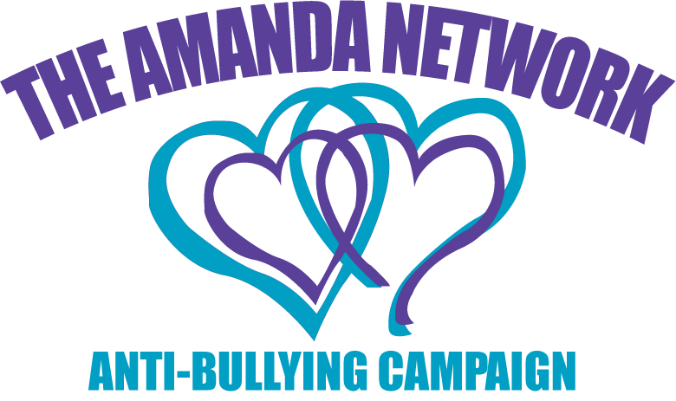
2012 Amanda Network, ABC
Donation Form
Thank you for your support!
I pledge to not allow bullying in my presence. If I don’t report it, I am just as guilty.

The Amanda Network, Anti-Bullying Campaign
Amanda Network, ABC
is a 501 (c) 3 Non-Profit Organization
A benefit on behalf of everyone who has
been bullied, cyber-bullied or sexually
bullied in Santa Clara County and beyond.

Please Print and Complete in Full
Donor:_____________________________________________________________________________
(Individual name, family name or business name as you would like it to be credited)
Contact Name: ______________________________________________________________________
Address:____________________________________________________________________________
City:__________________________ State:________ Zip:_________ Phone:____________________
Email:________________________________ Website:______________________________________

Please Print and Complete in Full
Donation Value $:_____________________________________________________________________
Please provide a thorough description of your donation, including any expiration dates and restrictions. Please be specific and use the back of this form if necessary.
___________________________________________________________________________________
___________________________________________________________________________________
___________________________________________________________________________________
___________________________________________________________________________________
___________________________________________________________________________________
___________________________________________________________________________________
___________________________________________________________________________________
___________________________________________________________________________________

If mailing in your donation, please send to the following address:
The Amanda Network Day of Awareness,
c/o CPUMC 1919 Gunston Way, San Jose, CA 95124.

Please attach this form to your donation and deliver no later than August 3 to CPUMC. Donations received after August 3, 2012 may not be credited in the program due to time constraints. Email: Info@AmandaNetwork.org

Donations are tax deductable as allowed by law. (Tax I. D. 94-6034786) Event Date: August 18, 2012.
Questions? Contact: Ann Brownell (408) 507-2787 or Stefanie McKeowan (408) 796-2428

