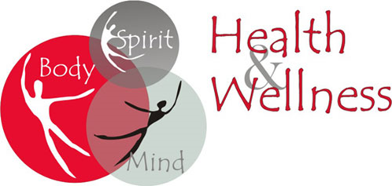
FREE
Massages
Zumba
Aerobics

FAIR
May 19, 2018 ▪ 8:30am-1:00pm

Other Activities

Screening to be eligible for a $10 Oral Health check-up
Screening to be eligible for a $25 Breast Health Education Session
Men's clothing/suits give away

Event Schedule

8:30am-Mission Muffins and registration
9:00am-Devotions and Welcome
9:15am-Zumba Class
10:00am-Learning Moment: Mind/Body Panel
10:30am-Massages and screening sign-ups (Georgetown University)
11:30am- Cooking Class Presentation by Gaurav Singh Cooking Class

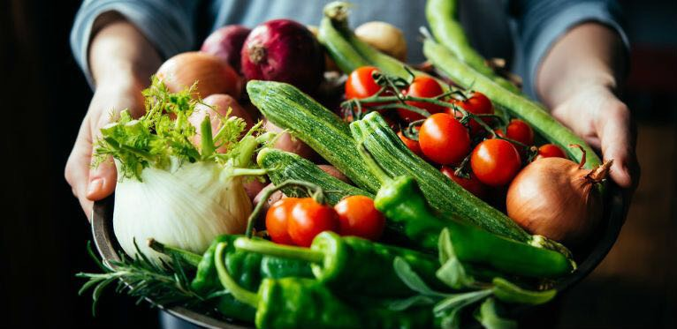

Cooking Class

(Plant-based)
Mind body connection and Cooking Class by Going Yogue

Mount Airy Baptist Church
1100 North Capitol Street, NW
Washington, DC 20002
202-789-0640
www.mountairybaptist.org
Dr. L.B. West, Senior Pastor

