3. The Supplication (v. 34).

Ephphatha is an Aramaic word. Mark provides an interpretation for his largely non-Jewish audience. (The Nelson Study Bible, Page 1657)

4. The Manifestation (v. 35).

This account of a unique healing is found only in the Gospel of Mark. The Lord’s procedure is unlike any other recorded healings. In all likelihood Jesus had particular teaching objectives in mind. (The Women’s Study Bible, Page 1661)

D. The People (Vs. 36). 36 Jesus commanded them not to tell anyone. But the more he did so, the more they kept talking about it. 37 People were overwhelmed with amazement. "He has done everything well," they said. "He even makes the deaf hear and the mute speak." (NIV)

1. The Request - Don’t Tell It (v. 36a).

Jesus’ command to tell no one, though unheeded, was meant to allow Him to move freely in the area. He knew that curiosity seekers could hamper His ministry. (The Nelson Study Bible, Page 1657)

2. The Response – They Told It (vs. 36b-37).

Jesus asked the people not to talk about his healing, because he didn’t want to be seen simply as a miracle worker. He didn’t want the people to miss his real message. We must not be so concerned about what Jesus can do for us that we forget to listen to his message. (Life Application Bible, Page 1745)

III. CLOSE – Jesus did all things well during His earthly ministry and He is still doing things well as He sits on the right hand of the Father interceding for us. When we fully submit to God’s purpose and plan for our lives, things will turn out well because God does all things well. He’ll use whatever has happened to us for our good and His glory.

RISING STAR MISSIONARY BAPTIST CHURCH
2800 E. 36th Street

Tucson, AZ 85713

Sermon Notes

May 24, 2015

He Does All Things Well
Mark 7:31-37

Sermon Notes: www.risingstarbaptist.org
Podcasting: www.allewisministries.org

Vision: A Local Church with a Global Reach
Motto: One Mind, One Heartbeat, One Direction.

Rev. Amos L. Lewis
Senior Pastor

He Does All Things Well
Mark 7:31-37

I. INTRODUCTION – What a testimony for some to say of you and me, “He or she does all things well.” Jesus had that effect on people. Everything He did, He did it well. He lived well. He taught well. He preached well. He healed well. He raised the dead well. He cleansed the lepers well. He cast out demons well. He forgave sinners well. He died well and most of all He got up well. As you read the Gospels, you should come to the conclusion that Jesus operated in a spirit of excellence. Since we are Christians, we represent Christ so we should operate in a spirit of excellence and do all things well. What we can’t do well, we need to let somebody else do it. However, I’ve noticed a lot of Christians have a tendency to fight the spirit of excellence but operating in a spirit of excellence is biblical. In fact, both Joseph and Daniel operated in the spirit of excellence. That’s why they kept getting promoted. We must remember when we do the natural, that’s when God will step and do the supernatural. What are you doing for the kingdom of God and for humanity?

II. EXPOSITION OF THE TEXT – As we come to our text, we see the people did their part, the natural, they brought the man to Jesus. Then Jesus did His part, the supernatural, he healed the man. This is called balance in ministry. You can’t do it all and God won’t do it all.

A. The Place (V. 31). 31 Then Jesus left the vicinity of Tyre and went through Sidon, down to the Sea of Galilee and into the region of the Decapolis.

1. The Place He Exited (v. 31a).

Jesus traveled 20 miles north from Tyre and passed through Sidon, which was deep into Gentile territory. From there He went east, crossed the Jordan, and traveled south along the eastern shore of the Sea of Galilee. (The MacArthur Study Bible, Page 1475)

2. The Place He Entered (v. 31b).

Decapolis – a confederation of 10 Helllenized cities south of Galilee and mostly east of the Jordan. The league of cities was formed shortly after Pompey’s invasion of Palestine (ca. 64 B.C.) to preserve Greek culture in the Semitic region. These cities were naturally Gentile strongholds. (The MacArthur Study Bible, Page 1399)

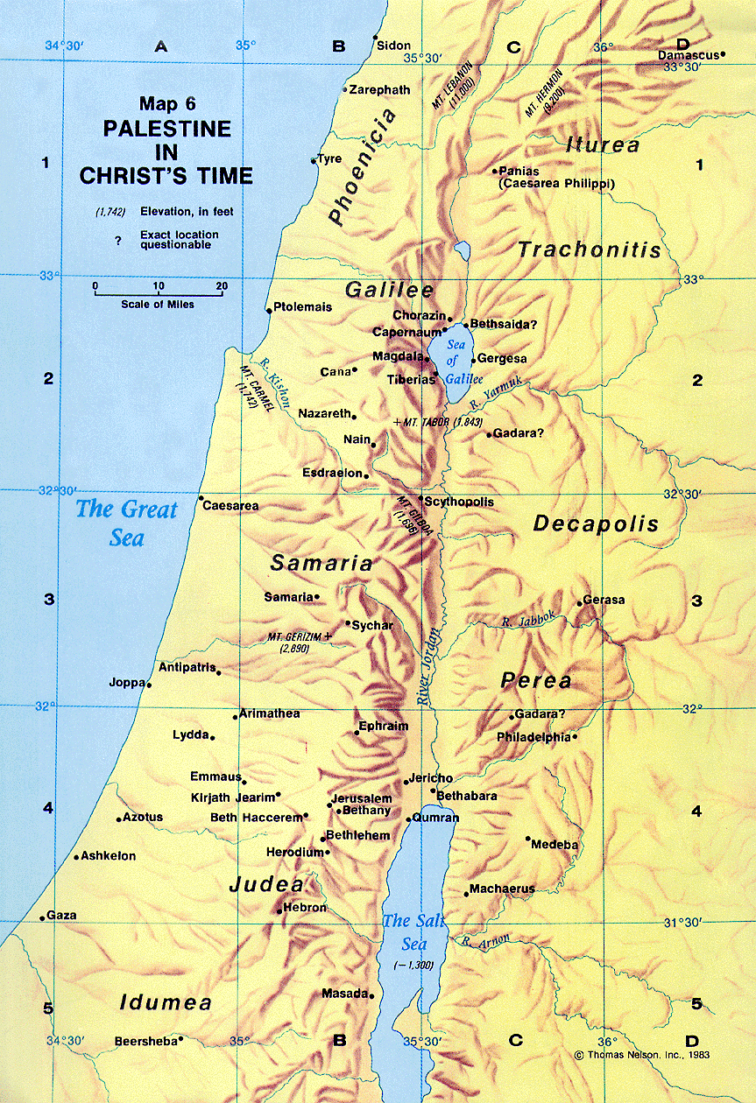

B. The Problem (V. 32) 32 There some people brought to him a man who was deaf and could hardly talk, and they begged him to place his hand on the man.
1. Their Friend (v. 32a).
2. Their Faith (v. 32b).

C. The Procedure (Vs. 33-35). 33 After he took him aside, away from the crowd, Jesus put his fingers into the man's ears. Then he spit and touched the man's tongue. 34 He looked up to heaven and with a deep sigh said to him, "Ephphatha!" (which means, "Be opened!"). 35 At this, the man's ears were opened, his tongue was loosened and he began to speak plainly.
1. The Separation (v. 33a).
2. The Medication (vs. 33b).

