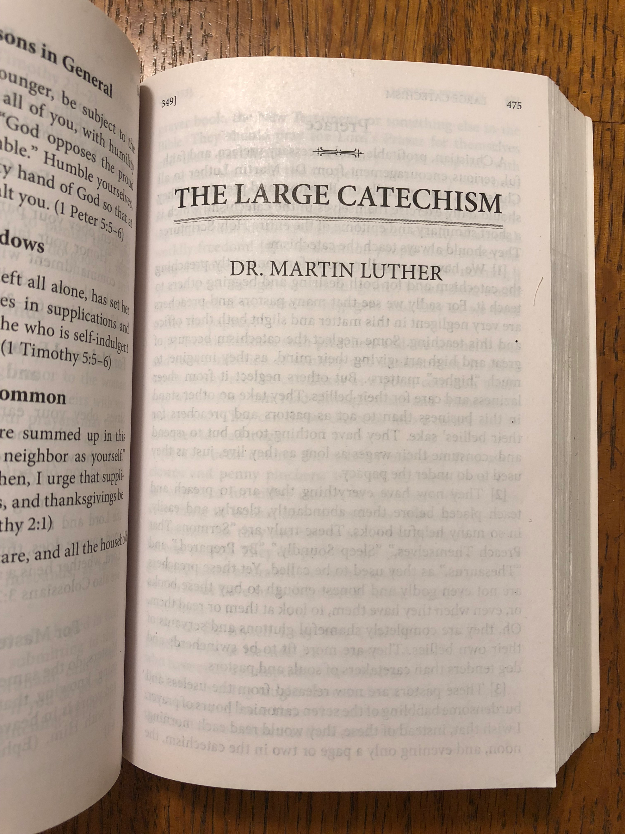
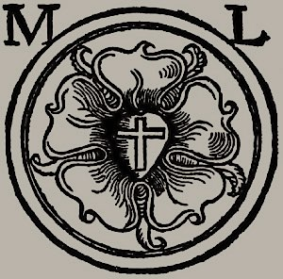
Gearing Up
With Luther’s Large Catechism
- refresh yourself on the foundational Christian teachings
- explore just how doctrine connects with life
- encounter Luther’s genius in an approachable way

Thursdays 6:30-7:45pm
Starting January 24th

To REGISTER, submit the “Order Form” (next page)
by Sunday January 13th (you will need a copy of
Concordia: The Lutheran Confessions)

Questions? ask Pastor Colter
knippac@ZionLutheranNH.org 916-332-4001

Not yet a member with Zion?
or
Know someone you would be glad to see partner in mission with us?

Talk with Pastor Colter about
Order Form
Intro to Zion
(launching January 24th)

knippac@ZionLutheranNH.org 916-332-4001

Concordia: The Lutheran Confessions

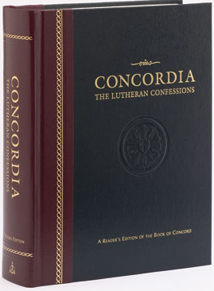
Choose ONE of these options:
- Hardback (standard) $35
- Paperback edition $25
- Pocket edition $19
- Deluxe Pocket edition $35
Scholarships available
(talk with Pastor Colter)

Your Name: ____________________________

Order through the church office
(Zion will cover tax and shipping fees)
- Fill out the form above
- Bring in this form by Sunday January 13, 2019
- Provide the designated dollar amount above

OR
Feel free to order a copy on your own (available at cph.org)
— still let Pastor Colter know that you want to participate
— note: Electronic editions are also available for $19 in Kindle or iBook formats

