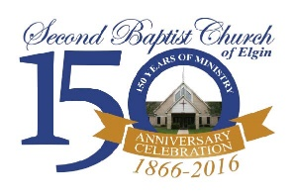
One Faith. One Ministry. One Church.

Second Baptist Church of Elgin
Job Description – Pastor

Primary function. — To provide kingdom leadership to the members of this church enabling them to focus on the Great Commission, and equipping them to carry out the five functions of the New Testament church: evangelism, discipleship, ministry, fellowship, and worship.

RESPONSIBILITIES

Leading. — In consultation with God and in collaboration with the Deacon Ministry, the pastor will establish the vision annually for this body of believers. The pastor will lead and develop the ministerial staff in equipping the congregation to fulfill the Great Commission and accomplish the purpose statement of this church. The pastor will lead and equip the body of deacons so they can effectively lead the ministry of the church. The pastor will provide leadership, direction and operational support to the ministry and ministries of the church.
Administering. — The pastor will administer the ministerial staff of the church. The pastor will administer the policies and procedures of the church.
Ministering. — The pastor will use his spiritual gifts to edify and build this local body of believers. The pastor will provide appropriate pastoral care to members of the church and the community and will equip the members of the ministerial staff and the deacon body to do the same.
Communicating. — The pastor will preach and teach the Bible, believing that it has God for its author, salvation for its end, and truth without any mixture of error for its matter. The pastor will communicate the vision for ministry that God gives to this congregation.

EXPECTATIONS

The pastor is expected to be a servant leader. The pastor is expected to live an exemplary life modeling the call, character, and competencies becoming a minister of the gospel of Jesus Christ. The pastor is expected to be active in the local community. The pastor will demonstrate a servant spirit as a growing disciple of Jesus Christ.

