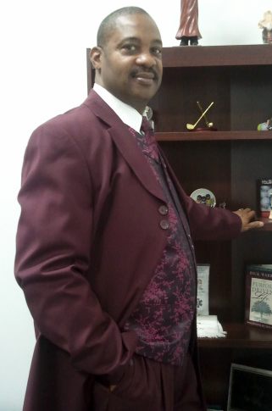
ST. TITUS ONE POWER WORD
OCTOBER, 2015
“Scary Economics”
“Scary” is defined as: causing fright or alarm. And “Economics” is defined as: financial considerations; economically significant aspects. With these definitions one could easily say that their current state of finances exhibit “Scary Economics”.
“Scary Economics”
Why are we suffering this way? One could without much hesitation suggest that the government is to blame. In fact every country right now is having similar effects economically. To what should we really pinpoint as the culprit of our “Scary Economics”?
“Scary Economics”
Well you know me, Let’s see what the Bible says regarding these types of happenings, In Matthew 6:21 it answers “for where your treasure is, there your heart will be also”, in fact another answer lies in Matthew 6:19-20 “Lay not up for yourselves treasures upon the earth, where moth and rust doth corrupt, and where thieves break through and steal: But lay up for yourselves treasures in heaven, where neither moth nor rust destroys, and where thieves do not break in and steal.”
“Scary Economics”
The problem seems to be that your heart is not with our God so he’s not interested in protecting your finances. The whole world including us have turned to our own imaginations and away from the ways of our creator, so why do expect him to protect what does not appear to want protecting? We make many plans to spend economics that he supplied on any and everything but the work of the Lord. Where is our true Tithes and Offerings as prescribed in the book of Malachi?
“Scary Economics”
When we come back to our God for real, the manifestation of blessed finances and more will be present. Don’t just come to Church, be the Church.
*************************************************************************
St. Titus One M. B. Church 12257 S. Emerald Avenue Chicago, IL 60628
773-785-5530 www.sttitusone.com
Sunday School: 9 a.m. Sunday Morning Worship: 11 a.m.
Evening Service: 6:30 p.m. Mid-Week Bible Study: Wed. – 6:30 p.m. Saturday Bible Study – 1:00 p.m.
This message was brought to you by Rev. Michael A. Jones, I., Pastor, St. Titus One M. B. Church. If you were blessed by this message, please pass it on. And if you’re not a member of any church, we invite you to join us for our services as specified above. We will be blessed by your presence as we love visitors and new members. To be added to our email list, please email us at sttitusone@sbcglobal.net

