

**February 25:** All Church Business Mtg-12:15—Ministry Center

**February 25:** Beyond the Walls Uth-6pm—Ministry Center

**February 27:** Community group hosts and leaders mtg.—7PM

**March 10:** ENGAGE Night of Praise and Prayer

**March 21:** Messiah in the Passover-7pm—Ministry Center

Rev. Paul D. Allen II – Lead Pastor

Deacons –Kenny Montlick, Mark Riccio, Randall Roach

Prayer Request: ________________________________________________________________________________________

My Family

Marital Status___________________

Spouse’s Name__________________

Children’s Names/Ages

__________________________________

I’d like more info about…

☐Membership @ SCC ☐Serving @ SCC

☐Adult Community Groups

☐Women’s Ministry ☐Youth Ministry

☐Children’s Ministry

***Sunday, February 25th***

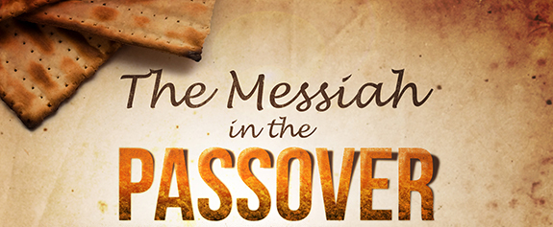

**Adult Sunday School:** 9 AM-Theater 12

**Worship Experience:** 10:00 AM – Better: “Jesus is Greater than our Weakness”

**Refreshments:** Carmen, Cinzia

**Splash Kids: Guppies—** Kimmie W. **Turtles**— Carol L**. Swordfish**— Sarah S.

**Barracudas—** Glori B.  **Lifesavers—** Abby & Sam **Media:** Daniel B.

**Sign In/Out:** Patti M. **Opener:** Sarah S.

**Beyond the Walls Student Ministries:** 6PM Ministry Center

**Messiah in the Passover Demonstration** –Wed March 21st—7 PM at the Ministry Center.

We are really excited to host Richard Flashman who will be presenting Messiah in the Passover. This evening will be open to all, so feel free to bring some friends! The evening will be instructive and participatory.

☐ Plan on me/us at the Messiah in the Passover Demonstration, March 21st.

Number attending

All Sign ups must be accompanied with, at least, a name and email address on the opposite side of this form

Sign Me Up

***Tuesday, February 27th***

**What is a Community Group?**

Community Groups are (1) small groups of people (2) sharing life together (3) with the aim of growing spiritually (4) through authentic relationships.

A Community Group consists of 6 - 12 adults who are meeting together regularly, continually encouraging one another to mature in their faith, and serving to meet one another’s needs. In Community Groups we experience care and accountability in the context of authentic relationships.

A Community Group seeks to be a balance of the following five areas:

1. Bible Study

2. Fellowship

3. Prayer

4. Accountability

5. Service

***Community Groups will re-launch the week of March 18th! We will post locations and sign ups very soon. Stay tuned!***

**Prayer:** 6AM & 8AM—Meet at the Ministry Center—53 School Ground Rd.

**Community Group leaders and hosts Mtg:** *7PM Ministry Center—9 Business Park Dr.*

Recently I have

☐Become a follower of Jesus

☐Received the baptism of the Holy Spirit

☐Shared my faith in Christ with someone

☐Begun daily prayer and Bible reading

☐Decided that I can serve God and others

by_______________________________

***Wednesday, February 28th***

My Spiritual Journey

**Team Leader’s Meeting: 7PM**—Ministry Center



**Adult Sunday School:** 9 AM-Theater 12

**Worship Experience:** 10:00 AM – Better: “Jesus is Greater than our Failures”

**Refreshments:** Reta, Becky, Cathy

**Splash Kids:** **Guppies**— Sylvia C. **Turtles**— Steph G. **Swordfish—** Meagan R.

**Barracudas—** Laurie A. **Lifesavers—** Michelle & Gabby **Media:** Andrew P.

**Sign In/Out:** Sarah S. **Opener:** Laurie A.

**Beyond the Walls Student Ministries:** 6PM Ministry Center

***Sunday, March 4th***

***`***

**Young Adults Group: 7:30PM—**Bud and Becky Allen’s house- 745 Robert Frost Dr. Branford

***Friday, March 2nd***