

**March 4:** Beyond the Walls Uth-6pm—Ministry Center

**March 6:** Community group hosts and leaders mtg.—7PM

**March 10:** ENGAGE Night of Praise and Prayer

**March 12:** Deacon’s Mtg.

**March 18:** Splash Kids Team Leaders Mtg. –12:30 Ministry Center

**March 21:** Messiah in the Passover-7pm—Ministry Center

Rev. Paul D. Allen II – Lead Pastor

Deacons –Kenny Montlick, Daniel **Patenaude,** Randall Roach

Prayer Request: ________________________________________________________________________________________

My Family

Marital Status___________________

Spouse’s Name__________________

Children’s Names/Ages

__________________________________

I’d like more info about…

☐Membership @ SCC ☐Serving @ SCC

☐Adult Community Groups

☐Women’s Ministry ☐Youth Ministry

☐Children’s Ministry

***Sunday, March 4th***

**Messiah in the Passover Demonstration** Wed March 21st—7 PM at the Ministry Center.

We are really excited to host Richard Flashman who will be presenting Messiah in the Passover. This evening will be open to all, so feel free to bring some friends! The evening will be instructive and participatory.

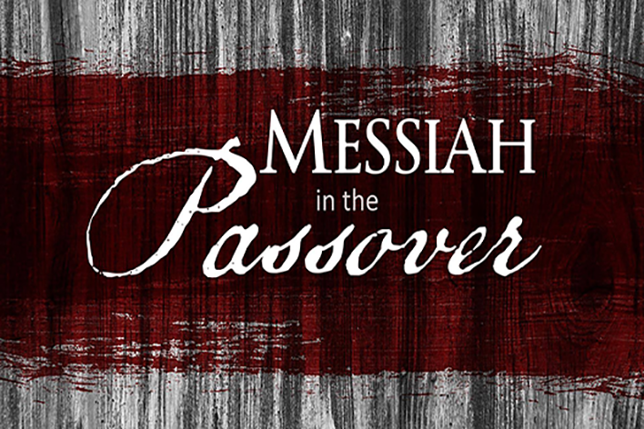

**Adult Sunday School:** 9 AM-Theater 12

**Worship Experience:** 10:00 AM – Better: “Jesus is Greater than our Failures”

**Refreshments:** Reta, Becky, Cathy

**Splash Kids:** **Guppies**— Sylvia C. **Turtles**— Steph G. **Swordfish—** Meagan R.

**Barracudas—** Laurie A. **Lifesavers—** Michelle & Gabby **Media:** Andrew P.

**Sign In/Out:** Sarah S. **Opener:** Laurie A.

**Beyond the Walls Student Ministries:** 6PM Ministry Center

☐ Plan on me/us at the Messiah in the Passover Demonstration, March 21st.

Number attending

All Sign ups must be accompanied with, at least, a name and email address on the opposite side of this form

Sign Me Up

***Tuesday, March 6th***

Recently I have

☐Become a follower of Jesus

☐Received the baptism of the Holy Spirit

☐Shared my faith in Christ with someone

☐Begun daily prayer and Bible reading

☐Decided that I can serve God and others

by_______________________________

**Prayer:** 6AM & 8AM—Meet at the Ministry Center—53 School Ground Rd.

**Community Group Leaders and Hosts Mtg:** *7PM—9 Business Park Dr.*

My Spiritual Journey

***Friday, March 9th***

**Community Groups begin in 2 weeks!**

***Community Groups will re-launch the week of March 18th! We will post locations and sign-ups next Sunday!***

**Young Adults Group: 7:30PM—**Bud and Becky Allen’s house- 745 Robert Frost Dr. Branford

There will be 4 community groups happening at different times and places. Please contact Pastor Paul if you have any questions.



**Work Day:** 9AM-3PM—New Building 9 Business Park Dr.

**ENGAGE Prayer & Praise Night:** 7PM—Ministry Center

***Saturday, March 10th***

***`***

**WORKDAY THIS SATURDAY!**

Our next big workday at the new building is THIS SATURDAY-March 10th 9am-3pm! We will start painting, so if you can paint, we need your help!

Almost all of the 5,000 square feet of space will need painting so we’re going to need lots and lots of help. So if you can help for 1 hour or 6, we can use you!

**Adult Sunday School:** 9 AM-Theater 12

**Worship Experience:** 10:00 AM – Better: “Jesus is Greater than the Cross”

**Refreshments:** Ruth, Lina

**Splash Kids:** **Guppies**— Lina C. **Turtles**— Patti M. **Swordfish—** Cathy R.

**Barracudas—** Kenny M. **Lifesavers—** Abby & Sam **Media:** Daniel B.

**Sign In/Out:** Laurie A. **Opener:** Kenny M.

**Beyond the Walls Student Ministries:** 6PM Ministry Center

***Sunday, March 11th***

***`***

