**The Apostles Post**

26238 North Highway 59

Wauconda, Illinois

SEPTEMBER 2014



**FROM THE VICAR'S DESK** *(M. C. Gillette)*

**WHERE IN THE WORLD IS (MOTHER) MARTHA? – PART 3** *(M. C. Gillette)*

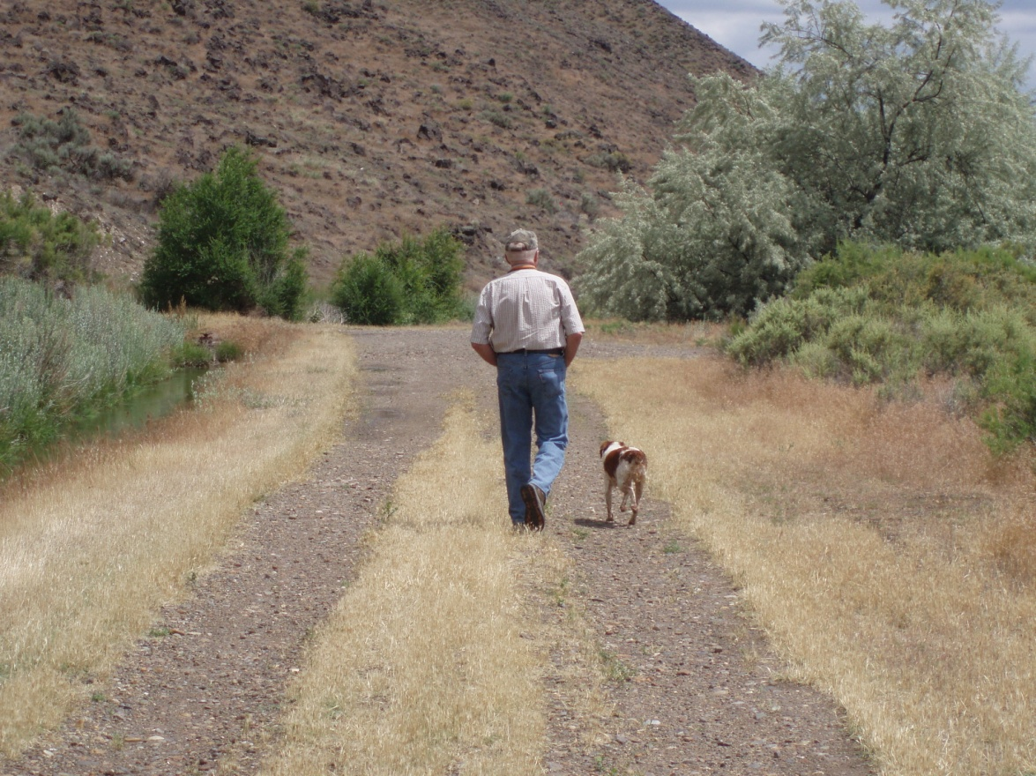

With the continuing caveat of 'if all is going according to plan,' when this issue of The Apostles Post is published, I'll be finishing up my sabbatical time in Chile and heading to Idaho where – for reasons that continue to escape me, as I cannot for the life of me figure out why anyone would actually choose to live there– my parents, sons, and grandson reside.

Now I know that parts of Idaho are beautiful. Snow-capped mountains, roaring rivers, all sorts of wild and tangled beauty. But nobody *I* know actually lives in the beautiful parts of Idaho. Everybody *I* know lives in a part of Idaho which is dusty, dry, barren high desert, interrupted here and there by scrub brush, various invasive species of flora, and tumbleweeds. If you leave my parents' neighborhood (that's my father in the picture, walking one of the dogs) and turn right, you can drive about 250 miles before seeing a traffic light, although depending on the time of year you might very well be stopped by shepherds driving their flocks across the road. (To be fair, if you turn left, you don't have to go too far before encountering a traffic signal. There's one just a few miles down the road, controlling the comings and goings to – the sugar beet processing plant.)

I make fun of Idaho, but of course I go there, because for better or worse, I have family there. And family – however you identify it, however it's constituted, by blood or law or affinity or some combination thereof – is important. It's important because our personal identities are firmly and unavoidably rooted in our relationships.

I have borrowed these words from an article I read recently by one of my favorite pastoral people, David Lose, because they make my point simply and well. Identity, Professor Lose notes, is deeply, profoundly, and irrevocably relational. We tend to think it is something highly personal, something we develop, discover, or even create on our own – "I need some space to be me" – "I took some time away to find myself" – but just about anything we can say about ourselves ultimately involves others. "My" identity, as it turns out, ultimately emerges from the nexus of relationships I enjoy with countless others. If you think about it, we can't even be reclusive hermits without other people to exclude and isolate ourselves from!

*How* we decide who we are in great part determines the 'who'. Do we define ourselves first and foremost based on socio-cultural forces and indicators, or based on the fact that we are children of the Living God and brothers and sisters in Christ? I think this is one of the questions our scriptures are attempting to get us to consider when they talk about serpents in the Garden and Satan in the wilderness and kings and 'scribes and Pharisees' and so forth. The serpent, for example, invites Adam and Eve to craft their own identities independent of God. Satan tempts Jesus to ignore the identity he has just been given at his baptism (as God declares 'This is my Son’) and replace it with an identity of his own making. The elites – Herod and Caiaphas and the members of the Sanhedrin, base not only their identities, but the identities of those for whom they presume to speak, on a set of rules of their own making. People who don't follow these rules are deemed to be troublemakers, 'outliers' who threaten to undermine society and the control over it the elite enjoy. People who root and ground their identities somewhere other than the 'norm' do so at a very high cost. And yet... that's just what Jesus did. And it's what Jesus calls us to do.

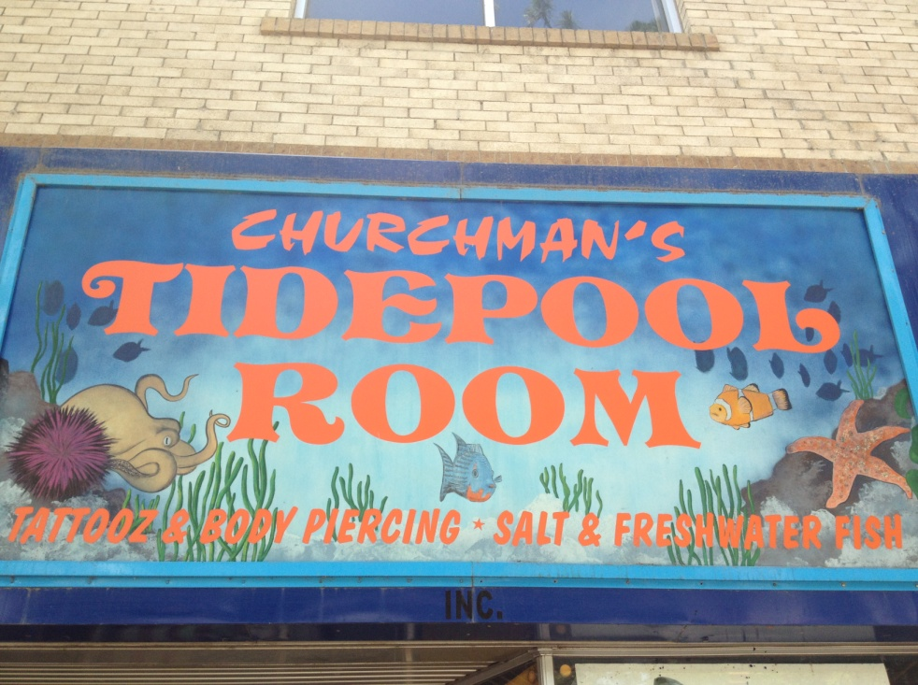

The people who show up on our 'family trees' when we do our genealogies are, indeed, hugely important to us, whether we see them every day or have never met them; because somehow, at some point, they have influenced our lives. If we are lucky, we love these people. If we are really lucky, we even like them – enough to go, on purpose, to a place where 'downtown' features enterprises such as 'Churchman's Tidepool Room,' where you can get tattoos, piercings, AND salt and freshwater fish all in one convenient location.

But no matter how fond we are of our 'families,' if our identities are not first and foremost as children of God, we will have a difficult time becoming who we were ultimately meant to be. Scripture reminds us that once, "While Jesus was still speaking to the crowds, his mother and his brothers were standing outside, wanting to speak to him. Someone told him, “Look, your mother and your brothers are standing outside, wanting to speak to you." But to the one who had told him this, Jesusreplied, “Who is my mother, and who are my brothers?” And pointing to his disciples, he said, “Here are my mother and my brothers! For whoever does the will of my Father in heaven is my brother and sister and mother.”(Matthew 12:46-50)

My brothers and sisters – I will see you soon!

---------------------------------------------------------------------------------------------------------------------------------------------------

**SOME CHURCHY STUFF** *(M. C. Gillette)*

*In this monthly article, we look at terms and definitions of things you might see or hear around church. Nothing fancy here – these entries are out of the Armentrout/Slocum An Episcopal Dictionary of the Church, sometimes supplemented by me, and sometimes simply copied directly. If something in particular piques your interest, let me know, and we’ll deal with it in more depth.*

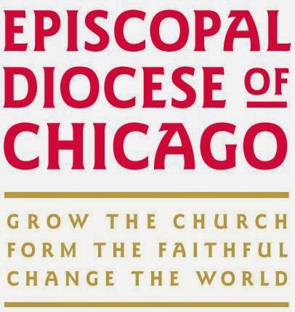**CHICAGO, DIOCESE OF.** Yup, we're in the Episcopal Dictionary! Here's what it has to say about us: The primary convention of the Diocese of Illinois met at the 'Episcopal Hall of Worship' in Peoria, 09 March 1835. The General Convention *(the big, triannual meeting of all the Episcopal churches in the country)* of 1877 voted to divide the Diocese of Illinois into three dioceses – Illinois, Quincy, and Springfield. The name of the Diocese of Illinois was changed to the Diocese of Chicago on 28 May 1884. On 04 March, 1861, the Church of the Atonement, Chicago became the Cathedral Church of St. Peter and St. Paul. It was destroyed by fire on 06 March 1921. On 02 December 1928, St. James Church, Chicago, was designated as the Cathedral, but this arrangement was terminated in 1931. St. James' Church, Chicago, was again designated the Cathedral on 03 May, 1955, and was formaly set apart on 04 June 1955. The Diocee of Chicago consists of the following counties: Boone, Carroll, Cook, DeKalb, Dupage, Ford, Grundy, Iroquois, Jo Daviess, Kane, Kankakee, Kendall, Lake, LaSalle, lee, Livingston, Marshall, McHenry, Ogle, Putnam, Stephenson, Whiteside, Will, and Winnebago.

**CHICAGO-LAMBETH QUADRILATERAL.** This is a statement of the four Anglican essentials for a reunited Christian Church. It concerns the scriptures, creeds, sacraments, and the historic episcopate. It was approved by the House of Bishops at the 1886 General Convention *(as noted above, the 'y'all come' convention of the whole Episcopal church convened once every three years)*, which was held in Chicago, and subsequently approved with modifications by the bishops of the Anglican Communion at the Lambeth Conference of 1888.  *(Lambeth Palace is the official London residence of the Archbishop of Canterbury in England, in North Lambeth, on the south bank of the River Thames. Lambeth Conferences are decennial (once every 10 years) assemblies of all the bishops in the world-wide Anglican Commnion convened by the Archbishop of Canterbury.)*

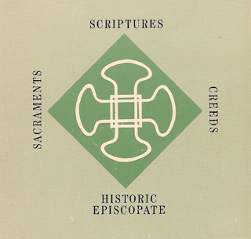 A primary source for the Quadrilateral was *The Church-Idea, An Essay Towards Unity* (1870) by William Reed Huntington (1838-1090), and Episcopal priest. He indicated the Anglican basis for an ecumenical 'Church of the Reconciliation' in America should be acceptance of (1) the Holy Scriptures as the Word of God; (2) the Nicene Creed as the rule of faith; (3) the two sacraments ordained by Christ himself (baptism and the eucharist); and (4) the episcopate as the keystone of governmental unity in the church. This 'foursquare' approach became known as the 'Quadrilateral.' Huntington was the moving force behind its approval by the House of Bishops in Chicago.

The Chicago version of the Quadrilateral provides an ecumenical statement of purpose and introduction which states that the Episcopal Church is 'ready in the spirit of love and humility to forego all preferences of her own' concerning things of human ordering or choice regarding modes of worship, discipline, and traditional customs. However, the statement of purpose warns that Christian unity 'can be restored only by the return of all Christian communions to the principles of unity exemplified by the undivided Catholic Church during the first days of its existence.'

The four points of the Quadrilateral were listed by the Chicago statement as 'inherent parts' of the sacred deposit of Christian faith and order 'committed by Christ and his Apostles to the Church unto the end of the world, and therefore incapable of compromise or surrender....' The Chicago statement lists the Nicene Creed as the sufficient statement of the Christian faith. With respect to baptism and the eucharist, the Chicago statement calls for administration of these sacraments 'with unfailing use of Christ's words of institution and of the elements ordained by Him.' The Chicago version expressed the fourth part of the Quadrilateral in terms of 'The Historic Episcopate, locally adapted in the methods of its administration to the varying needs of the sations and peoples called of God into the unity of His Church.' Although the Quadrilateral was not enacted by the House of Deputies at the 1886 General Convention, it was incorporated in a general plan referred for study and action by the newly created Joint Commission on Christian Reunion.

The Quadrilateral was passed in a modified form as 'Resolution II' of the Lambeth Conference of 1888. At Lambeth the four essential 'parts' were termed 'Articles.' The introductory statement of purpose of the Chicago version of the Quadrilateral was deleted and replaced by a simple statement that the four Articles 'supply a basis on which approach may be by God's blessing made towards Home Reunion.....' The Lambeth version states that the scriptures provide 'the rule and ultimate standard of faith.' The Lambeth text affirms the Nicene Creed as the 'sufficient statement of the Christian faith’,but also adds the 'Apostles' Creed, as the Baptismal Symbol' to the creedal article of the Quadrilateral. The Lambeth version adds the statement that the cominical sacraments of Baptism and Eucharist were 'instituted by Christ himself’. The article concerning the historic episcopate was not changed at Lambeth.

At the 1985 General Convention of the Episcopal Church, the Commission on Christian Unity was continued with the goal of seeking Christian unity on the basis of the 'principles enunciated throughout the Declaration of the house of Bishops made at Chicago in 1886, and as reaffirmed by the Lambeth Conference of 1888'. Thus for the first time the entire General Convention of the Episcopal Church affirmed the Quadrilateral in its Lambeth form. The Chicago-Lambeth Quadrilateral has continued to serve as the primary Anglican working document and reference point for ecumenical Christian reunion. The Chicago and Lambeth versions of the Quadrilateral are included in the 'Historical Documents' section of your Book of Common Prayer (pp. 876-78), but are copied here:

**The Chicago-Lambeth Quadrilateral 1886, 1888**

*Adopted by the House of Bishops Chicago, 1886*

We, Bishops of the Protestant Episcopal Church in the United States of America, in Council assembled as Bishops in the Church of God, do hereby solemnly declare to all whom it may concern, and especially to our fellow-Christians of the different Communions in this land, who, in their several spheres, have contended for the religion of Christ:

1. Our earnest desire that the Saviour’s prayer, “That we all may be one,” may, in its deepest and truest sense, be speedily fulfilled;

2. That we believe that all who have been duly baptized with water, in the name of the Father, and of the Son, and of the Holy Ghost, are members of the Holy Catholic Church;

3. That in all things of human ordering or human choice, relating to modes of worship and discipline, or to traditional customs, this Church is ready in the spirit of love and humility to forego all preferences of her own;

4. That this Church does not seek to absorb other Communions, but rather, co-operating with them on the basis of a common Faith and Order, to discountenance schism, to heal the wounds of the Body of Christ, and to promote the charity which is the chief of Christian graces and the visible manifestation of Christ to the world;

But furthermore, we do hereby affirm that the Christian unity . . . can be restored only by the return of all Christian communions to the principles of unity exemplified by the undivided Catholic Church during the first ages of its existence; which principles we believe to be the substantial deposit of Christian Faith and Order committed by Christ and his Apostles to the Church unto the end of the world, and therefore incapable of compromise or surrender by those who have been ordained to be its stewards and trustees for the common and equal benefit of all men.

As inherent parts of this sacred deposit, and therefore as essential to the restoration of unity among the divided branches of Christendom, we account the following, to wit:

1. The Holy Scriptures of the Old and New Testament as the revealed Word of God.

2. The Nicene Creed as the sufficient statement of the Christian Faith.

3. The two Sacraments,—Baptism and the Supper of the Lord,—ministered with unfailing use of Christ’s words of institution and of the elements ordained by Him.

4. The Historic Episcopate, locally adapted in the methods of its administration to the varying needs of the nations and peoples called of God into the unity of His Church.

*Furthermore*, Deeply grieved by the sad divisions which affect the Christian Church in our own land, we hereby declare our desire and readiness, so soon as there shall be any authorized response to this Declaration, to enter into brotherly conference with all or any Christian Bodies seeking the restoration of the organic unity of the Church, with a view to the earnest study of the conditions under which so priceless a blessing might happily be brought to pass.

*Note: While the above form of the Quadrilateral was adopted by the House of Bishops, it was not enacted by the House of Deputies, but rather incorporated in a general plan referred for study and action to a newly created Joint Commission on Christian Reunion.*

***Lambeth Conference of 1888 Resolution 11:***

That, in the opinion of this Conference, the following Articles supply a basis on which approach may be by God’s blessing made towards Home Reunion:

(a) The Holy Scriptures of the Old and New Testaments, as “containing all things necessary to salvation,” and as being the rule and ultimate standard of faith.

(b) The Apostles’ Creed, as the Baptismal Symbol; and the Nicene Creed, as the sufficient statement of the Christian faith.

(c) The two Sacraments ordained by Christ Himself—Baptism and the Supper of the Lord – ministered with unfailing use of Christ’s words of Institution, and of the elements ordained by Him.

(d) The Historic Episcopate, locally adapted in the methods of its administration to the varying needs of the nations and peoples called of God into the Unity of His Church.

|  |  |  |  |
| --- | --- | --- | --- |
| **UPCOMING SERVICES – CHURCH OF THE HOLY APOSTLES – SEPTEMBER 2014** | | | |
| Sunday  07 September  9:30 a.m. | Sunday  14 September  9:30 a.m. | Sunday  21 September  9:30 a.m. | Sunday  28 September  9:30 a.m. |
| Scheduled  Presider: Schaefer  Preacher: Schaefer | Scheduled  Presider: Schaefer  Preacher: Schaefer | Scheduled  Presider: Schaefer  Preacher: Schaefer | Scheduled  Presider: Gillette  Preacher: Gillette |
| 13th Sunday after Pentecost  Proper 18 (A) | 14th Sunday after Pentecost  Proper 19 (A) | 15th Sunday after Pentecost  Proper 20 (A) | 16th Sunday after Pentecost  Proper 21 (A) |
| FIRST LESSON:  Exodus 12:1-14  RESPONSE:  Psalm 149  SECOND LESSON:  Romans 13:8-14  GOSPEL:  Matthew 18:15-20 | FIRST LESSON:  Exodus 14:19-31  RESPONSE:  Psalm 114  SECOND LESSON:  Romans 14:1-12  GOSPEL:  Matthew 18:21-35 | FIRST LESSON:  Exodus 16:2-15  RESPONSE:  Psalm 105:1-6, 37-45  SECOND LESSON:  Philippians 1:21-30  GOSPEL:  Matthew 20:1-16 | FIRST LESSON:  Exodus 17:1-7  RESPONSE:  Psalm 78:1-4, 12-16  SECOND LESSON:  Philippians 2:1-13  GOSPEL:  Matthew 21:23-32 |

**IN OUR** **PARISH LIFE**

**CHURCH OF THE HOLY APOSTLES  
ANNUAL RUMMAGE SALE - REQUEST FOR DONATIONS**

**Sale Dates: Friday Sept 19 from 10am-6pm and**

**Saturday Sept 20 from 8am-3pm**

Dig deep into your closets, dresser drawers, kitchen cabinets, and basements for suitable items to donate such as clothing, shoes, tools, kitchenware (including pots, pans, dishes and glassware), planters, pottery, art, knickknacks, furniture, books, costume jewelry, blankets, quilts and bedding. Examples of items we will **not** be taking for the sale include mattresses, cribs, play pens, bassinets, car seats, baby walkers, TVs, chemicals, and items that have been recalled by the manufacturer. Unlike prior years, this year we are unable to collect and store your donations in Lincoln Hall until we get closer to the date of the sale. For more information, please contact John or Karole McLaughlin.

**SHAWL MINISTRY:** Our Prayer Shawl Meetings in September will be on Monday, September 8 from 7:00 to 8:30 p.m. and then on Tuesday, September 23 from 1:00 to 2:30 p.m. As we approach the Fall we are preparing for our October campaign for shawls for cancer patients to be gifted to Good Shepherd in Barrington and Sage Cancer center in McHenry along with Froedtert in Milwaukee.  We also continually knit and crochet to keep our own supply of shawls to be gifted to those in need.   If you know of anyone who loves to knit or crochet and looks for something to fill their time, please let me know and we can ask if they would be willing to join our efforts.  We also are most willing to teach those who would like to learn.

Thank you to whoever left us some yarn in the bag in Lincoln Hall.  It will be put to good use. A very warm thank you to all the lovely ladies who continuously knit and crochet shawls and keep us going.  Another warm thank you to the group of ladies who tie our fleece blankets.   We would not be a ministry without all of you.

Hugs, *Marsha Taylor*

**WAUCONDA/ISLAND LAKE FOOD PANTRY:** The milk jug count for July was $37.26. In July the food pantry served 264 families which totaled 713 individuals.  Eighteen families were new to the pantry. Please keep them in your prayers. There is a sign-up sheet in Lincoln Hall if you are interested in volunteering on Saturdays between 10 AM and 12 noon. If you have any questions please contact Rick or Marsha Fedor or email [fedor711@comcast.net](mailto:fedor711@comcast.net).

**BOOK DISCUSSION GROUP:** The Book Group normally meets on the 4th Tuesday of the month at 7:30 pm, rotating among members' homes. We enjoy lively conversation, good food and wine, and outstanding fellowship. All we are missing is you! Please contact Lisa Earley if you would like more information. Here is what we are reading this year:

September 23 - *Movable Feast* (Ernest Hemingway) at the home of Barb Barrie

October 28 - *In the Time of the Butterflies* (Julia Alvarez) location TBD

November 25 - *Empty Mansions*(Bill Dedman) location TBD

December 23 - *Divergent* (Veronica Roth) location TBD

**RECYCLE YOUR SHOES!** We will be collecting shoes to be reused or recycled. Any and all shoes will be accepted-shoes in good condition will be given to others, and shoes that have seen better days will be ground up and reborn as playground material! You may deposit your old shoes in the collection box located in the Narthex near the Food Pantry milk jug. Please contact Marsha Fedor with any questions.

**BLESSING OF THE ANIMALS/POTLUCK CHILI DINNER will be held on Sunday, Oct. 5 at 5:00pm.**

**All animals, wild or tame, are welcome!**

|  |  |  |  |  |  |  |
| --- | --- | --- | --- | --- | --- | --- |
| **SEPTEMBER 2014 (See page 4 for Service Schedule.)** | | | | | | |
|  | | | | | | |
| **SUN** | **MON** | **TUE** | **WED** | **THU** | **FRI** | **SAT** |
|  | 1 | 2 | 3 | 4 | 5 | 6  Food Pantry  10am-noon |
| 7  9:30am service | 8  7:00pm  Shawl  Ministry | 9 | 10 | 11  Wauconda Farmer’s Market  3-7 pm | 12 | 13  Food Pantry  10am-noon |
| 14  9:30am service  Rummage Sale  Set-Up at noon | 5 | 16  Bishop’s  Committee  7:00pm | 17 | 18 | 19  Rummage Sale  10am-6pm | 20  Rummage Sale  9am-3pm  Food Pantry  10am-noon |
| 21  9:30am service | 22 | 23  1:00pm  Shawl  Ministry___  Book Group  7:30 pm | 24 | 25 | 26 | 27  Food Pantry  10am-noon |
| 28  9:30am service  3:45pm  Wauconda Care  Center Service | 29 | 30 |  |  |  |  |

**September Birthdays September Anniversaries**

Sept 12 Sally Norwich Sept 01 Dave and Sharon Thompson

Sept 14 Michael Groble Sept 28 Thomas and Shelley Nash

Sept 21 Mtr. Martha Gillette

Sept 21 Tom Roberts

Sept 24 Wayne Chmiel

Sept 26 Kristen Hoebbel

Sept 29 Claire Thompson

**CHURCH OF THE HOLY APOSTLES ANNUAL AUCTION DINNER AND DANCE**

I know it is hard to believe, but it is time once again for our Annual Auction Dinner and Dance and we, the Auction Dinner and Dance Committee, really need your help to make this year’s event a huge success. This event is one of our major fundraisers, which help to provide the means to keep the doors of our church open and our mission alive.

This year’s event will once again be held in the Community Room at St. Michael’s Church, Barrington on October 24, 2014. I know this is not our usual time slot, but I think this change will work wonders for us. The start time is 6:00 PM and will include a social hour with a cash bar, dinner, silent and live auctions, raffles, and a dance to close out the evening.

As always, the success of the Auction Dinner and Dance will depend on you and your support of this event. I know you are wondering what you can do to help make this event a huge success. The success of the live and silent auctions depends on donated items provided by you and the people or merchants you get to donate items. In addition to the auction items we print Auction Dinner Programs and sell advertisement space to merchants and anyone that would like to place an ad with us. For this we need your help in selling ads for our booklet which give your favorite stores, shops, and individuals an opportunity to advertise their goods and services or just to wish us success in our fund raiser. We also have raffle tickets to sell for three great prizes. The prizes this years are not just designed for our local communities, but can be sent to anyone anywhere in the world. The first place prize last year was a 50 inch wide screen TV which may have only appealed to folks in the local area. However, this year’s prizes have worldwide appeal. The prizes are as follow:

1st Place – Two (2) Samsung Galaxy Tabs S 10.5 Wi-Fi 16GB LED

2nd Place - $500.00 Visa Gift Card

3rd Place - $150.00 Gift Certificate Lettuce Entertain You.

We must not forget that after we get all these great items to be auctioned off, we really need to get folks there to bid on them. We need to fill the room with bidders. This means we all must buy tickets and actively sell tickets to non-church members for this great event. We do not have enough Church Of The Holy Apostles members to make this fundraiser a success by ourselves. We need you to sell auction dinner tickets and raffle tickets to your family members, friends, neighbors, co-workers, club members and continue to encourage them to come.

This event is more than just an auction and dance to raise money, but is also a major social event with great fellowship opportunities. This is a time to kick back, relax, and have fun with your church family, your friends and the new friends you will meet. It’s a time to bring your friends, neighbors, co-workers and family members to meet your church family and learn about The Church of The Holy Apostles. It is a time to put our church in the spot light and give the local communities a time to see who we are. Please make this event one of your major priorities for this year. Call your friends, co-workers and family members to make plans for a get-together as we do for trips and other outings. So let’s all do this same type of planning for the night of October 24, 2014 for a night of auction fun, dinner, dancing and socializing.

As always, together we can make this fund raiser a very successful, delightful event. The Board of Directors for The Auction Dinner and Dance has set the stage for this event, but it will take more than just the members to run this event on the night of October 24th. We need your help and support to pull this event off. You are the key! We need your talents, your time and your support to make this event a success. The success of the Auction Dinner and Dance and the future of The Church of the Holy Apostles and its mission is in your hands. We are counting on YOU!

**Jim Pinder**

CEO, Auction Dinner and Dance

847-414-3430

**FROM: Church of the Holy Apostles**

**26238 North Highway 59**

**Wauconda, Illinois 60084**