**The Apostles Post**

26238 North Highway 59

Wauconda, Illinois

MAY 2014



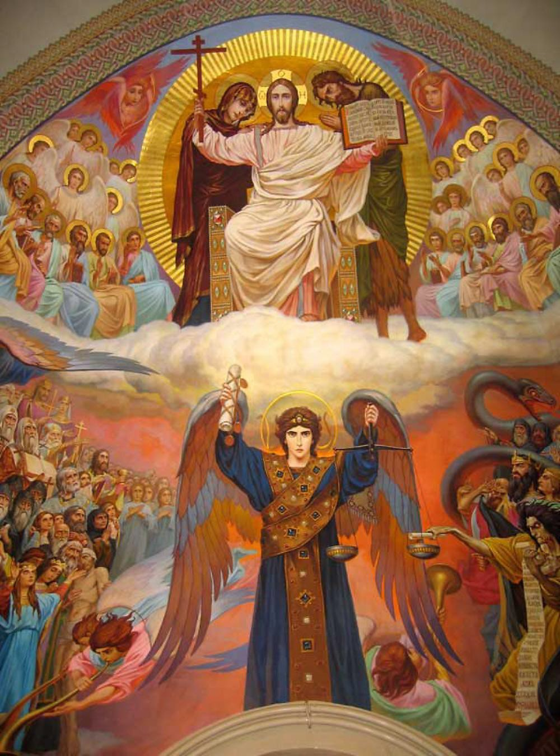**FROM THE VICAR'S DESK** *(M. C. Gillette)*

Do you remember the Millennium Development Goals (MDGs)? The eight initiatives agreed to by all member-states of the United Nations in the year 2000, initiatives intended to dramatically improve quality of life for millions of the world's poor and disenfranchised? We talked quite a bit about them in a Christian Formation class 5 or 6 years ago. They're listed on a poster which hangs in Lincoln Hall, over by the pictures from the Food Pantry and the newsletters from the Mission Possible folks. Remember?

1. Eradicate extreme poverty and hunger.

2. Achieve universal primary education.

3. Promote gender equality and empower women.

4. Reduce child mortality.

5. Improve maternal health.

6. Combat HIV/AIDS, malaria, and other diseases.

7. Ensure environmental sustainability.

8. Global partnership for development.

The target date for achieving these goals was/is – 2015. There has been some progress. There have been some setbacks. For more about current implementation status and strategies, and ancillary news associated with the MDGs, go to: <http://www.un.org/millenniumgoals/>

Although the MDGs are 'civil' initiatives, they are certainly reflective of the Gospel principles by which we as Christians are called to live our lives. With the original 'goal achievement' date of 2015 fast upon us, I would like to invite your renewed prayers for the people these goals were established to support, for those whose lives are dedicated to serving the world's oppressed, impoverished, and afflicted, and for those whose interests and actions hinder, or work directly against, the ability of the vulnerable to live into their potential as children of the living God. In preparing worship materials for the Women's Witness Trip (2) to Israel and Palestine – the trip that starts my sabbatical, as I join the women involved as Chaplain – I wrote a litany based on the MDGs, which I offer to you here as one way to begin these prayers.

**A LITANY BASED ON THE MILLENNIUM DEVELOPMENT GOALS**

**One:** Each human being was created in God's own image – with dignity, talents, and the opportunity to flourish. But sin has crept into our hearts, into our economies, into our political structures, and into our relationships, and it has robbed some of God’s children of their flourishing. In a world where some voices have been silenced by the world’s powers, while others have been amplified – whether because of their gender or the color of their skin or the size of their bank accounts or the people they know – our scriptures tell us to "Speak out for those who cannot speak." God of justice and peace, empower us to use our voices.

***All: Give us the words, O God, to speak for those who cannot speak.***

**One:** We pray for the eradication of extreme poverty; for those with no reliable source of income; for those whose labor is misappropriated and unfairly compensated; for those who are ill- housed, ill-fed, ill-clothed, ill-cared for; for those whose poverty corrodes their dignity. God of the least of these, empower us to use our voices.

***All: Give us the words, O God, to speak for those who cannot speak.***

**One:** We pray for universal primary education; for the education of girls, minority children, children in rural areas, children with disabilities; for those whose families cannot afford school fees or uniforms, those who must work instead of attending school; for those whose families fear the power of learning; for all school-aged children without access to schools. God of the living Word, empower us to use our voices.

***All: Give us the words, O God, to speak for those who cannot speak.***

**One:** We pray for gender equality and women's empowerment; for women whose roles and tasks are defined for them, women without options, without choice; for women who do the same job as men, but are paid less; for women who have no representation in government; for women whose bodies are controlled by the whims and desires of others; for women who live in fear in their own communities and homes. God who created us all in the Divine image, empower us to use our voices.

***All: Give us the words, O God, to speak for those who cannot speak.***

**One:** We pray for children who die from preventable causes; for sick children who live in parts of the world where illness and injury go untreated for want of resources, or because walls and checkpoints, borders and barbed wire deny them access to care; for children who starve to death or die of thirst or exposure; for children killed in the course of war; for children who are abused, neglected, or worked to death. God whose kingdom belongs to the little children, empower us to use our voices.

***All: Give us the words, O God, to speak for those who cannot speak.***

**One:** We pray for improved maternal health; for the mothers who die, one each minute, from complications during pregnancy, childbirth, or after delivery; for children and husbands left alone in the wake of these preventable deaths; and for midwives, skilled birth attendants, doctors, and nurses who assist women in giving birth. God whose Son was born of a woman, empower us to use our voices.

***All: Give us the words, O God, to speak for those who cannot speak.***

**One:** We pray for the ability to combat HIV/AIDS, malaria, and other diseases; for those without access to Anti-Retro-Viral drugs to treat HIV; for those whose communities are ravaged by preventable diseases which come in the wake of conflict, natural disasters, environmental degradation, or ignorance and skepticism about preventive measures; for pharmaceutical research focused on cures and treatments, not simply profit; for access to adequate care for the poorest and most vulnerable. God of healing and wholeness, empower us to use our voices.

***All: Give us the words, O God, to speak for those who cannot speak.***

**One:** We pray for environmental sustainability; for the millions of people who lack access to clean water and basic sanitation; for the extinction of species and unchecked damage to ecosystems; for the human greed which ravages the earth; for the will to practice responsible stewardship. God who created all and pronounced it good, empower us to use our voices.

***All: Give us the words, O God, to speak for those who cannot speak.***

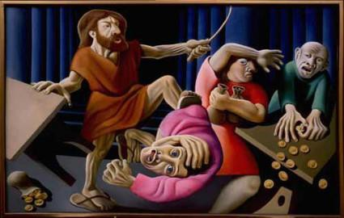**One:** We pray for a global partnership for development; for financial systems that are fair, that treat people with dignity, and do not prey on the vulnerable; for developing and recovering countries and communities struggling under the weight of crippling debt; for freedom from avarice, hoarding, corruption, and usury; for constructive efforts to shrink the gap between rich and poor. God who up-ends and un-settles, empower us to use our voices.

***All: Give us the words, O God, to speak for those who cannot speak.***

**One:** Give us the words, O God, to speak for those who cannot speak.

***All: Empower us to use our voices. Amen.***

**HERE AND THERE** (M. C. Gillette)

*In this on-going article, we pull things from our various Diocesan calendars and church websites to see what’s going on around us. For more information about what's happening at the Diocesan Headquarters and the Cathedral of Saint James, you can always visit their websites:* [http://www.episcopalchicago.org](http://www.episcopalchicago.org/) *or* [*http://www.saintjamescathedral.org/*](http://www.saintjamescathedral.org/) *For a direct link to Diocesan and Cathedral events calendars, go to:* <http://www.episcopalchicago.org/our-diocese/calendars/>

BISHOP LEE’S LETTER ON RENK DIOCESE, SOUTH SUDAN from April 23, 2014:

Dear Friends:

We have received credible reports from our friends in the [Diocese of Renk](http://www.episcopalchicago.org/at-work-in-the-world/global-mission/diocese-of-renk/) that the area is engulfed in fighting between the South Sudanese army and rebel troops loyal to former deputy president Riek Machar. It is not clear who controls the town. The Rev. Jacob Panchol, whom some of us have met during trips to the Diocese of Renk, informed us by telephone that he and the local chief, Chief Bior Kuir Aguer Deng, were currently safe and that most of the people in Renk had fled the area several days ago. Some 4,000 worshippers typically attend the celebration of the Easter Vigil, but on Saturday evening, only 60 worshippers were present.

Our friend Bishop Joseph Garang Atem is also safe. Indeed, earlier today he arrived in Chicago on a previously scheduled trip. He and I will participate in the Rev. Matt Gunter’s [consecration as bishop of Fond du Lac](http://www.episcopalfonddulac.org/bishopsearch/consecration.htm) on Saturday, and Bishop Joseph will be with us on Sunday for a prayer vigil for South Sudan at 4 pm at [St. James Cathedral](http://www.saintjamescathedral.org/).

Reports of the violence against unarmed civilians in South Sudan are horrifying. Rebel fighters massacred hundreds of innocent civilians last week in Bentiu, and armed youth attacked a UN Mission in Bor last week killing at least 48 civilians. More than a million people have fled their homes since the violence broke out late last year.

Please join us, in person or in spirit, for the vigil at the cathedral on Sunday, April 26, and hold the people of South Sudan and our companions in the [Diocese of Renk](http://www.episcopalchicago.org/at-work-in-the-world/global-mission/diocese-of-renk/) in your thoughts and prayers.

Faithfully,

The Rt. Rev. Jeffrey D. Lee  
Bishop

**Runners and volunteers wanted for June 6-7 Ragnar Relay**

In June, Bishop Lee and 11 other members of the Diocese of Chicago will run the Ragnar Relay, a day-and-night-relay race from **Madison, WI to Montrose Harbor, Chicago** to raise funds for **Episcopal Relief & Development**. Now is the time to join the team! A **Ragnar Team** consists of 12 runners. During the relay, each person runs three legs of a 36-leg relay race. Each leg averages between 3-7 miles with the total amount of miles per runner averaging between 13-16 miles. Runners with varying levels of experience can run this race. When not running, team members travel the route together in two large vans. If you are interested in joining Bishop Lee on this relay race or would like to volunteer to help our team get across the finish line, please contact Jennifer Baskerville-Burrows, director of networking, [**via email**](mailto:jbburrows@episcopalchicago.org) as soon as possible.

[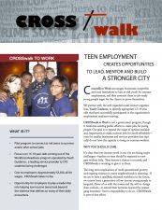](http://www.episcopalchicago.org/files/7413/9326/4536/CROSSwalk_to_Work_Brochure.pdf)**CROSSwalk to Work – Summer jobs program supports at-risk youth**

What do **Pepper Construction** and **Holy Comforter Preschool** have in common? They're both hiring CROSSwalk to Work interns this summer. What began as a 2012 procession against youth violence is evolving in its second year with **CROSSwalk to Work** -- a pilot program to connect at-risk high school aged youth with summer jobs and mentorship. This summer we hope to connect 50 youth with 50 jobs. We're looking for employers who can hire one or more youth for 8-10 weeks this summer in an entry-level/low-skilled job. This is an opportunity to invest in young people's futures and the health and healing of our communities.

**SOME CHURCHY STUFF** *(M. C. Gillette)*

*In this monthly article, we look at terms and definitions of things you might see or hear around church. Nothing fancy here – these entries are out of the Armentrout/Slocum An Episcopal Dictionary of the Church, sometimes supplemented by me, and sometimes simply copied directly. If something in particular piques your interest, let me know, and we’ll deal with it in more depth.*

****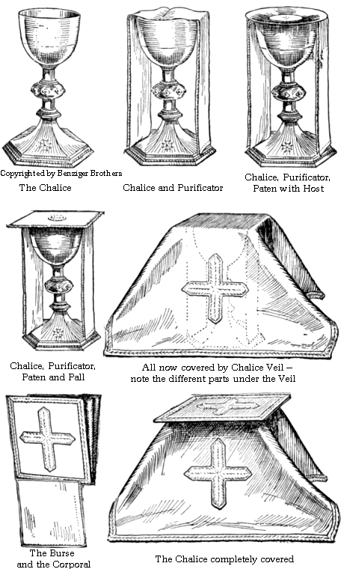**CHALICE.** The cup for the wine that is consecrated and administered at the eucharist. The chalice normally has a footed base. It is appropriate for only one chalice to be on the altar during the Eucharistic Prayer, but add-itional chalices may be filled with consecrated wine as needed after the breaking of the bread. The chalice usually matches the paten, which is the plate or dish for the consecrated bread. Chalices are typically made of silver, or other precious or semi-precious metals, and may be decorated by jewels or engraved designs. Pottery chalices are also used. And, of course – crystal! Like ours!

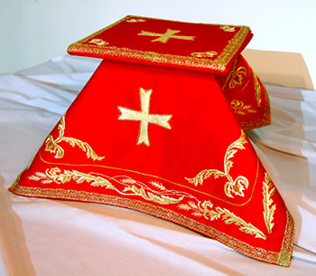**CHALICE VEIL.** We don't use one of these, because we don't use *any* drapings in the liturgical colors of the day, but they are pretty common. They are squares of material that cover the chalice and paten until they are needed for preparation of the altar at the eucharist. They typically match the eucharistic vestments and the liturgical color of the day. The chalice veil is placed on top of the pall, which rests on top of the chalice and paten. A purificator rests between the chalice and paten. Additional purificators and the corporal may be kept in the burse. When the chalice and paten are completely prepared for the liturgy with chalice veil and burse, they may be referred to collectively as a 'vested chalice.'

|  |  |  |  |
| --- | --- | --- | --- |
| **UPCOMING SERVICES – CHURCH OF THE HOLY APOSTLES – MAY 2014** | | | |
|  | | | |
| Sunday  04 May  8 & 10:30 a.m. | Sunday  11 May  8 & 10:30 a.m. | Sunday  18 May  8 & 10:30 a.m. | Sunday  25 May  9:30 a.m. |
| Scheduled  Presider:  Bullion  Preacher:  Bullion | Scheduled  Presider:  Gillette  Preacher:  Gillette | Scheduled  Presider:  Gillette  Preacher:  Gillette | Scheduled  Presider:  Dafoe Lane  Preacher:  Dafoe Lane |
| 3rd Sunday of  Easter (A) | 4th Sunday of  Easter (A) | 5th Sunday of  Easter (A) | 6th Sunday of  Easter (A) |
| FIRST  LESSON  Acts  2:14a, 36-41  RESPONSE  Psalm  116:1-3, 10-17  SECOND LESSON  1 Peter  1:17-23  GOSPEL  Luke  24:13-35 | FIRST  LESSON  Acts  2:42-47  RESPONSE  Psalm  23  SECOND LESSON  1 Peter  2:19-25  GOSPEL  John  10:1-10 | FIRST  LESSON  Acts  7:55-60  RESPONSE  Psalm  31:1-5, 15-16  SECOND LESSON  1 Peter  2:2-10  GOSPEL  John  14:1-14 | FIRST  LESSON  Acts  17:22-31  RESPONSE  Psalm  66:7-18  SECOND LESSON  1 Peter  3:13-22  GOSPEL  John  14:115-21 |



**WELCOME ! WELCOME ! WELCOME** !

Holy Apostles is very pleased to have The Rev. Wendy Lane with us as Presider and Preacher at the 9:30 a.m. services from May 25 through June 29. The Rev. Wendy is a retired priest in the Diocese of Chicago. During her years in ministry she worked as Associate Rector at St. Simon’s Episcopal Church in Arlington Heights and The Church of the Holy Spirit in Lake Forest. At the diocese Wendy was a member of the Peace and Justice Commission, and has served on the Convention Planning Committee and mentored several women in the ordination process for the Commission on Ministry. In retirement Wendy and her husband enjoy traveling and spending time with family and friends. They live in Lake Forest, have two grown daughters, two grandsons and are active members of The Church of the Holy Spirit.

**IN OUR** **PARISH LIFE**

**BOOK DISCUSSION GROUP:** We are very excited to announce our selections for 2014! The Book grounormally meets on the 4th Tuesday of the month at 7:30 pm, rotating among members' homes. We enjoy lively conversation, good food and wine, and outstanding fellowship. All we are missing is you! Please contact Lisa Earley if you would like more information. Here is what we are reading this year:

May 27 - *The Glass Castle* (Jeannette Walls) at the home of Sandy Brown & Scott Stoltz

June 24 - *The Deep End of the Ocean* (Jacquelyn Mitchard) at the home of Julie Zuidema

July 22 - *The Boy Who Harnessed the Wind* (William Kamkwamba & Bryan Mealer) at the home of Lisa Earley

August 26 - *I Know This Much is True* (Wally Lamb) at the home of Judi Dura

September 23 - *Movable Feast* (Ernest Hemingway) at the home of Barb Barrie

October 28 - *In the Time of the Butterflies* (Julia Alvarez) location TBD

November 25 - *Empty Mansions*(Bill Dedman) location TBD

December 23 - *Divergent* (Veronica Roth) location TBD

**SHAWL MINISTRY:** Please join our hearty group of yarn warriors on the second and fourth Mondays each month at 7:00pm in Lincoln Hall. We knit, crochet and tie together prayer shawls and hats to be given away to

people in need of comfort all over the world. Our shawls have been sent throughout the United States, and as far

as the United Kingdom and Australia!

**WAUCONDA/ISLAND LAKE FOOD PANTRY:** The milk jug count for March was $93.37. In March the food pantry served 251 families which totaled 677 individuals. Nine families were new to the pantry. Please keep them in your prayers. There is a sign-up sheet in Lincoln Hall if you are interested in volunteering on Saturdays between 10 AM and 12 noon. If you have any questions please contact Rick or Marsha Fedor or email [fedor711@comcast.net](mailto:fedor711@comcast.net).

**TAIZE SERVICE of Silence and Light:** All are welcomed to the Taize Service on Friday May 30, beginning at 7:00 pm. This service provides opportunities for silence, interspersed with chants and readings. We pray that in the “sound of sheer silence” you will hear the voice of God.

**RUN HOME CHICAGO- A Race to End Homelessness:** The third annual 5K Run/Walk, sponsored by the Primo Center for Women and Children, will be held on Saturday, June 7 at Soldier Field. Proceeds will go to support local non-profit agencies that serve the homeless. Comedian Steve Harvey will serve as host this year. For more information please call 312-446-3144.

**A MESSAGE FROM GAIL PERMENTER:**

Altar Guild Members:  
    There are awesome women in the Altar Guild who have spent many many hours and many years devoted to this ministry.  I would like to acknowledge Eileen Kinney who is one such member.  She is stepping down as an active member of the Guild due to personal reasons.  I so appreciate the service she provided as she took her turn each month setting up the altar for services.  Thank you, Eileen, very much.    
Speaking of awesome people...I hope you all have noticed the shiny brass and silver that now adorns the church.  Many hands had a "hand" in polishing candesticks, offering plates, the Baptismal Font, the goblets and the candle followers.  Thanks to Sandy Brown, Marsha Taylor, Lynn Chmiel, Julie Zuidema, and Angie and Jim Pinder.  We had a fun morning and got so much accomplished in such a short time.  Jim Pinder has the magic polishing material and was giving unsolicited "guidance" in method and procedures of polishing.  I'd say by the look of the final product we all ROCKED!  Thanks again to the polishing crew.  I appreciate it so so much.  The bagels and hot cross buns were yummy too!

|  |  |  |  |  |  |  |
| --- | --- | --- | --- | --- | --- | --- |
| **MAY 2014 (See page 5 for Service Schedule.)** | | | | | | |
|  | | | | | | |
| **SUN** | **MON** | **TUE** | **WED** | **THU** | **FRI** | **SAT** |
|  |  |  |  | 1 | 2 | 3  Food Pantry 10-12  THRIVE 8:30-1:30  Dog Grooming |
| 4 | 5 | 6 | 7 | 8 | 9 | 10  Food Pantry  10am-noon |
| 11 | 12  7:00pm  Shawl  Ministry | 13 | 14 | 15 | 16 | 17  Food Pantry  10am-noon |
| 18 | 19 | 20  Bishop’s  Committee  7:00pm | 21 | 22 | 23 | 24  Food Pantry  10am-noon |
| 25  3:45pm  Wauconda Care  Center Service | 26  7:00pm  Shawl  Ministry | 27  Book Group  7:30 pm | 28 | 29 | 30  Taize Service  7:00pm | 31  Food Pantry  10am-noon |

**May Birthdays May Anniversaries**

May 23 Alton Ellegood May 16 Carl and Lucy Reed

May 31 Don Hoebbel May 18 Graham Southall and

Alicja Lukasczewicz-Southall

**FROM: Church of the Holy Apostles**

**26238 North Highway 59**

**Wauconda, Illinois 60084**