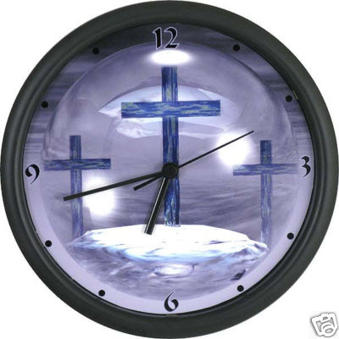
God's Time is the Best Time
Responsive Reading for November 2011
Theme: “A Time of Thanksgiving’”
Sunday, November 6, 2011
Psalm 30:1-8

¹ I will extol thee, O Lord; for thou hast lifted me up,
And hast not made my foes to rejoice over me.
² O Lord my God, I cried unto thee, and thou hast healed me.
³ O Lord, thou hast brought up my soul from the grave:
Thou hast kept me alive, that I should not go down to the pit.
⁴ Sing unto the Lord, O ye saints of his,
And give thanks at the remembrance of his holiness.
⁵ For his anger endureth but a moment; in his favour is life:
Weeping may endure for a night, but joy cometh in the morning.
⁶ And in my prosperity I said,
I shall never be moved.
⁷ Lord, by thy favour thou hast Made my mountain to stand strong:
Thou didst hide thy face, and I was troubled.
⁸ I cried to thee, O Lord;
And unto the Lord I made supplication.

Sunday, November 13, 2011
Psalm 69:29-36

²⁹ But I am poor and sorrowful:
Let thy salvation, O God, set me up on high.
³⁰ I will praise the name of God with a song,
And will magnify him with thanksgiving.
³¹ This also shall please the Lord better than an ox
Or bullock that hath horns and hoofs.
³² The humble shall see this, and be glad:
And your heart shall live that seek God.
³³ For the Lord heareth the poor,
And despiseth not his prisoners.
³⁴ Let the heaven and earth praise him,
The seas, and every thing that moveth therein.
³⁵ For God will save Zion,
And will build the cities of Judah:
That they may dwell there, and have it in possession.
³⁶ The seed also of his servants shall inherit it:
And they that love his name shall dwell therein.

Sunday, November 20, 2011
Psalm 95:1-7

¹ O come, let us sing unto the Lord:
Let us make a joyful noise to the rock of our salvation.
² Let us come before his presence with thanksgiving,
And make a joyful noise unto him with psalms.
³ For the Lord is a great God,
And a great King above all gods.
⁴ In his hand are the deep places of the earth:
The strength of the hills is his also.
⁵ The sea is his, and he made it:
And his hands formed the dry land.
⁶ O come, let us worship and bow down:
Let us kneel before the Lord our maker.
⁷ For he is our God;
And we are the people of his pasture, and the sheep of his hand.
To day if ye will hear his voice,
⁸ Harden not your heart, as in the provocation,
And as in the day of temptation in the wilderness.

Sunday, November 27, 2011
2 Corinthians 9:8-15

⁸ And God is able to make all grace abound toward you; that ye, always having all sufficiency in all things, may abound to every good work:
⁹ (As it is written, He hath dispersed abroad; he hath given to the poor: his righteousness remaineth for ever.
¹⁰ Now he that ministereth seed to the sower both minister bread for your food, and multiply your seed sown, and increase the fruits of your righteousness;)
¹¹ Being enriched in every thing to all bountifulness, which causeth through us thanksgiving to God.
¹² For the administration of this service not only supplieth the want of the saints, but is abundant also by many thanksgivings unto God;
¹³ Whiles by the experiment of this ministration they glorify God for your professed subjection unto the gospel of Christ, and for your liberal distribution unto them, and unto all men;
¹⁴ And by their prayer for you, which long after you for the exceeding grace of God in you.
¹⁵ Thanks be unto God for his unspeakable gift.

