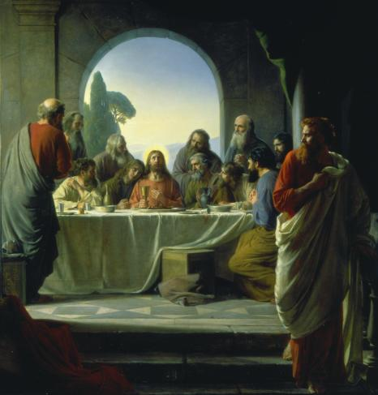

Responsive Reading for January 2011
Theme: “I Know It Was The Blood”

Sunday, March 6, 2011
1 Corinthians 11:23-34

23 For I have received of the Lord that which also I delivered unto you, That the Lord Jesus the same night in which he was betrayed took bread:
24 And when he had given thanks, he brake it, and said, Take, eat: this is my body, which is broken for you: this do in remembrance of me.
25 After the same manner also he took the cup, when he had supped, saying, This cup is the new testament in my blood: this do ye, as oft as ye drink it, in remembrance of me.
26 For as often as ye eat this bread, and drink this cup, ye do shew the Lord’s death till he come.
27 Wherefore whosoever shall eat this bread, and drink this cup of the Lord, unworthily, shall be guilty of the body and blood of the Lord.
28 But let a man examine himself, and so let him eat of that bread, and drink of that cup.
29 For he that eateth and drinketh unworthily, eateth and drinketh damnation to himself, not discerning the Lord’s body.
30 For this cause many are weak and sickly among you, and many sleep.
31 For if we would judge ourselves, we should not be judged.
32 But when we are judged, we are chastened of the Lord, that we should not be condemned with the world.
33 Wherefore, my brethren, when ye come together to eat, tarry one for another.
34 And if any man hunger, let him eat at home; that ye come not together unto condemnation. And the rest will I set in order when I come.

Sunday, March 13, 2011
Luke 22:10-24

10 And he said unto them, Behold, when ye are entered into the city, there shall a man meet you, bearing a pitcher of water; follow him into the house where he entereth in.
11 And ye shall say unto the goodman of the house, The Master saith unto thee, Where is the guestchamber, where I shall eat the passover with my disciples?
12 And he shall shew you a large upper room furnished: there make ready.
13 And they went, and found as he had said unto them: and they made ready the passover.
14 And when the hour was come, he sat down, and the twelve apostles with him.
15 And he said unto them, With desire I have desired to eat this passover with you before I suffer:
16 For I say unto you, I will not any more eat thereof, until it be fulfilled in the kingdom of God.
17 And he took the cup, and gave thanks, and said, Take this, and divide it among yourselves:
18 For I say unto you, I will not drink of the fruit of the vine, until the kingdom of God shall come.
19 And he took bread, and gave thanks, and brake it, and gave unto them, saying, This is my body which is given for you: this do in remembrance of me.
20 Likewise also the cup after supper, saying, This cup is the new testament in my blood, which is shed for you.
21 But, behold, the hand of him that betrayeth me is with me on the table.
22 And truly the Son of man goeth, as it was determined: but woe unto that man by whom he is betrayed!
23 And they began to inquire among themselves, which of them it was that should do this thing.

Sunday, March 20, 2011
Matthew 26:19-29

19 And the disciples did as Jesus had appointed them; and they made ready the passover.
20 Now when the even was come, he sat down with the twelve.
21 And as they did eat, he said, Verily I say unto you, that one of you shall betray me.
22 And they were exceeding sorrowful, and began every one of them to say unto him, Lord, is it I?
23 And he answered and said, He that dippeth his hand with me in the dish, the same shall betray me.
24 The Son of man goeth as it is written of him: but woe unto that man by whom the Son of man is betrayed! it had been good for that man if he had not been born.
25 Then Judas, which betrayed him, answered and said, Master, is it I? He said unto him, Thou hast said.
26 And as they were eating, Jesus took bread, and blessed it, and brake it, and gave it to the disciples, and said, Take, eat; this is my body.
27 And he took the cup, and gave thanks, and gave it to them, saying, Drink ye all of it;
28 For this is my blood of the new testament, which is shed for many for the remission of sins.
29 But I say unto you, I will not drink henceforth of this fruit of the vine, until that day when I drink it new with you in my Father’s kingdom.

Sunday, March 27, 2011
Mark 14:16-26

16 And his disciples went forth, and came into the city, and found as he had said unto them: and they made ready the passover.
17 And in the evening he cometh with the twelve.
18 And as they sat and did eat, Jesus said, Verily I say unto you, One of you which eateth with me shall betray me.
19 And they began to be sorrowful, and to say unto him one by one, Is it I? and another said, Is it I?
20 And he answered and said unto them, It is one of the twelve, that dippeth with me in the dish.
21 The Son of man indeed goeth, as it is written of him: but woe to that man by whom the Son of man is betrayed! good were it for that man if he had never been born.
22 And as they did eat, Jesus took bread, and blessed, and brake it, and gave to them, and said, Take, eat: this is my body.
23 And he took the cup, and when he had given thanks, he gave it to them: and they all drank of it.
24 And he said unto them, This is my blood of the new testament, which is shed for many.
25 Verily I say unto you, I will drink no more of the fruit of the vine, until that day that I drink it new in the kingdom of God.
26 And when they had sung an hymn, they went out into the mount of Olives.

