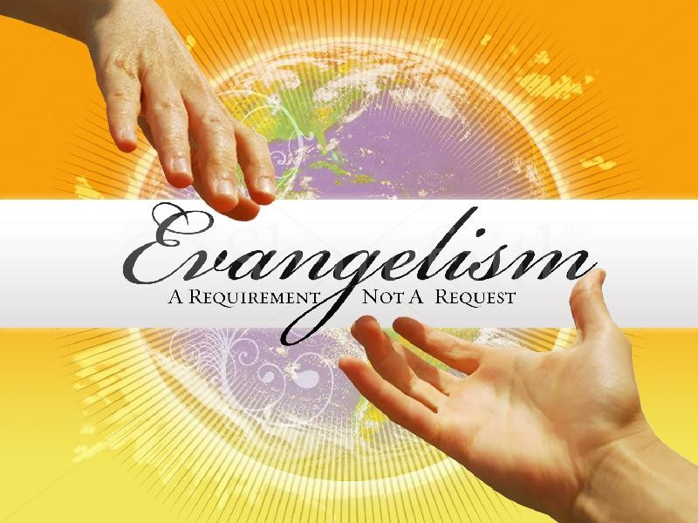

Responsive Reading for March 2012
Theme: “Serving The Lord Payees Off”

Sunday, March 4, 2012
Joshua 24:14-20

¹⁴ Now therefore fear the LORD, and serve him in sincerity and in truth: and put away the gods which your fathers served on the other side of the flood, and in Egypt; and serve ye the LORD.
¹⁵ And if it seem evil unto you to serve the LORD, choose you this day whom ye will serve; whether the gods which your fathers served that were on the other side of the flood, or the gods of the Amorites, in whose land ye dwell: but as for me and my house, we will serve the LORD. ¹⁶ And the people answered and said, God forbid that we should forsake the LORD, to serve other gods;
¹⁷ For the LORD our God, he it is that brought us up and our fathers out of the land of Egypt, from the house of bondage, and which did those great signs in our sight, and preserved us in all the way wherein we went, and among all the people through whom we passed:
¹⁸ And the LORD drave out from before us all the people, even the Amorites which dwelt in the land: therefore will we also serve the LORD; for he is our God.
¹⁹ And Joshua said unto the people, Ye cannot serve the LORD: for he is an holy God; he is a jealous God; he will not forgive your transgressions nor your sins.
²⁰ If ye forsake the LORD, and serve strange gods, then he will turn and do you hurt, and consume you, after that he hath done you good.

Sunday, March 11, 2012
Psalm 101:1-8

¹ I will sing of mercy and judgment: unto thee, O LORD, will I sing.
² I will behave myself wisely in a perfect way. O when wilt thou come unto me? I will walk within my house with a perfect heart.
³ I will set no wicked thing before mine eyes: I hate the work of them that turn aside; it shall not cleave to me.
⁴ A froward heart shall depart from me: I will not know a wicked person.
⁵ Whoso privily slandereth his neighbour, him will I cut off: him that hath an high look and a proud heart will not I suffer.
⁶ Mine eyes shall be upon the faithful of the land, that they may dwell with me: he that walketh in a perfect way, he shall serve me.
⁷ He that worketh deceit shall not dwell within my house: he that telleth lies shall not tarry in my sight.
⁸ I will early destroy all the wicked of the land; that I may cut off all wicked doers from the city of the LORD.

Sunday, March 18, 2012
Daniel 3:12-18

¹² There are certain Jews whom thou hast set over the affairs of the province of Babylon, Shadrach, Meshach, and Abednego; these men, O king, have not regarded thee: they serve not thy gods, nor worship the golden image which thou hast set up.
¹³ Then Nebuchadnezzar in his rage and fury commanded to bring Shadrach, Meshach, and Abednego. Then they brought these men before the king.
¹⁴ Nebuchadnezzar spake and said unto them, Is it true, O Shadrach, Meshach, and Abednego, do not ye serve my gods, nor worship the golden image which I have set up?
¹⁵ Now if ye be ready that at what time ye hear the sound of the cornet, flute, harp, sackbut, psaltery, and dulcimer, and all kinds of musick, ye fall down and worship the image which I have made; well: but if ye worship not, ye shall be cast the same hour into the midst of a burning fiery furnace; and who is that God that shall deliver you out of my hands?
¹⁶ Shadrach, Meshach, and Abednego, answered and said to the king, O Nebuchadnezzar, we are not careful to answer thee in this matter.
¹⁷ If it be so, our God whom we serve is able to deliver us from the burning fiery furnace, and he will deliver us out of thine hand, O king.
¹⁸ But if not, be it known unto thee, O king, that we will not serve thy gods, nor worship the golden image which thou hast set up.

Sunday, March 25, 2012
Romans 7:1-6

¹ Know ye not, brethren, (for I speak to them that know the law,) how that the law hath dominion over a man as long as he liveth?
² For the woman which hath an husband is bound by the law to her husband so long as he liveth; but if the husband be dead, she is loosed from the law of her husband.
³ So then if, while her husband liveth, she be married to another man, she shall be called an adulteress: but if her husband be dead, she is free from that law; so that she is no adulteress, though she be married to another man.
⁴ Wherefore, my brethren, ye also are become dead to the law by the body of Christ; that ye should be married to another, even to him who is raised from the dead, that we should bring forth fruit unto God.
⁵ For when we were in the flesh, the motions of sins, which were by the law, did work in our members to bring forth fruit unto death.
⁶ But now we are delivered from the law, that being dead wherein we were held; that we should serve in newness of spirit, and not in the oldness of the letter.

