16 Questions Leaders Should Ask Themselves
Guest Post by Matt Monge

- Are you more motivated mostly by the drive to capture success or by a desire to serve others?

- Do you use your grasp of internal politics as a weapon to get what you want? Or are you sensitive to the human dynamics at play in the organization, but work toward collaborative, empowering solutions that appeal to shared goals, values, and visions?

- Do you rely completely on facts, logic, and proof? Or do you use intuition and foresight–gut and instinct–to balance those things?

- Do you control information, knowing it makes you more valuable? Or do you freely and generously share your knowledge and know-how?

- Are you highly competitive, independent, and primarily interested in the spotlight? Or are you more concerned about working closely with others, allowing yourself to be interdependent, and deflecting praise when it comes your way?

- Do you place an over-emphasis on speed and fast action? Or do you focus on gaining understanding; adapting to organizational environments; and balancing the need for progress with the need for appropriate buy-in, input, and decentralized decision-making?

- Do you spend more time telling or listening?

- Do you equate patience with indecision? Or do you value listening and observation in order to make good decisions?

- Do you act like you’re listening to those with whom you disagree? Or do you actually listen to those with whom you disagree?

- 10. Do you get annoyed when others won’t think or act the way you want them to? Or are you thankful for the variety and use it as an opportunity to examine your own thoughts, presuppositions, and conclusions?

- Do you view your network as connections to be used to get you things or give you information when you want it? Or do you view them as other humans who have unique strengths, information, and perspectives that you could learn from?

- Do you secretly relish being able to look down from atop the org chart? Or do you view your leadership position more as an immense privilege and responsibility to serve a larger group of people to a greater degree?

- Do you use intimidation (in all its forms) over inspiration?

- Which is more important: what benefits you or the good of the whole?

- Do you believe leadership is about control? Or do you believe leadership is about finding ways not to have so much of it?

16. Do the people whose work you admire always happen to work exactly like you do? Or do you value the diverse and interesting ways people are wired to work?
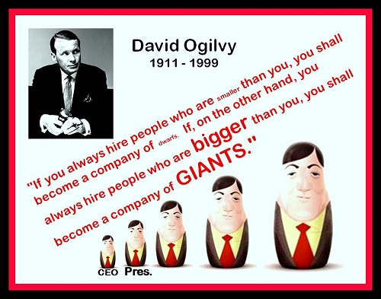
So are you looking for “dwarfs” or “GIANTS?”
Matt Monge – Credit union executive by day. Workplace mojo maker by night. Matt’s primary passion is his work as Chief Culture Officer at Mazuma Credit Union, but he also does speaking and consulting work on the side to help other organizations with what he’s passionate about: developing awesome culture, organizational identity, and leadership. Matt’s blog: themojocompany.com You can follow Matt on twitter @mattmonge

