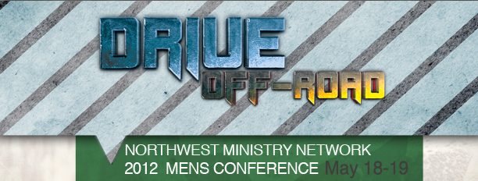

www.nwministry.com

OFF-SITE EVENTS, FRIDAY May 18th, 2012

- Bicycle Ride 7:00am
- Motorcycle Rides 9:00am and 1:00pm
- Top Gun Combination Shoot-off 9:00am – 4:00pm
- Golf Tournament 12:30pm Shotgun Start

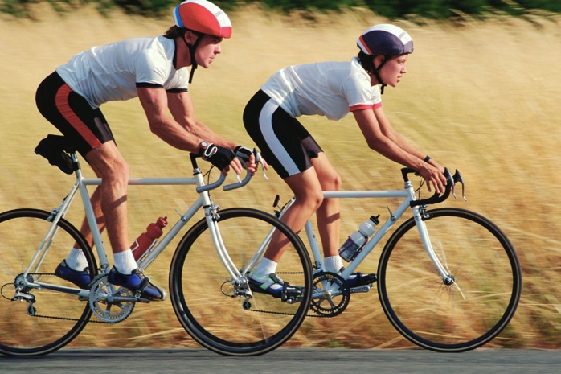
Bicycle Ride, 7:00am
Contact: Ken Zeigler, 360-460-0036 or cozi@olypen.com

Description: Meet at Faith AG parking lot. Self-supporting, choose 50 or 75 mile rides. 75 mile ride is more strenuous and faster paced. Bring your own bicycle and helmet. Details and maps provided at start of ride. Dress for weather, bring minimum 2 water bottles, energy food, tools, tube and pump. Stops along the way to buy items as needed.
*No cost. Please check box on mail-in or online registration.
www.drive2012.eventbrite.com

Faith Assembly of God
1800 N. Road 72
Pasco, WA 99301

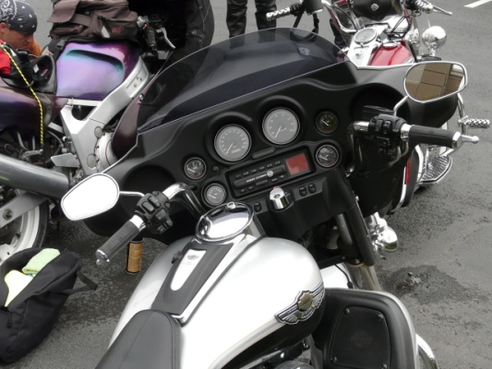
Motorcycle Rides, 9:00am and 1:00pm
Contact: Dennis Montgomery, water.one56@yahoo.com

Description: For both rides, meet at Faith AG parking lot. The 9:00am morning ride will take about 3.5 hours with a couple stops for refreshments. The 1:00pm afternoon ride is less than 2 hours with a stop for beverage. Anyone with prior experience as a road captain or sweep rider is asked to please contact Dennis if you are interested in leading or sweeping.
*No cost. No registration needed (must be registered for Men’s Conference).

Faith Assembly of God
1800 N. Road 72
Pasco, WA 99301

Top Gun Combination Shoot-off, 9:00am – 4:00pm
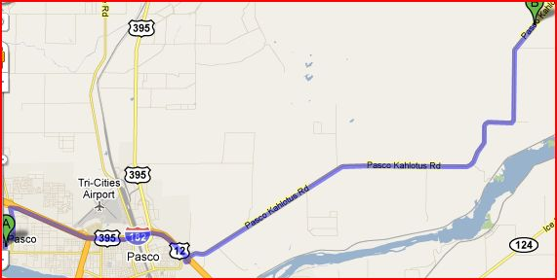
Contact: Dave Myers, 509-438-1277

Description: Modern rifle, Shotgun, Handgun, Muzzleloader and Archery. New! Exploding target event with modern rifle (extra charge). Bring your own firearms, ammunition, sunscreen and hearing/eye protection. Participate in as many venues as you wish. Top Gun is high score in combination of all events. Lunch included.
Cost is $20.00 in advance; $25.00 day of event. *Please register online or mail-in.
www.drive2012.eventbrite.com

Fishhook Ranch Outfitters LLC.
15401 Pasco-Kahlotus Rd.
Pasco, WA 99301
509-544-6557

Directions from Rd 68 in Pasco:
Take I-182 /US-12 East
Drive 6 miles and take the Pasco-Kahlotus Hwy exit (drive under the overpass, exit right)
Bear right onto E.Lewis Street which turns into the Pasco-Kahlotus Hwy. Drive east 15.8 miles to destination.

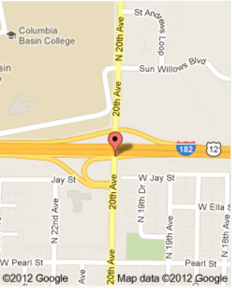
Golf Tournament, 12:30pm Shotgun Start
Contact: Darrel Johnsen, 509-539-5285

Description: Different course this year: SUN WILLOWS GOLF COURSE. 4-man Best-ball Scramble. List players on your registration. Otherwise, teams will be assigned. Cost includes green fees, cart and range balls. Bring your own clubs. Cost is $50.00
*Please register online or mail-in. www.drive2012.eventbrite.com

Sun Willows Golf Course
2535 North 20th Avenue
Pasco, WA 99301
Phone: 509-545-3440

Directions:
Come into Richland from 182 or 240
Take exit 12B and turn left onto North 20th Ave
Turn right at Sun Willows Blvd, 2nd stoplight
(Behind Red Lion near the airport)

